End of the Fiscal Year Reminders

The fourth quarter of the fiscal year is here. During this busy time, keep in mind the following reminders and tips as you go about making awards in support of the NIH mission.
- Be sure to keep an eye on Year End deadlines. The NIH FY2022 Communications SharePoint site is a central storage point and one stop shop of general NIH-wide communications regarding Year End.
- Review the list of required and priority sources to help you determine available required and priority sources.
  - Remember to shop the NIH Supply Center for availability of items before seeking outside sources for supplies that are available at NIH.
  - Take advantage of the resources of category management. Information and available solutions can be found at the GSA Acquisition Gateway.
  - Leverage pre-negotiated instruments and other streamlined acquisition methods including NIH-wide contracts and Blanket Purchase Agreements.
- Seek ways to provide maximum practicable opportunities in acquisitions to small business, veteran-owned small business, service-disabled veteran-owned small business, HUBZone small business, small disadvantaged business, and women-owned small business concerns. Find the Small Business Specialist assigned to support your IC on the NIH Small Business Program Office Staff Listing page.
- Ensure you are complying with Made in America laws that support American manufacturing. Even though the August 8, 2022 deadline for submission of FY22 non-availability waivers has passed, waiver requests still can be submitted but with the understanding that there is no guarantee that they will be completed in time before the end of the fiscal year. Also, waiver requests for the next fiscal year can be sent to the NIH Buy American Waivers mailbox at NIHBuyAmericanWaiver@od.nih.gov. Additional information can be found on the ASRB SharePoint site in the Buy American – Made in America Office folder.

Purchase Card Reconciliation: Top 5 Reminders

On average, NIH Purchase Cardholders make over 20,000 purchases a month. These purchases are loaded into NBS daily and purchase cardholders and approving officials complete a process known as reconciliation. Reconciliation consists of reviewing the transactions that are on the monthly Purchase Card Statement in NBS, validating these purchase card transactions, and verifying payment. Reconciliation also certifies that purchases were made for official Government purposes. Cardholders and Approving Officials must ensure the following:

1. Cardholders must log transactions into NBS within 5 business days of when the transaction was made. An NBS log constitutes an obligation of funds. Ideally a log should be created before a purchase is made, however, in some cases it may occur shortly afterwards. Once a purchase is made and shows on the cardholder’s statement, the cardholder will then match that transaction to the corresponding log. Open logs that are not anticipated to be matched against an order must be cancelled. Cardholders must routinely review their open logs to ensure that any logs no longer needed are cancelled promptly, allowing these funds to be used for other legitimate NIH purchases.

2. Reconcile on Time. Purchase card transactions are posted daily to the cardholder’s account in NBS and cardholders are encouraged to reconcile daily. The billing cycle ends on the 5th of every month. Cardholders generally have until the 13th of every month to match and verify their transactions. Cardholders should not wait until the deadline to reconcile! If a cardholder cannot reconcile by the deadline, a reconciliation extension request must be submitted via the cardholder’s respective IC Purchase Card Coordinator. Failure to submit monthly reconciliation on time may result in suspension of the cardholder’s government purchase card. The card approving official (CAO) is responsible for reviewing and approving cardholders’ transactions under their approving authority to ensure the transactions are legal, proper, mission essential, and in accordance with purchase card policy.

3. Disputes: Occasionally there may be charges that a cardholder does not recognize and will need to be disputed in NBS. There is no interconnectivity from NBS to the servicing bank so when a cardholder disputes an invoice in NBS, the bank is not notified. The cardholder needs to first contact the vendor and try to resolve the dispute. If a dispute cannot be resolved with the merchant, cardholders must file a dispute with Citibank within 90 days of the transaction date. Remember: Disputing a transaction in NBS does not stop payment to the merchant nor does it generate a formal dispute with the bank.

4. Credits: Once the bank and/or merchant credit is received, the dispute should be matched to the credit under the dispute/credit tab of NBS reconciliation. Generally, disputes should not remain open in NBS for longer than 90 days.

5. Bottom Line: Do not wait to reconcile. If you have questions or have system issues, please reach out to your IC Coordinator, and ask for help. Reconciliation is a dual responsibility of the cardholder and CAO. Each bank transaction must be verified by the cardholder and approved by the CAO.

Principal Place of Performance Zip Code (+4)
Congress and other government agencies use the Federal Procurement Data System (FPDS) data to monitor NIH contracting spending/achievements throughout the year.
FAR 4.604(b)(1) states that the responsibility for completion and the accuracy of the individual contract action report resides with the contracting officer who awarded the contract actions.
Information entered in the Place of Performance (POP) Zip Code(+4) field is dependent upon the information contained in the Product/Service Code (PSC) field of the FPDS record.
- If the place of performance is located outside the U.S., enter the Vendor's Postal Code in the Place of Performance Zip Code (+4) field.
- Next, update the Vendor's Principal Place of Performance Code and the Country of Product or Service Origin fields.
An incorrect entry will trigger FedDataCheck #123 or #151
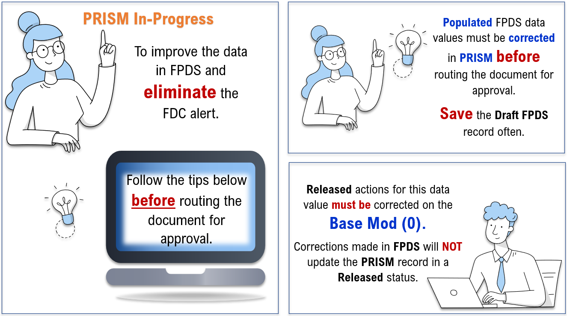
To verify the Vendor’s PSC, look up the Vendor’s SAM record, or request a CRA Vendor Report!
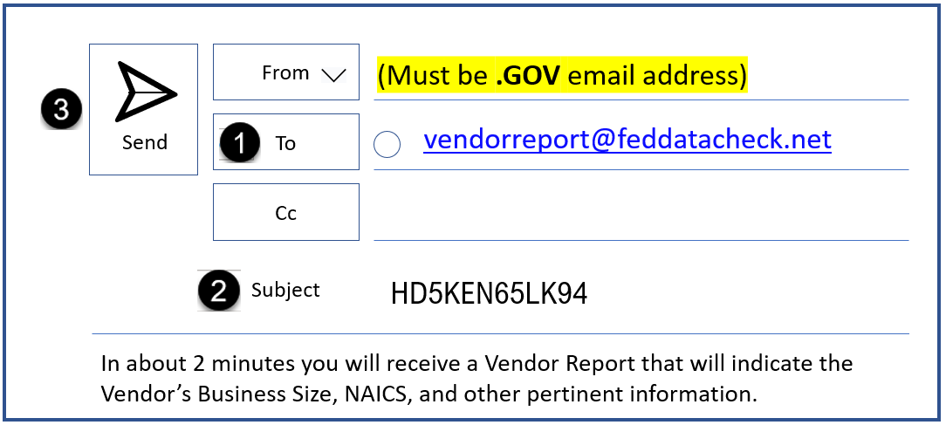
Although the System for Award Management (SAM) is the official source for vendor information. The Contractor Responsibility Assessment (CRA) report provides vendor information quickly. Open Outlook, address an email to vendorreport@feddatacheck.net, in the subject line enter the Vendor’s Unique Entity ID, click Send.

FedDataCheck #123 – A manufactured product where the Place of Performance incorrectly reflects where the product will be used

Definition: Principal Place of Performance for Goods/Supplies - Items being manufactured should reflect the manufacture site as the place of performance. All other goods should enter the location the item was taken from inventory (e.g., the store location, etc.).
If the place of performance is located in the U.S. in an area that has no ZIP Plus 4 code (e.g., a national park, a remote location, etc.), use the closest location that does have a ZIP Plus 4.
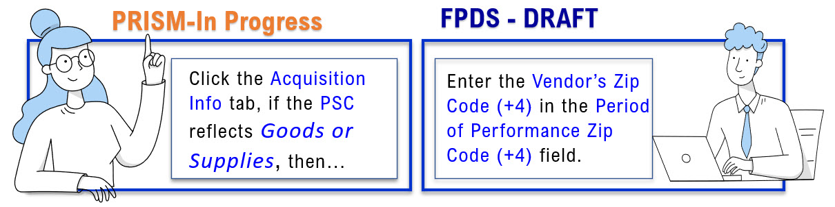
Outside the USA, enter the Postal Code then update the POP Code and the Country of Product or Service Origin.

FedDataCheck #151 – The Place of Performance does not appear to reflect where the “Service” will be performed.

For services awards, the Place of Performance is where the services will be performed. And in particular, this data check focuses on the PSC codes: 1) D317 - IT and Telecom- Web-Based Subscription and 2) D319 - IT and Telecom- Annual Software Maintenance Service Plans.
Definition: Principal Place of Performance for Services - The predominant place of performance at the time of award. Predominance is based on funding. If the funds Equal – the CO should use best judgement. In the case of subscription Services, software licenses, or similar type Services; use the location where these Services are being used.
In the case of Services that begin in one location and end in another, use the destination. In the case of Services being performed in oceans/seas, choose the closest major city (if in U.S. waters). In another country’s waters, choose that country. In the case of Services being performed in open waters, choose the closest country, or choose the closest major city if that country is the U.S.
In the case of Services being performed in atmosphere or space choose the location from which the equipment conducting the Services were launched.
If the place of performance is not specified by the government in the Statement of Work and the CO does not have any other information indicating a specific location the CO may use the Contractor’s location as the place of performance.
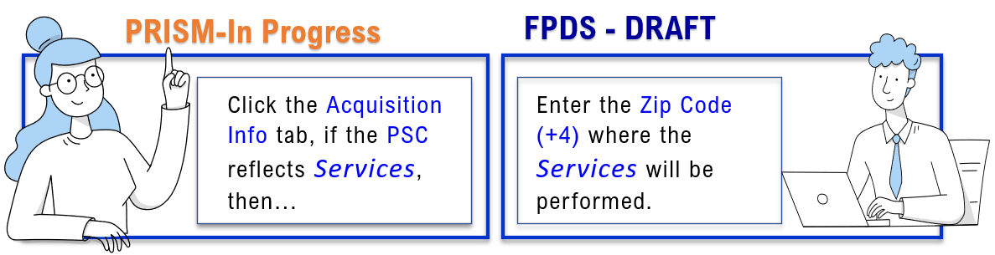
PSC https://www.acquisition.gov/psc-manual.
For more information download the most recent version of the FPDS Data Dictionary - https://www.fpds.gov/downloads/Version_1.5_specs/FPDS_DataDictionary_V1.5.pdf
The FedDataCheck Tool is a product of Potomac Wave Consulting. The tool automatically scans FPDS for data inconsistencies such as FAR violations, Statutory/Legislative violations, and other data inconsistencies. Contracting Officials are alerted via email when a violation or data inconsistency occurs.

NIH’s 2022 Personal Property Reutilization Campaign

The Property Management Branch (PMB) is leading the way at NIH to help the Community improve the use of its resources. We would like to place emphasis on extending the useful life of assets to support NIH’s overall mission.

PMB is in the initial stages of an important effort to promote HHS and NIH policies, goals, and objectives. We strive to further educate and remind the Community of our duty to use the resources entrusted to us wisely, effectively, and efficiently.

REUTILIZATION of personal property helps NIH save dollars for research and lessens our impact on the environment. Per NIH acquisition policy, it is mandatory to check NIH sources for excess property before initiating a new procurement. The NIH Property Management Branch often has Laboratory Equipment, Computers, Peripherals and Furniture readily available for reutilization at no cost to the NIH Community. For more information visit NIH Excess Product Catalog at:
https://excessproductcatalog.od.nih.gov/ec/dashboard#!/home

The Property Management Branch is happy to announce the relocation of the Property Reutilization and Disposal warehouse (PRDS and formerly known as GDC). The New PRDS warehouse is located at 800 East Gude Drive, Rockville, MD 20850.

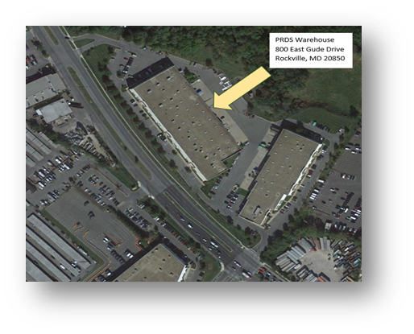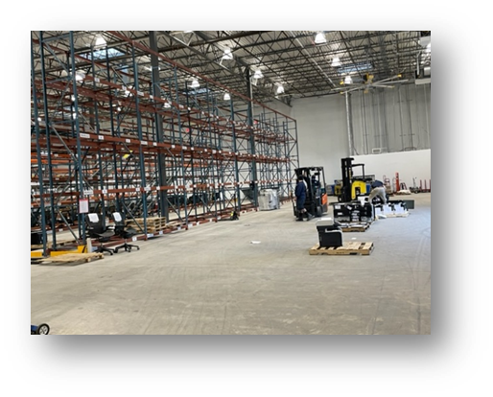
Watch for more information coming soon to the Community via NIH events, promotional devices, and electronic communications.

Thank you for a Successful FY22

The Supply Management Branch within the Division of Logistics Services would like to thank both our team and our customers for the success we have had this year. As we continued to live through the pandemic and endemic, the NIH campuses slowly came back to life with people coming in every day. We were proud to be your #1 source of supply to ensure you were able to come back to work safely and preparedly. Below are just a few of the tasks we were able to come together to accomplish this year:

Expanded our Green Product Catalog- in addition to the already carried green products, we expanded our portfolio to add more laboratory green-certified products including pipette tips and tubes. We are always looking to add even more green products to our catalog, so if there is something you do not see, please reach out to our Customer Service Team at NIHSC-CustomerService@od.nih.gov.

Found Comparable Alternative Items for National Backordered Items- with more manufacturer shortages and national backorders, some items were extremely hard to come by. Our team worked to ensure you were not left without options. We found comparable alternatives to offer customers so they could continue to fight for the MISSION at NIH.

Moved to our NEW Warehouse- the Supply Center moved to their new warehouse this summer and could not be more excited! Improvements are being made every day to continue to modernize the new space and make the shopping experience for customers the best it can be.

We cannot thank you enough for all of your hard work and dedication. We cannot wait to see what is to come in FY23!

If you would like to receive more information or have any questions, contact our Customer Service Team at NIHSC-CustomerService@od.nih.gov. Thank you and remember- we are ONE NIH!

NITAAC Wins 3rd Consecutive EPEAT Award

Globally recognized, EPEAT helps purchasers, manufacturers and resellers buy and sell environmentally preferable electronic products. That’s why we’re so proud of our EPEAT Three-peat. We’ve won their sustainability award for the third year in a row. What does it mean to you? With the FAR requiring 95% of all electronic product acquisitions be EPEAT-registered, and the Office of Management and Budget directing federal agencies to acquire 80% of the laptops and desktops from GSS, there’s no smarter move at year’s end than NITAAC-GSS. NITAAC takes considerable pride in doing our part to ensure the federal government has access to sustainable laptops, desktops, printers, monitors and servers to meet all our agency partner information technology (IT) needs. Best of all, if you don’t find what you’re looking for on GSS, you can just as easily look on CIO-CS, our commodities contract for everything IT. In addition to popular equipment, you’ll find cloud and as-a-service solutions. From tablets to enterprise licensing to cybersecurity, CIO-CS adds products daily and we’d be happy to add yours too. Read all about it on the NITAAC Director’s Corner.

Important NITAAC Information for End-Of-Fiscal-Year

NITAAC has contracts that meet all of your IT needs from Commodities and Solutions on CIO-CS to Services and Solutions on CIO-SP3 and CIO-SP3 Small Business. And they’re all available with direct ordering through our Electronic Government Ordering System (e-GOS) up to the very last minute of the very last day of the fiscal year.
You’ll be glad to know we’ve just released Version 8 of NITAAC’s Government-Wide Strategic Solutions (GSS) program which is actually under the CIO-CS GWAC. That’s the preferred program from the Office of Management and Budget’s Category Management Initiative that allows any agency to fulfill the majority of its office needs. For other commercial off-the-shelf solutions at low, low prices, like Cloud-in-a box, Cybersecurity or Anything-as-a-Service, CIO-CS is available through the end of this fiscal year and beyond. As long as awards are made by close of business on September 30th, you can make direct awards at NITAAC. CIO-CS was awarded later than CIO-SP3, and has a number of years left on the contract. If you can’t make an award by the 30th, there’s plenty of time to get it done as soon as next fiscal year begins.

If you want to use CIO-SP3 or CIO-SP3 Small Business for IT Services/Solutions, all contracts have been extended through at least November 1st. Since the fiscal year closes on September 30th, you’ll have until close of business on that day to make direct awards. Each task order under our GWACs can have up to a 5-year period of performance, taking you well into fiscal 2027. We’ve committed to keeping the contracts open until CIO-SP4 is fully awarded and onboarded so there may even be another extension. Watch for an announcement around November 1.

To learn more about all of our contracts, visit our website at nitaac.nih.gov. Or contact NITAACsupport@nih.gov at 1.888.776-6542.

REGISTRATION LINK | DATE/TIME
NITAAC Monthly GWACs Training Session  Learn about our three Best in Class (BIC) IT Government-Wide Acquisition Contracts (GWACs) (CIO-SP3, CIO-SP3 Small Business and CIO-CS) boast streamlined acquisition and fast ordering, a single login Electronic Government Ordering System (e-GOS) with built-in FAR guidance, and automated ordering. But that’s not all NITAAC offers. You’ll also find Assisted Acquisitions, free scope assessments and much more. | Thursday, August 25, 2022  1:00pm – 3:00pm EDT

Acquisition Policy Zone
Additional OALM communications can be found on the CDMP SharePoint site.
HHS Policy Flashes can be found on the HHS Office of Acquisition Policy Max.gov site.
Date Issued | Policy Communication | Description
4/26/22 | Policy Flash 22-07  Revised HHS Acquisition Policy, Guidance and Instructions (PGI) | This Policy Flash is issued to provide all Department of Health and Human Services (HHS) Operating and Staff Divisions (OPDIVs/STAFFDIVs) with information related to the recently revised HHS Acquisition Policy, Guidance, and Instructions (PGI) Part 307 - Acquisition Planning.  PGI Part 307.105 has been modified, effective immediately, as follows: (modified text highlighted) 307.105 Acquisition Plan (Contents of written acquisition plans). 307.105-70 Scope. FAR 7.102 and HHSAR 307.105 require acquisition planning for all acquisitions. The HHSAR requires a written acquisition plan for all acquisitions above the Simplified Acquisition Threshold. See the Acquisition Plan Template. Solicitations for requirements with an estimated value at or above the required threshold for Senior Procurement Executive (SPE) review and approval, shall not be issued until the written acquisition plan has been approved and signed by the SPE. The written market research report and independent government estimate must also accompany acquisition plans that are submitted for approval.
5/4/22 | Email from Nancy Norton, Associate Director, OAMP | As required by the Safer Federal Workforce Task Force guidance and subsequent HHS implementation, NIH has established a plan for execution of attestation of vaccination or proof of a negative COVID-19 test result for onsite contractors in the previous 72 hours if the COVID-19 Community Level increases from LOW to MEDIUM or HIGH.
6/10/22 | Email from Nancy Norton, Associate Director, OAMP | Made In America Waivers - HHS and OALM are working on additional guidance. In the meantime, Staff are reminded they must still be in compliance with the waiver requirement and ensure waiver requests are submitted in accordance with HHS Class Deviation 2022-01, Regarding Requirements for Nonavailability Determinations under the Buy American Act. All waiver requests must have HCA approval prior to submission to the Made in America Office (MIAO).
6/29/22 | Policy Flash 22-08 - National Labor Relations Act (NLRA) | This Policy Flash is issued to provide all Department of Health and Human Services (HHS) Heads of Contracting Activity (HCA) and all HHS OPDIV/STAFFDIV acquisition offices, with notification of the recently revised Employee Rights under the National Labor Relations Act (NLRA) poster.
6/30/22 | OALM Communication 22-83  Data Management and Sharing Policy – DGS Language and Frequently Asked Questions | This communication serves to inform you of upcoming changes to solicitation and contract requirements for the management and sharing of research data, as described in the Final NIH Policy for Data Management and Sharing, NOT-OD-21-013 which was released on October 29, 2020, with an effective date of January 25, 2023. Currently, NIH Data Sharing requirements are identified in DGS and reflect the 2003 NIH Final Statement on Sharing Research Data, NOT-OD-083-032. New articles have been developed for NIH Policy for Data Management and Sharing, NOT-OD-21-013.

Acquisition Training Information

Acquisition Training at NIH
Acquisition training classes that are offered by the NIH Training Center can be accessed at the following link: Acquisitions Management Courses

Federal Acquisition Certification Coursework
CON courses and other Federal Acquisition Certification required courses can be found at the NIH Training Center, Federal Acquisition Institute, and Defense Acquisition University.
Section 508 Accessibility Training
Section 508 Accessibility Training courses can be accessed at: CIT Section 508 Accessibility Training Website.

Green Purchasing Training
Green Purchasing Training and other Green Training courses can be found at: OALM Green Purchasing Website.
THANKS!
We would like to thank all those who contributed to this and future editions of the OALM Newsletter.
The OALM Newsletter will be published four (4) times in calendar year 2022. We encourage staff to submit articles that would be of interest to our readers. We will do our best to include such articles in future editions of the OALM Newsletter.
Please address all correspondence to the editors: Alan Ambrose, AmbroseA@od.nih.gov, Jesse Lee, Jesse.Lee2@nih.gov, Luke Makenzie, Luke.Makenzie@nih.gov, or Michele McDermott, McDermottMl@od.nih.gov.

If you have any questions or comments regarding the information, policy and/or procedures published in this issue, you may contact Michele McDermott at the e-mail address above. For future issues please contact the Simplified Acquisitions Helpline on 301-496-0400 or via e-mail at OALMnewsletter@mail.nih.gov and you will be referred to the appropriate editor.

