DGS Change PDF Document Header
The Preview copy of a DGS document has document headers printed at the top of each page. To modify the printed document header, perform the following steps:
- Navigate and login to the DGS application.
- Open a draft document for edit.
- From the Summary screen, select Details to view the document’s detail screen.
- Select Change Header
  - For RFP documents, the menu item is entitled “Change Title/Header”
  - For Contract documents, the menu item is entitled “Change Title/Ref#/FP#/Header”
- The Change Document Title and PDF Header screen displays:
Change PDF Header on RFP Document:
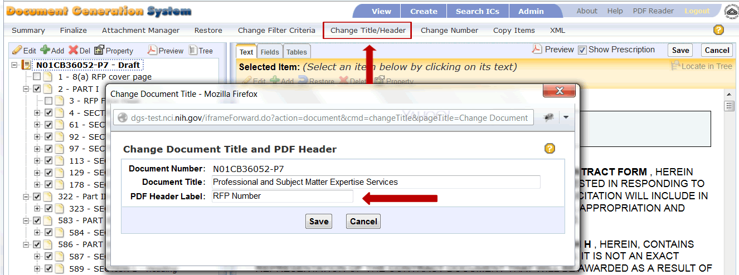
Change PDF Header on Contract Document:
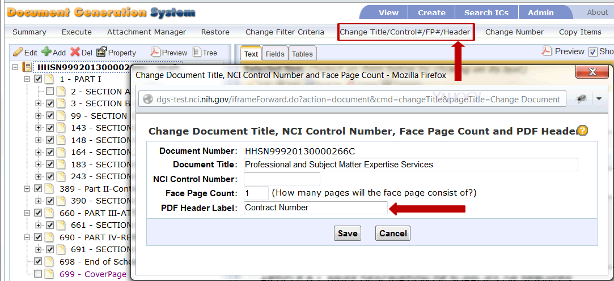
- Click within the PDF Header Label input field.
- Modify the text as needed.
- Select Save to retain changes.
- Select Preview to generate the PDF document.
- Note changes to the document’s header.
