New NIH-wide Blanket Purchase Agreement Available
A new NIH-wide Blanket Purchase Agreement (BPA) was awarded January 10, 2019 for Microsoft Enterprise Agreement Software and Professional Services.

In addition to providing core licensing needs for Microsoft software across NIH, which are ordered by OLAO on behalf of the Center for Information Technology (CIT), the BPA is available for use by all Institutes and Centers (IC) for IC-specific needs.

This single award BPA was awarded to a Contractor Teaming Arrangement (CTA) with the following members:
- Dell Marketing, L.P. (CTA Lead) GSA Schedule #GS-35F-059DA
- Dell Federal LLP (CTA Team Member) GSA Schedule #GS-35F-0884P
- Deloitte Consulting LLP (CTA Team Member) GSA Schedule #GS-35F-0617Y
- Carahsoft Technology Corp. (CTA Team Member) GSA Schedule #GS-35F-0119Y
BPA Number: 75N98019A00012

Award Date: January 10, 2019

BPA Term: Five years, if all options exercised (ultimate completion date January 9, 2023)

Scope of BPA (see Ordering Guide for more information about scope):
Functional Area 1 – Microsoft Software Enterprise Agreement
Functional Area 2 – Microsoft Cloud Computing Services
Functional Area 3 – BPA Program Management and Oversight
Functional Area 4 – Packaged Services
Functional Area 5 – Professional Services
Functional Area 6 – Training

An Ordering Guide is available to provide the NIH community information about scope, ordering eligibility, and process for issuing delivery and task orders. The Ordering Guide is available on the OLAO NIH Wide Contracting Vehicles website.

If you have questions, please contact the BPA Contracting Officer, Robert Burdette or the CIT Information Systems Distribution & Procurement (ISDP) program.

Delivering Value with Intelligent Vending
In October 2018, the NIH Supply Center launched a pilot Intelligent Vending Machine (IVM) initiative in Building 37 on the NIH campus in Bethesda, MD. The concept of the IVM brings a reliable method to have necessary supplies available and convenient to the customer, near their

labs and offices. The IVM provides the convenience by on-demand accessibility of essential laboratory products 24/7 to the NIH researcher and lab personnel.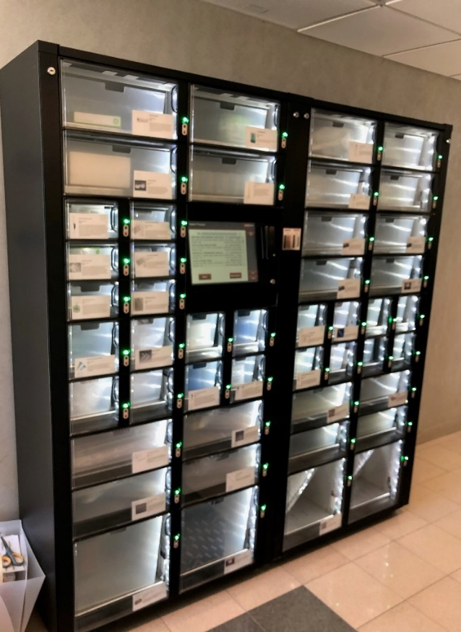

The NIH Supply Center conducted market research with the NCI and occupants within Building 37, to determine the most frequently used products that are candidates for easy access utilizing the IVM. The IVM purchase transaction mimics the process at the Self-Service Supply (SSS) Stores in Buildings 10 and 31. An SSS Store CAN Card and a NIH PIV ID Card are required to make a purchase from the machine.

The goal of the IVM initiative is to expand throughout the NIH campus to service additional labs and offices, which will include IVMs stocked with office supplies for administrative offices.

The IVM in Building 37 is located on the ground floor adjacent to the elevators. The SSS CAN Cardholders are welcome to shop at the IVM and share your IVM experience.

With the implementation of the pilot IVM, the NIH Supply Center continues to deliver value to its customers - Cost, Convenience, Customer Service - We Are Right Next Door!

Contact the NIH Supply Center Customer Service at 301-496-9156/9157/3395 or Email: NIHSC Customer Service.

The Path to Excellence and Innovation Upcoming Events
On February 28, 2017, the President of the United States of America issued Executive Order (EO) 13779: The White House Initiative to Promote Excellence and Innovation at Historically Black Colleges and Universities. This EO encourages federal agencies to assist in strengthening Historically Black Colleges and Universities’ (HBCUs) ability to equitably participate in federal programs, explore new ways to improve the relationship between the federal government and HBCUs and establish how each respective agency intends to increase the capacity of HBCUs to compete effectively for grants, contracts, and cooperative agreements. In accordance with this EO, the National Institutes of Health Office of Acquisition and Logistics Management (OALM) announced the formation of the Path to Excellence and Innovation (PEI) Program. The PEI is a program specific to HBCUs that have biomedical research capabilities, but lack grant and acquisition expertise. Through technical assistance and training, the PEI will equip HBCU participants to successfully compete for federal procurements and grants.
Ms. Diane J. Frasier housed the PEI under the Small Business Program Office (SBPO) with Ms. Annette Owens-Scarboro appointed as the program coordinator. Supreme Solutions Inc., an 8(a) vendor, was awarded a support contract to assist in the development of the PEI.
The SBPO has several upcoming events aimed at continuing to build the PEI’s structure and program expansion. On February 14, 2019, the PEI will host a roundtable at Bowie State University. The purpose of this roundtable is to introduce the mid-Atlantic HBCUs to the PEI and the various opportunities NIH offers. At the end of February, NIH staff from the SBPO will be traveling to the University of the Virgin Islands (UVI) to offer training to the University’s staff. UVI is a member of the PEI pilot program and requested training on the acquisition lifecycle for the institution’s faculty and staff on the St. Croix and St. Thomas campuses. The purpose of this event is to educate staff about how to compete successfully for NIH contracts.
On March 12-13, 2019, NIH will host the HBCU Industry Day at the Natcher Conference Center. During this event, NIH will strive to facilitate relationships with HBCUs through exposure to the federal contracting process and access to NIH program and acquisition officials. This event will include various workshops, exhibitions, and matchmaking HBCUs with NIH Offices of Acquisition and other federal agencies. Registration is open now via the OAMP Small Business Upcoming Events webpage and all NIH employees are welcome to attend.
For questions about the PEI program or any of these events, please send your inquiries to the SBPO staff at NIHSmallBusiness@nih.gov.

Lean Six Sigma Brown Bag Session
What if you could realize hundreds of thousands of dollars in cost avoidance for your office? What if you could reduce completion time for a complex process by 99.5%? What if you could cut inventory shortages in half? NIH Lean Six Sigma Green Belt candidates have achieved these results (and more like them!) within their own ICs by leveraging Lean Six Sigma methodologies. Have YOU tried Lean Six Sigma?

The Office of Logistics and Acquisition Operations (OLAO) at NIH will be hosting a Brown Bag Session: What is Lean Six Sigma?

Lean Six Sigma is a set of methodologies used to systematically improve processes by:
- Emphasizing quality and/or speed of product or service delivery.
- Eliminating sources of variation and waste (defects).
- Targeting process improvements around issues voiced by the customer and the organization.
- Measuring performance against original process requirements (baseline).

Session Details:
When: Wednesday, February 20, 2019. 12-12:45 PM
Where: 6011 Executive Boulevard, Rockville, MD 20852. Room 525
Who: Session is open to all federal NIH Employees. Free of charge!!
RSVP by 02/18/19: leansixsigma@od.nih.gov (Outlook invite will be sent to those who RSVP with WebEx and parking info)

Implementing the Revised Common Rule
The general compliance date for the Final Rule amending the Federal Policy for the Protection of Human Subjects (Common Rule) was January 21, 2019. While many NIH staff are familiar with the changes to the Common Rule on a high level, they might not be sure how those changes will affect processes at NIH. Insight into the biggest changes and information about the Revised Common Rule implementation are available by viewing the Revised Common Rule Implementation Training webinar. The Office of Extramural Research (OER) staff will review changes to the Common Rule that affect policies and procedures for NIH-funded extramural research, including expansion of exemptions to the Common Rule; a new requirement for clinical trials to post informed consent forms; and changes to IRB review requirements. The webinar is live and can be viewed anytime.

Recap Corner
Below is a recap of recent OALM communications to the NIH acquisition workforce.

ID | Title | Date | Purpose
19-01 | NIH Purchase Card SmartPay 3 (SP3) Transition | 10/19/18 | Provided information on the SP3 transition.
19-02 | Annual Independent Verification and Validation Review (IV&V) for FY2018 | 10/25/18 | Provided awareness of the recurring annual review.
19-03 | FY 2014 Canceling Year Lines | 11/5/18 | Update on the FY 2014 Canceling Year Lines.
19-04 | Unmatched Nov Purchase Card Transactions as of Nov 7 AM | 11/7/18 | Provided the unmatched purchase card transactions for the November statement period as November 7th.
19-05 | SP3 Milestone Schedule | 11/7/18 | Provided the SP3 milestone schedule with critical deadlines.
19-06 | Unmatched Nov Purchase Card Transactions as of Nov 9 AM | 11/9/18 | Provided the unmatched purchase card transactions for the November statement period as of November 9th.
19-07 | Unmatched Nov Purchase Card Transactions as of Nov 13 AM | 11/13/18 | Provided the unmatched purchase card transactions for the November statement period as of November 13th.
19-08 | Unmatched Nov Purchase Card Transactions as of Nov 14 AM | 11/14/18 | Provided the unmatched purchase card transactions for the November statement period as of November 14th.
19-09 | Unmatched Nov and Dec Purchase Card Transactions as of Nov 15 AM | 11/15/18 | Provided the unmatched purchase card transactions for the November and December statement period as of November 15th.
19-10 | Unmatched Nov and Dec Purchase Card Transactions as of Nov 16 AM | 11/16/18 | Provided the unmatched purchase card transactions for the November and December statement period as of November 16th. Also provided the December statement deadlines.
19-11 | FY 2014 Canceling Year Lines | 11/19/18 | Update on the FY 2014 Canceling Year Lines.
19-12 | Do not destroy SmartPay 2/JPMorgan cards until further notice | 11/20/18 | Notified community that cardholders are not to destroy SmartPay 2/JP Morgan cards until further notice.
19-13 | Unmatched Dec Purchase Card Transactions as of Nov 23 AM | 11/23/18 | Provided the unmatched purchase card transactions for the December statement period as of the morning of November 23rd. Also provided the December statement deadlines.
19-14 | IMPORTANT DCIS ALERT - OA/IC DCIS Representative Update | 11/28/18 | Provided an updated of the Contract Data Management Program (CDMP) Representatives and customers.
19-15 | Purchase Card Transition Update/Instructions | 11/28/18 | Provided an update on the SP3 purchase cards.
19-16 | SmartPay 2 contract for JPMorgan purchase cards has been extended | 11/30/18 | Provided information on the SmartPay 2 contract extension.
19-17 | FY 2014 Canceling Year Lines | 12/10/18 | Update on the FY 2014 Canceling Year Lines.
19-18 | SmartPay 2 Extension and New SmartPay 3 Implementation | 12/10/18 | Provided information on the SmartPay 2 contract extension and implementation.
19-19 | SmartPay 2 Extension and New SmartPay 3 Implementation | 1/8/19 | Provided a reminder of upcoming important dates and information on the SmartPay 3 implementation.
19-20 | Update on unmatched SmartPay2 transactions for Jan and reminders on SmartPay 3 | 1/10/19 | Provided an update on unmatched SmartPay2 transactions for January and reminders on SmartPay 3.
19-21 | Update on unmatched Jan Purchase card transactions as of Jan 19 NOON | 1/11/19 | Provided an update on unmatched transactions for the January cycle as of Jan 11th noon.
19-22 | Last day to create SmartPay2 logs in NBS | 1/14/19 | Reminder that January 14th was the last day for purchase cardholders to create any SP2 logs in NBS for charges on their JPMorgan cards.
19-23 | ACTION REQUIRED >> DATA CORRECTIONS – FPDS Item 6T Inherently Governmental Functions / FedData Check Alert #141 [493 Actions] | 1/23/19 | Provided a list of contract actions that require correction of data in FPDS.
19-24 | IMMEDIATE ATTENTION: FPDS is down, Wednesday 1/23/19 | 1/23/19 | Alerted community that FPDS was working sporadically on January 23, 2019.
19-25 | Update on unmatched SmartPay2 transactions for Jan and reminders on SmartPay 3 | 1/25/19 | Provided an update on unmatched SmartPay2 transactions for January and reminders on SmartPay 3.
19-26 | FY 2014 Canceling Year Lines | 2/4/19 | Update on the FY 2014 Canceling Year Lines.

Acquisition Training Information

Acquisition Training at NIH
Acquisition Training Classes that are offered by the NIH Training Center can be accessed at the following link: Acquisition Management Training

Federal Acquisition Certification Coursework
CON courses and other Federal Acquisition Certification required courses can be found at the NIH Training Center, Federal Acquisition Institute, and Defense Acquisition University.
Section 508 Accessibility Training
Section 508 Accessibility Training courses can be accessed at: CIT Section 508 Accessibility Training Website.

Green Purchasing Training
Green Purchasing Training and other Green Training courses can be found at: OALM Green Purchasing Website.

NIH Blanket Purchase Agreement (BPA) Lists Available Online

Lists of all NIH Blanket Purchase Agreements (BPAs) can be found at the NIH Blanket Purchase Agreement webpage.
This location contains Two BPA Lists:
1. Complete vendor alphabetical list;
2. Vendor list sorted by commodity; and
If you have any questions or need further clarification, please contact the BPA helpline at 301-496-5212 or email.

THANKS!
We would like to thank all those who contributed to this and future editions of the OALM Newsletter.
The OALM Newsletter will be published four (4) times in calendar year 2019. We encourage staff to submit articles that would be of interest to our readers. We will do our best to include such articles in future editions of the OALM Newsletter.
Please address all correspondence to the editors: Milton Nicholas, NicholaM@od.nih.gov, McDermott, McDermottMl@od.nih.gov, Jesse Lee, Jesse.Lee2@nih.gov, or Barry Solomon, SolomonBJ@od.nih.gov.
If you have any questions or comments regarding the information, policy and/or procedures published in this issue, you may contact Michele McDermott at the e-mail address above. For future issues please contact the Simplified Acquisitions Helpline on 301-496-0400 or via e-mail at OALMnewsletter@mail.nih.gov and you will be referred to the appropriate editor.

