Return to Work Guidance June 2020 version

Appendix I (Onsite Contractor Version)

Code of Conduct Expectation
To safely and successfully open the NIH, we must consciously cultivate a culture of safety and responsibility in all areas. In occupational health and safety guidance, there are several key elements to building a workplace culture of safety that we incorporate in this effort: communication, employee involvement, training, leadership by example and a well-defined reporting process. This document is meant to inform the expected Code of Conduct of all NIH staff to uphold the safety work practices and policies set into place to minimize exposure of staff as they are returning to physical workspaces.
Please sign below to acknowledge that you understand NIH’s expectations in complying to this Code of Conduct:

Individual (Onsite Contractor Personnel) Responsibilities
To be permitted to enter physical workspaces, individuals must:
- Complete COVID-19 worksite specific training relevant for one’s access as required by NIH Policy. Additionally, a DOHS video will be required for all NIH staff and tracked in the Learning Management System (LMS). (See attached tip sheet)
- Comply with occupational health policies regarding reporting and contact-tracing of individuals with any COVID-19 symptoms or test-confirmed diagnosis. These include reporting any COVID-19-like symptom to OMS, staying home if/ when sick, quarantining or self-isolating as instructed by physicians or after traveling as required by local government.
- Comply with the safety measures defined in the approved plan specific to their research or administrative group and with NIH policies on face coverings and distancing protocols. This means wearing appropriate facial coverings, cleaning and disinfecting work site as required and complying with other risk mitigation measures outlined by NIH and DOHS.
- Agree that each and every access of buildings represents an attestation – that one declares her/ himself symptom-free, consent to the opt-in health policy, and agree to comply with all safety measures on and between campuses, both inside and outside buildings.

NIH Work Unit Responsibilities
- Develop staffing and spacing usage plans.
- Review plans with workers and revise as necessary based on feedback.
- Submit return to work plans for review by ICO leadership.
- Provide site specific training to all workers prior to reentry on COVID-19 related enhanced practices.

Contractor (Company) Responsibilities
- Ensure open reporting of safety and health related concerns.
- Ensure staff understand reporting of COVID-like symptoms and do not report to the workplace with symptoms, or if they have had a high-risk exposure to someone with COVID disease.
- Ensure staff are complying with the return to work plans, policies and reporting requirements and enforcing these requirements when necessary.
__________________________ Contractor Employee Name  __________________________  Supervisor Name (Company) | __________________________ Contractor Employee Signature  __________________________  Supervisor Signature (Company) | ___________________ Date  ___________________ Date

NIH Coronavirus Safety Guidance Video
Technical Tips
DEADLINE: Before you Return to the Workplace

INTRODUCTION
This course is intended to be viewed as a supplement to the NIH Safety Guidance. Please also read that document and discuss with your supervisor. The information below provides tips to help alleviate common HHS Learning Portal (LMS) technical issues.

LAUNCHING THE ONLINE COURSES
- Select the following link: NIH Coronavirus Safety Guidance Video
- Choose “Launch and Register”
- NEW IMPORTANT INSTRUCTION: CLOSE the LMS window after launch in order to successfully view the video
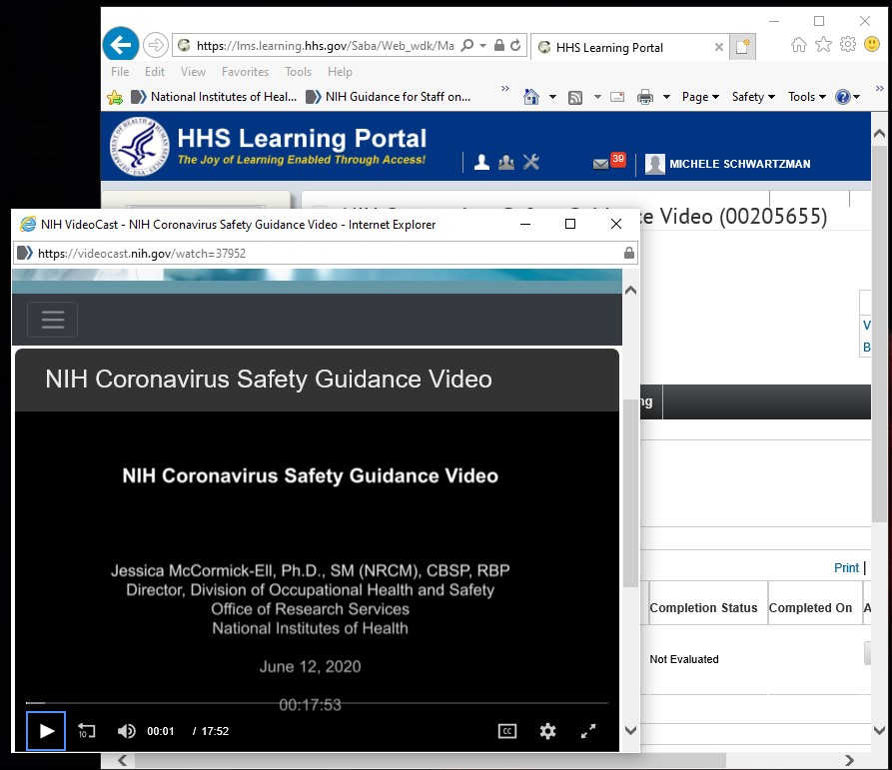

W
ATCH
T
HE
V
IDEO
A
GAIN
?
Close the
LMS window
once video
appears

- Select the following link: NIH Coronavirus Safety Guidance Video
- Choose “Launch and Register”
- On the “Please read… screen, select “Continue Registration” in the lower right
- The video should re-launch. Please close the LMS window again.

TECHNICAL TIPS
- Windows users access via Internet Explorer (IE) and Google Chrome
- Mac users access via Google Chrome or Safari
- Unfortunately, the LMS is not mobile-ready. This means that if someone completes the training on their devices, it will NOT mark complete. The trainings will need to be manually marked complete. 1

COMPLETING THE COURSE
- You must complete each course in its entirety to receive credit. Once completed, the LMS will track your completion for each course. If your completion does not automatically appear, give the LMS time to update. It can take up to an hour.

- In order to view your Completed Learning (transcript), please use the following reference guide: View Your Completed Learning.

ADDITIONAL ASSISTANCE

- For LMS technical questions and technical support, submit an HR Systems Support Ticket Form.

- For course content questions, please refer to the NIH Safety Guidance, contact DOHS_COVID19@mail.nih.gov, or contact your supervisor.

- For non-LMS related technical issues with your equipment, please contact the NIH IT Service Desk via http://itservicedesk.nih.gov for assistance.

