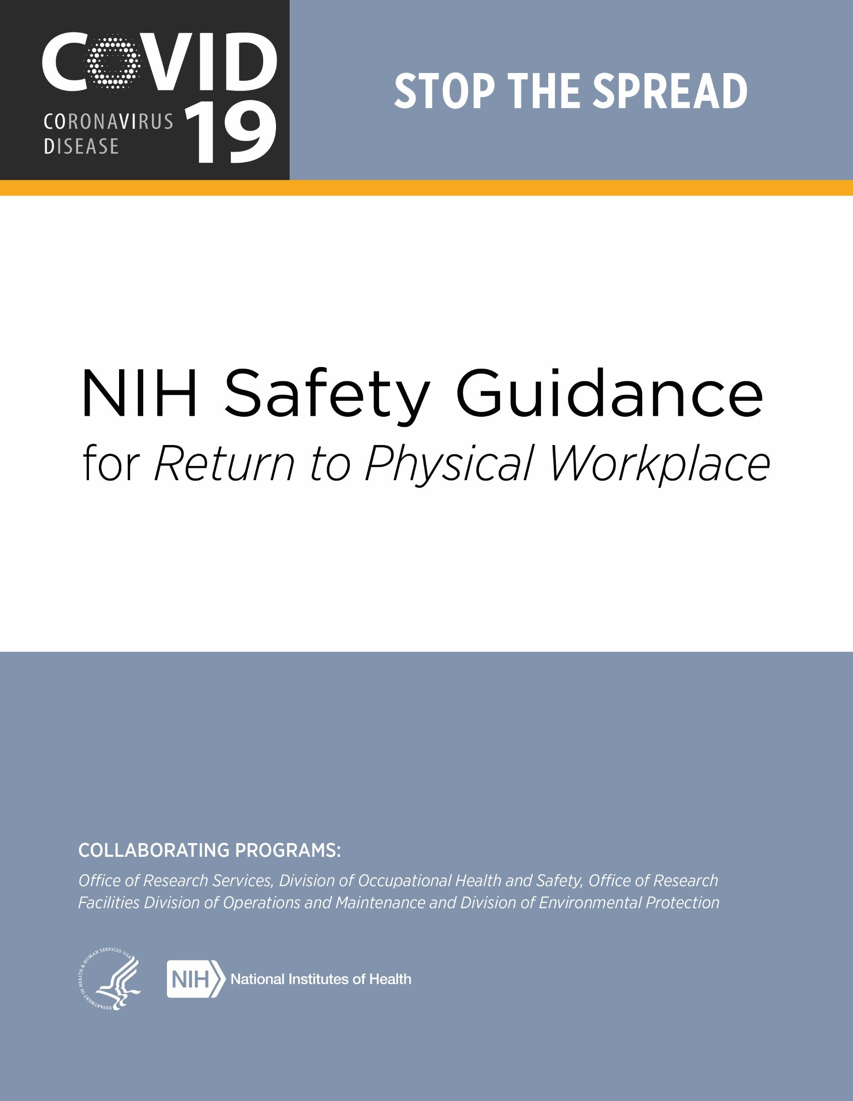

Contents
Executive Summary ................................................................................................................................. 2
Return to Work Expectations ................................................................................................................... 2
Symptom Monitoring and Reporting Requirements ................................................................................ 3
Staffing Plans ........................................................................................................................................... 4 Alternative Work Scenarios ..................................................................................................................... 4
Guidance on Personal Safety ................................................................................................................... 4
Facial Coverings .................................................................................................................................. 4 Use, Care and Changing of Face Coverings ........................................................................................ 5
Physical Distancing ............................................................................................................................. 6 Hand Hygiene...................................................................................................................................... 6
Gloves ................................................................................................................................................. 6
Coughing/Sneezing Hygiene ............................................................................................................... 6
Guidance on Cleaning and Disinfection .................................................................................................. 7
Guidance for Personnel in Specific NIH Workspaces ............................................................................. 8
Office Environments............................................................................................................................. 8
Common Areas.................................................................................................................................... 9 Restrooms....................................................................................................................................... 9 Elevators.......................................................................................................................................... 9
Stairwells ......................................................................................................................................... 9
Hallways and Corridors ................................................................................................................. 10
Break Areas .................................................................................................................................... 10 Meeting Spaces and Conference Rooms ........................................................................................ 10
Food Services and Cafeterias ......................................................................................................... 10
Laboratories ........................................................................................................................................ 10
Laboratory Scheduling Precautions ................................................................................................ 11
Laboratory Cleaning and Disinfection Precautions ......................................................................... 11
Personal Protective Equipment (PPE) Precautions .......................................................................... 12
NIH Centralized Services ..................................................................................................................... 12
Mechanical Spaces ............................................................................................................................... 13
Staff Wellness .......................................................................................................................................... 13 Appendix I- Code of Conduct .................................................................................................................. 14
Appendix II – Map of Disposal Containers for Face Coverings .............................................................. 15
Appendix III- Disinfectant Labels ............................................................................................................ 16

Executive Summary
The NIH Division of Occupational Health and Safety (DOHS) has compiled this guidance to provide NIH staff, including employees, contractors, and trainees, with information on recommended practices and available resources, as well as establish NIH’s expectation of staff on a Code of Conduct based on this guidance as we return to physical workspaces. The pandemic brings many new uncertainties that warrant changes to our daily “normal” operations. Implementing these changes can be a challenge. The goal of this document is to provide awareness, options and tools for new, enhanced safety practices in your workspaces. Occupational health and safety principles are grounded in risk mitigation measures including elimination, substitution, engineering controls, administrative controls, work practice controls and personal protective equipment. All of these controls are covered in this document, with suggested mechanisms for use in our laboratory, non-laboratory and common areas. Additionally, some areas will require specialized guidance. DOHS is working with partners within the Office of Research Services (ORS) and the Office of Research Facilities (ORF) to review processes for those locations. Additional practices may be performed in spaces not outlined in this document. This guidance is not meant to supersede or be in conflict with the procedures or policies of any NIH Institutes, Centers, and Offices (ICOs). A one-size-fits-all approach is not possible, but we hope this will assist all ICOs in developing their specific procedures.
Finally, in public health emergencies, it is important that all persons follow these recommendations in order to ensure the safest workplace for everyone. In most cases, these recommendations do not eliminate risk completely. They attempt to create awareness on how risks are handled and how we can behave and respond in order to protect ourselves, colleagues, patients and the general NIH community. Key points include:
- Staff, visitor and patient safety are paramount
- Physical distancing in the workplace limits the spread of coronavirus
- Face coverings will be mandatory while on campus, with specific guidance based on work areas
- Vigilant adherence to hand hygiene and surface disinfection routines mitigates transmission risk
- Guidance in this document will be updated and reissued as national safety guidance changes
This document includes a “Code of Conduct Acknowledgement” (Appendix I) for all supervisors to discuss and sign with staff. This Code of Conduct highlights the responsibilities we have to each other, and to ourselves, to maintain the highest level of safe practices at the NIH. NIH leadership expects all staff to comply with this Code of Conduct.
DOHS has created a COVID-19 Safety Reporting Tool and a Coronavirus hotline at 301-480-8990 for reporting unsafe conditions, COVID-19 symptoms and medical follow-up.

Return to Work Expectations
This document is intended to provide guidance for all NIH staff returning to the workplace in the era of COVID-19. Topic areas have been identified to educate staff on protecting themselves as well as others in work areas. Not all areas are the same: laboratories, offices, and customer support areas will need to develop specific procedures for their respective activities. The goal is to minimize the risk of transmission in the NIH community and to provide examples of how work areas might be organized to support procedures and best practices.
To safely open the NIH, we must embrace a culture of responsibility. Every NIH staff member has a critical role in ensuring the occupational health and safety of their colleagues. Principal Investigators and supervisors will play a key role in establishing new protocols for their staff. These staff members will then be responsible for practicing and employing new paradigms in their work. SARS-CoV-2 exposure is a hazard we all can help mitigate by adhering to personal hygiene, administrative controls, and distancing guidelines.
NIH ICOs will formulate detailed plans using this guidance as a high-level framework which should not be superseded. NIH ICOs and laboratories will need to perform internal assessments to determine which activities will be resumed and in what timeframe. This may begin in Group A and continue through Group D before an ICO is fully functioning with all staff back at their physical worksites (NIH Framework for Returning to Physical Workspaces). All NIH staff should be provided with information about their ICO-specific plans and have opportunities or platforms to discuss concerns with supervisors and/or ICO leadership. The plan should be revised as necessary, recognizing that not every concern can be immediately addressed and that some decisions may need to be modified as more information becomes available and as the pandemic evolves.
Until further notice, face coverings will be required for staff physically present on any NIH campus, when entering or exiting NIH-owned or leased facilities, or in common areas in and around NIH-occupied facilities. Face coverings are a fundamental part of preventing the spread of coronavirus. When you wear a face covering, you reduce the dispersion of airborne droplets. The health and safety of NIH employees, contractors, visitors and patients depends on everyone doing their part. Supervisors will be responsible for ensuring that staff comply with this policy.
If you see something at the NIH that you think may create a risk of coronavirus exposure, please report it to your supervisor or your ICO Health and Safety Committee. Concerns can also be reported anonymously through the COVID-19 Reporting Tool or to the Coronavirus hotline at 301-480-8990. All reported concerns will be investigated and shared with appropriate staff, including NIH and ICO senior leadership, if necessary.

Symptom Monitoring and Reporting Requirements
Self-monitoring can prevent the spread of coronavirus by limiting the exposure of others to symptomatic personnel. Before you leave for work, take a moment to assess yourself and see if you have any symptoms associated with coronavirus. According to the most recent CDC Guidance these symptoms are:
- Fever, chills • Fatigue
- Cough • Muscle aches/pain
- Shortness of breath • Diarrhea
- Sore throat • Headache
- Congestion or stuffy nose • Unexplained loss of taste or smell

NIH staff experiencing any of these symptoms should NOT report to work. Contact Occupational Medial Service (OMS) for an evaluation by completing the screening questionnaire. Please contact your supervisor to discuss your leave or duty status.
In addition, check if your family or housemates are experiencing symptoms. If so, encourage them to stay at home and seek an evaluation from a medical provider. If you have had close contact with someone with confirmed or suspected COVID-19 in the past 14 days, please contact coronavirus hotline at 301-4808990 before reporting to work and complete the screening questionnaire.

Staffing Plans
The NIH Coronavirus Response Team carefully considered the NIH Framework for Returning to Physical Workspaces developed by the NIH Office of Human Resources, in close coordination with NIH ICO leadership. The Framework provides guidance to NIH ICOs based on common principles as they develop their specific workplans to bring their staff gradually and safely back to physical workspaces.
Importantly, the plan focuses on a gradual ramp up of staff only if certain criteria are met, most notably a 14-day trend in declining COVID-19-like case reports and confirmed COVID-19 positive cases in the counties where NIH has facilities. The NIH Office of the Director (OD) will continuously monitor local conditions and trends to update and revise staffing guidelines and policies. Maximum telework will continue until further notice as we assess local health and operational conditions. NIH staff should not return to their physical workspaces unless previously approved to do so.

Alternative Work Scenarios
ICOs will need to evaluate the best staffing options available for the identified work function or office. Staffing scenarios for the laboratory may differ significantly from an administrative office setting, which may, in turn, differ from a front-facing customer service operation. Alternating days or weeks, shift work, or physical separation of workstations should be considered. Understanding there will be scenarios where physical distancing cannot be achieved, DOHS (301-496-2960) is available to consult and help develop alternative safety measures to mitigate risk. In these situations, ICOs will need to assure strict adherence to face coverings, other protective measures and other administrative controls, and supervisors must minimize these situations to the best of their ability. Maximum use of telework and flexibilities is still highly encouraged, and your health and safety are our highest priority.

Guidance on Personal Safety

Facial Coverings
Facial coverings are required to be worn by all staff and visitors, at all times on any NIH campus or facility including in common areas and conference rooms. Appropriate use of facial coverings is critical in minimizing transmission as you can spread COVID-19 to others even if you do not feel sick or have any of the cited symptoms. Facial coverings with exhalation ports are NOT recommended since they will not provide source control, as air will leave from these valves without adequate filtration. Exhalation ports are the small, plastic-like items on the front of the facial covering that allow air to move out of the mask. The mask or cloth face covering is not a substitute for physical/social distancing and should be used to supplement other controls recommended in this document. Staff should evaluate the need for a separate mask to be used during their commute to their worksite and home. In addition, cloth face coverings should only be used in a BSL2 environment if the individual is not performing research.
It is strongly recommended that cloth face coverings be changed and laundered daily. If reuse of a facial covering is necessary, face coverings and/or masks should be stored in paper bags or in some other protective device to reduce the potential for damage or contamination that could occur if the facial covering was placed on a desk or in a backpack, pocket or purse alone. Paper bags are recommended because the facial covering may be damp from breath condensation, and the paper allows the facial covering to dry out. Additionally, data indicate the virus is viable on paper for a shorter duration than plastic. A plastic bag would trap this condensation inside and not allow the facial covering to dry out.
Cloth face coverings should be cleaned using a mild detergent (e.g., Dawn®, Palmolive®, etc.) and warm water. They can be cleaned in a washing machine, a bowl or a sink. It is recommended to dry masks using a dryer on hot setting if available or hang dry. The use of a washing machine and dryer may damage some face coverings (e.g. elastic straps) and they should be carefully inspected each time they are used. Cloth face coverings must be immediately removed from use if visibly dirty or damaged.
The Clinical Center has issued its own facial covering policy. Persons entering the building will be issued a disposable surgical mask. Cloth face coverings must be replaced by the surgical mask whenever inside the Clinical Center. Any type of disposable mask worn at the time of entry on an NIH campus or in an NIH facility should be discarded into a trash can or in Medical Pathological Waste (MPW) containers that are commonly found in laboratories and clinical areas. For convenience, white step cans have been placed at the entries/exits of buildings, at common points of departure from NIH campuses, leased facilities and in the Clinical Center. A map of disposal locations is included as Appendix II of this document. The NIH Division of Environmental Protection (DEP) is the point of contact for disposal and questions regarding additional disposal container requests at 301-496-6349.
See details regarding face covering and mask use and care below.

Type and Intended Use of Face Coverings/Masks
Type  Description  Intended | Cloth Face Covering | Disposable Mask | Medical-Grade Surgical  Mask  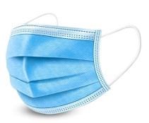 | N95 Respirator  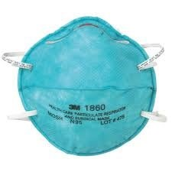
 | Home-made or commercially manufactured face coverings that are washable and help contain wearer’s respiratory emissions* | Commercially manufactured masks that help contain wearer’s respiratory emissions | FDA-approved masks to protect the wearer from large droplets and splashes; helps contain wearer’s respiratory emissions | Provides effective respiratory protection from airborne particles and aerosols; helps contain wearer’s respiratory emissions
 | Recommended for common areas and nonhealthcare settings. Covering should be replaced or laundered daily. They are not required when working alone in a personal office. |  | These respirators and masks are reserved for healthcare providers and individuals with patient contact. Use in other areas should be determined by a risk assessment conducted by DOHS.
* Face coverings and N95s with exhalation ports may not prevent droplet dispersion. Consult with DOHS if you have questions about your face covering or N95.

Use, Care and Changing of Face Coverings
Remember, facial coverings need to be worn over your nose and mouth.
- If changing from a cloth face covering to a lab mask, do so in a private setting before you enter the lab so as not to expose others.
- Wash your hands with soap or use hand sanitizer before putting the mask on, before adjusting and after removing.
- Make sure your mouth and nose are fully covered, pull the mask down over your chin and pinch the bridge of the nose. Assure there are no gaps in the mask and that it fits against the side of your face.
- Remove your mask using the ear loops/ties and avoid touching your eyes, nose and mouth.
- Place your dirty mask in a paper bag for storage and wash your hands immediately after removing.
- Use designated locations to take a break for a drink or to eat, ensuring adequate distance from others. After finishing your food or drink, immediately put your face covering back on.
- Remember, never eat or drink in a laboratory. Staff can take advantage of outdoor areas on campus to eat or take breaks, weather permitting.

Physical Distancing
In accordance with CDC guidance, staff should always maintain at least 6 feet from other individuals. Avoid unnecessary person-to-person close contact, such as handshakes. In-person meetings should be avoided as much as possible. To achieve this, NIH is recommending that laboratory areas not have more than one person per 200-250 net square foot of space, dependent on the space configuration. Office spaces of 125 square feet should only have one person at a time. These recommendations will be updated as more groups return to the physical workspace, and as therapeutics and vaccines become available. Please ensure space density decisions are coordinated with NIH leadership. The U.S. Fire Administration has a useful reference to assist ICOs with determining the appropriate distances and physical separation of staff as they return to work. Additional information on physical distancing can be reviewed at the US Fire Administration website.

Hand Hygiene
Wash your hands often with soap and water for at least 20 seconds, especially after you have been in a public place, after blowing your nose, coughing, sneezing, or touching your face. Alternatively, use a hand sanitizer that contains at least 60% ethyl or 70% isopropyl alcohol. There are many hand sanitizer stations located in NIH buildings. Ideally, hand sanitizer should be available within common-area office suites or lab locations in addition to these central stations. Laboratory settings must have soap and water available for washing hands after working with chemicals and/or biologicals as outlined in the NIH Chemical Hygiene Guide, Bloodborne Pathogens Guide and other safety guidance. Supervisors should place orders for needed supplies in advance of returning to physical workspaces.

Gloves
The use of gloves outside of a laboratory or the healthcare setting is not advisable. Washing your hands frequently is the best practice after touching potentially contaminated surfaces. If gloves are worn, they must be disposed in MPW boxes and after removing gloves, hand washing is required.

Coughing/Sneezing Hygiene
Wearing your cloth face covering will reduce the dispersal of aerosolized respiratory secretions. If you are in a private setting and not wearing a cloth face covering, remember to cover your mouth and nose with a tissue or the inside of your elbow when coughing or sneezing. Immediately wash your hands or use hand sanitizer that contains at least 60% ethyl or 70% isopropyl alcohol. Staff should minimize touching their face and instead use disposable tissues. Tissues should be immediately discarded after use.

Guidance on Cleaning and Disinfection
The ORF has developed a Standard Operating Procedure (SOP) which outlines procedures for communication and steps to be taken concerning the closure, ventilation, disinfection and reopening of NIH workspaces that may be contaminated by COVID-19. This SOP was developed for a scenario in which a staff member has been diagnosed with COVID-19 and has been in NIH workspaces (owned or leased) within 2 days prior to showing symptoms. Safety and communication are paramount throughout this process. These procedures involve a certain amount of risk management, since closing and disinfection must be focused on the locations most highly frequented by the infected staff member.
Identification of those areas is based on information from OMS and the person who tested positive for COVID-19 infection. Information on approved disinfectants can be found at https://www.epa.gov/pesticide-registration/list-n-disinfectants-use-against-sars-cov-2. When you use this website, scroll down, and all disinfectants listed will be effective against COVID-19. DOHS has compiled this list into a user friendly Excel sheet which will be made available to all ICOs. Additional guidance for laboratories is below, as these areas will have to ensure efficacy against the microorganisms studied in labs as well.
The supply store carries the disinfectants listed below which are EPA approved for Coronavirus. Ensure you read the label prior to use to ensure appropriate contact time and use of the material is performed. Please be advised that the active ingredients may differ between brands (e.g. different Clorox products have differing ingredients and contact times). The label of each disinfectant bottle contains the active ingredients, contact time and efficacy information (see Appendix III for additional information).
Some of the below items will require dilution prior to use (alcohols). Some of these items will be stronger and may be hazardous to humans and require gloves or other Personal Protective Equipment (PPE) for use. We advise the non-laboratory areas to purchase materials that are ready to use, such as wipes. Laboratory areas will have protective equipment (e.g. chemical fume hoods and gloves) that can be used for dilution and cleaning with stronger chemicals.
In general, if the material is not already in wipe form, spray disinfectant onto a paper towel and then wipe the surface clean. It is not advised to directly spray a surface as that can create aerosols. Please contact DOHS at 301-496-2960 with questions. The list below is accurate as of June 1, 2020 but is subject to change.
ALCOHOL | 6510005328519 | ALCOHOL, PREP PAD, 70%, 200 COUNT
ALCOHOL | 681000N209146 | ALCOHOL, ISOPROPYL 70%, 1 GL New Item
ALCOHOL | 6810011137320 | ETHANOL 190 PROOF, 1 GL
ALCOHOL | 6505008180293 | ETHANOL 190 PROOF, 1 PINT
ALCOHOL | 650500L062205 | ETHANOL 190 PROOF, 5 GL
ALCOHOL | 6505009262204 | ETHANOL 200 PROOF REAGENT, 5 GL
ALCOHOL | 650500L062206 | ETHANOL, 200 PROOF, 1 GL
ALCOHOL | 6505001050000 | ETHANOL, 200 PROOF, 1 PINT
DISINFECTANTS | 6840016212002 | BLEACH, GERMICIDAL CLOROX, 121 OZ,
DISINFECTANTS | 793000N203085 | BLEACH, GERMICIDIAL, WIPES, CLOROX HEALTHCARE, New Item
DISINFECTANTS | 793000L043454 | DISINFECTANT, LYSOL POWER SPRAY, BATHROOM CLEANER, 22 OZ
DISINFECTANTS | 793000L043457 | DISINFECTANT, LYSOL POWER, WIPES, 35-COUNT
DISINFECTANTS | 684000L041924 | DISINFECTANT, 409, SPRAY, 32 OZ
DISINFECTANTS | 793000N203087 | DISINFECTANT, BLEACH GERMICIDAL, PULL-TOP, CLOROX HEALTHCARE, 32 OZ New Item
DISINFECTANTS | 793000N203088 | DISINFECTANT, BLEACH GERMICIDAL, REFILL, CLOROX HEALTHCARE, 128 OZ New Item
DISINFECTANTS | 793000N203086 | DISINFECTANT, BLEACH GERMICIDAL, SPRAY, CLOROX HEALTHCARE, 32 OZ
DISINFECTANTS | 792000L041927 | DISINFECTANT, CIDECON PLUS, WIPES,180-COUNT
DISINFECTANTS | 684000L041921 | DISINFECTANT, CLOROX, SPRAY,19 OZ
DISINFECTANTS | 684000L041923 | DISINFECTANT, CLOROX, SPRAY,32 OZ, New Item
DISINFECTANTS | 793000N203083 | DISINFECTANT, HYDROGEN PEROXIDE, PULL TOP, CLOROX HEALTHCARE, 22 OZ New Item
DISINFECTANTS | 793000N203084 | DISINFECTANT, HYDROGEN PEROXIDE, REFILL, CLOROX HEALTHCARE, 1 GAL
DISINFECTANTS | 793000N203082 | DISINFECTANT, HYDROGEN PEROXIDE, SPRAY, CLOROX HEALTHCARE, 22 OZ New Item
DISINFECTANTS | 793000N203081 | DISINFECTANT, HYDROGEN PEROXIDE, WIPES, CLOROX HEALTHCARE, 95-COUNT New Item
DISINFECTANTS | 793000L046458 | DISINFECTANT, LYSOL, WIPES, 80-COUNT
DISINFECTANTS | 793000L012082 | DISINFECTANT, OPTI-CIDE, SPRAY, 24 OZ
DISINFECTANTS | 792000L041925 | DISINFECTANT, WIPES, CLOROX, 35-COUNT

Guidance for Personnel in Specific NIH Workspaces

Office Environments
If you work in an open office environment, be sure to maintain at least 6 feet distance from co-workers. This means having at least one workspace separating you from co-workers. All staff are required to wear a face covering while in any NIH shared workspace. Mission essential visitors such as maintenance staff and delivery workers will be required to furnish and wear a cloth face covering at NIH locations.
ICO leadership will assess office environments and processes to identify measures that facilitate physical distancing and minimize the potential for personnel to come within 6 feet of one another. Example measures include:
- Eliminate or reduce processes that prevent effective social distancing. For example, if processes can be performed online with a brief in-person visit to verify information or identity, this will greatly reduce the duration of visitors in a space.
- Use engineering controls such as transparent shielding between customers and service providers.
For instance, if a customer must have in-person, face-to-face interaction with an employee, a Lexan or Plexiglass barrier will minimize droplet transmission. These surfaces are also easily cleaned.
- Use administrative controls such as floor markings to indicate appropriate physical distancing between tasks or personnel. These markings help personnel and visitors better visualize spacing
that will minimize droplet transmission. This may also minimize surface contamination from people touching common work surfaces.
- Consider using directional controls in your workspaces to allow personnel to maintain social distance. Identify corridors as one-way or mark doorways as preferred entrances or exits.
- Use scheduling to control traffic flow within workspaces. Minimize overlapping appointments. Schedule appointments to allow maintaining adequate social distancing.
- Shared equipment like copiers, printers, coffee pots, etc. should be disinfected prior to and immediately after use to reduce the risk of contamination.
The ORS Medical Arts Branch has created visual graphics to assist with these recommendations. Please visit their website to order posters, flyers, stickers, etc., for your location at https://www.ors.od.nih.gov/COVID19signage. The site will include free downloads, which can be printed from any printer, as well as instructions for ordering larger specialty signage, posters and templates.
A cloth face covering is not required if you are working alone in an enclosed office space. A partitioned workspace, such as a cubicle, is not considered an isolated office space and consideration should be given to eliminating staffing personnel in adjacent cubicles.
Personnel working at a reception/front desk are expected to wear a face covering. Personnel working in these locations should consider how visitors and co-workers interact with them. These personnel may have more frequent contact with delivery personnel, customers, visitors and the public, and spaces should be configured and marked to promote safe distancing. Maintain physical distance whenever possible, frequently disinfect contact surfaces such as counters, chair armrests for visitor seating, door handles and equipment such as pens, clip boards and other office supplies that are touched by visitors. Wherever possible, eliminate touch points or shared office items. Staff in these roles should be afforded rest breaks to avoid prolonged contact time with visitors.

Common Areas
Restrooms: Use of restrooms should be limited based on size to ensure at least 6 feet distance between individuals. Wash your hands thoroughly before and afterward to reduce the potential transmission of the virus. Use a paper towel to turn on/off the water spigot and to grab door handles as you leave the
restroom.
Elevators: Minimize elevator use to whatever extent possible and avoid elevators where social distancing cannot be maintained. Consider using the stairs as an alternative where possible. If you are using the elevator, wear face covering and avoid touching the elevator buttons with your exposed hand/fingers. For high touch surfaces, one can use an elbow, or other device to prevent contamination of their fingers. Floor markings in the elevator are helpful visual tools to identify density numbers and locations for standing while in transit. Floors markings are available from the ORS Medical Arts Branch, and ORF can be consulted to assist in determining density numbers. The lead ICO in each building should work with building managers on deploying signage.
Do not enter elevators with others when a distance greater than 6 feet from the other individual cannot be easily achieved. Minimize talking in the elevator to minimize airborne droplets. Wash your hands or use alcohol-based hand sanitizers with greater than 60% ethyl or 70% isopropyl alcohol upon leaving the elevator. Hand sanitizer stations should be located outside each elevator.
Stairwells: When using stairwells minimize contact with the handrails. Keep your hand near the railing to allow you to prevent serious injury from a fall or use a disposable towel which will allow you to grasp the railing. Staff should wear face coverings in the stairwell. If you encounter another person in the stairwell, either wait on a landing for them to pass, or pass while turning your body away. Immediately, upon exiting the stairwell, wash your hands thoroughly or use an alcohol-based hand sanitizer with greater than 60% ethyl or 70% isopropyl alcohol. As a general reminder, stairwell doors must not be propped open as they exist in part to control smoke and provide a safe egress path out of buildings.
Hallways and Corridors: Wear a face covering when travelling in corridors and hallways. Minimize personal contact with people you meet or pass in the hallway and avoid touching doorknobs or surfaces. When possible, consider using one-way designations in corridors and applicable locations. The ORS Medical Arts Branch will have arrow floor markings to assist with this designation. Proceed directly to your intended destination.
Break Areas: Managers must identify appropriate break locations for staff with sufficient physical distancing. These break locations should be established where personnel can take a short rest or drink fluids. Staff should be encouraged to take frequent breaks to reduce the stress of wearing a mask throughout the day. Physical distancing measures must be maintained in break areas and during mealtimes. It is recommended that persons minimize communal food or food-based celebrations at this time. Minimize personal contact with people you meet or pass in the hallway and avoid touching doorknobs or surfaces. Proceed directly to your intended destination.
Meeting Spaces and Conference Rooms: Maximize the use of online meeting tools such as WebEx,
Microsoft Teams and Zoom. If meetings are required with in-person attendance, select a room with a capacity that exceeds the normal needs of your meeting. Space chairs apart to facilitate physical distancing. Wear face coverings when holding these meetings. Prior to and at the completion of these meetings, disinfect tables and chairs and other contact surfaces using an EPA List N approved disinfectant. Contact DOHS for assistance with identifying an appropriate disinfectant.
Food Services and Cafeterias: When using NIH dining facilities, always wear a face covering for the selection and purchase of your food items and when navigating the public space of the cafeteria. Be decisive when selecting food items from coolers and refrigerators. This will minimize the potential for cross-contaminating multiple items. NIH dining facilities have conducted site-specific hazard assessments and will have specialized practices in place tailored to protecting patrons and staff. Follow guidance from the food service facilities. Individuals are encouraged to consume their meals outside or back in their personal office space. Remember that food or drink should not be consumed in the laboratories.
Food service areas shall consider physical distancing when establishing their operations. These considerations must consider limiting available seating, reducing seating at tables in a manner that prevents multiple personnel from sitting at a table, or guarantees that personnel can maintain physical distancing. Dining facilities should identify ways that encourage outdoor dining. This will help improve social distancing and allow for the natural ventilation of the outdoors to reduce exposure among diners.

Laboratories
Research staff should carefully schedule activities to minimize multiple individuals in the laboratory at the same time. Experiments should be planned out to ensure that shared equipment and space is not overpopulated with staff. Laboratory staff will be responsible for cleaning high touch surfaces within the laboratory and it is recommended that each laboratory establish a schedule with written procedures and clearly defined responsibilities. In most cases, the disinfectant already in use for research purposes will also be effective against SARS-CoV-2. Laboratory staff may contact DOHS to assist with this assessment.
A review of required PPE to conduct research should be performed to assess the operational and hazard requirements before changes are implemented or new items introduced. In most situations, your cloth face covering will not meet the necessary PPE requirements to perform research. Do not get complacent and forget that there are other serious hazards encountered every day in laboratories. Follow established SOPs and safety guidance to ensure you meet additional requirements regarding safe laboratory practices. If COVID-19 guidance and SOPs conflict, you should discuss it with your supervisor or consult with your ICO-assigned DOHS Safety Specialist.

Laboratory Scheduling Precautions
Laboratory staff shall maintain physical distancing in the workplace whenever possible. This may involve scheduling work in shifts or spacing work appropriately on the bench and in the bays. Lab managers and PIs should consider coordinating the use of shared lab spaces to ensure there is no inadvertent double booking of space. A well-defined schedule or online calendar will help control access to and use of equipment. Consider moving shared equipment into a space where physical distancing is possible.
Lab workers should plan their experiments thoroughly, taking extra care to identify when they will do the work, what equipment they will need, and where they will work. A thoroughly planned experiment will allow staff to reduce time in the laboratory and reduce the likelihood of encountering other staff members. Use appropriate disinfection procedures and PPE to reduce possible exposure to SARS-CoV-2.

Laboratory Cleaning and Disinfection Precautions
Proper proactive and thorough disinfection and cleaning processes can greatly reduce the risk of exposure to coronavirus. Laboratories should establish routines for disinfection of spaces and high contact surfaces. Supervisors should clearly identify the personnel responsible and procedures for disinfecting the laboratory space. These additional recommendations are not a replacement or substitute for general laboratory practices that are ongoing prior to this pandemic. Good work practices include cleaning of lab benches/ biological safety cabinets prior to and after completing work, timely cleanup of spills and preventing contamination of common surfaces by laboratory materials (e.g. not using dirty gloves on common surfaces). Gloves are worn for many tasks in the laboratory, and when they are removed, they should not be reused, and hands should be washed with soap and water immediately. It may be of benefit to declutter lab areas, and to have designated pipettes and reagents for individuals to decrease sharing of commonly used items. It is important to be aware that some laboratory chemicals may not be compatible with disinfectants, so take care if using disinfectant cloths in wiping down reagent bottles.
Be certain that disinfectants used by the laboratory are appropriate for coronavirus. Common laboratory disinfectants that are used at the NIH and are effective against coronavirus include: 10% bleach solutions
(made fresh daily); 70% ethanol; Dispatch; Clorox hydrogen peroxide spray; Lysol wipes; Opticide; Peroxiguard; Vesphene III; Micro-Chem Plus; and Cavicide. Please review the label for efficacy and contact time instructions. Please be advised that the active ingredients may differ between brands (e.g.
different Clorox products have differing ingredients and contact times). Active ingredients in the disinfectant, contact time and efficacy information are listed on the label of disinfectants (Appendix III). For any questions on disinfectants, please contact DOHS at 301-496-2960.
Other cleaning and disinfection considerations include:
- Core facilities and shared spaces should implement clear expectations for shared equipment and require that personnel clean and disinfect equipment prior to start and after the completion of all work.
- Identify high-contact laboratory surfaces, equipment and tools, and minimize sharing as much as possible. When equipment must be shared, implement cleaning and disinfection protocols for all laboratory users. Many of the common NIH disinfectants will be acceptable, and laboratory staff should consider the pros and cons when determining the best agent. Concerns include whether the disinfectant could corrode items, leave sticky film, etc. DOHS is available to answer questions as needed.

- Common equipment considerations include:
− | Common laboratory surfaces and equipment: desks, workbenches, drawer handles, centrifuges, incubators, refrigerators, freezers, liquid nitrogen dewars
− | Common laboratory tools: pipettes, reagents, bottles, markers, computer keyboards and mice, touchscreens
− | Disinfectants must be chosen in line with manufacturer’s instructions to prevent damage to equipment. Depending on the volume of use, commonly touched surfaces should be cleaned before and after use.

- Scientific equipment may require specialized disinfecting procedures to avoid damaging the equipment. Review manufacturer guidance prior to disinfecting.
- Consider using disposable benchtop coverings (e.g. Chux, diapers, etc.) and properly disposing after use. Disposable plastic covers may be considered for keyboards.
- Follow the NIH Exposure Control Plan for further guidance.

Personal Protective Equipment (PPE) Precautions
Laboratory staff must not become complacent when selecting PPE for their work. Face coverings used when performing research should not be worn out of the laboratory. Masks or face coverings used outside of the laboratory should not also be used in the laboratory. Depending on your lab environment, this may require you to change from a cloth face covering to a disposable lab covering before starting an experiment. This recommendation is to avoid contamination of a personal face covering that would be worn in personal areas and would not be easily cleaned/discarded if accidentally contaminated with chemicals or biological materials. If you are sitting at your desk working in a laboratory environment, the cloth face covering is appropriate. If working with animals, it is not, as it will absorb allergens and is directly in your breathing zone.
While performing laboratory work, wear appropriate PPE according to your laboratory protocols. Remember:
- Avoid touching your face while wearing gloves
- Do not wear gloves used for laboratory work outside of the laboratory
- Dispose of all used laboratory PPE in Medical Pathological Waste (MPW) containers
- Do not wear laboratory PPE outside of laboratory areas

NIH Centralized Services
ORS programs (e.g., Division of Library Services, Division of Immigration Services, Division of Amenities and Travel Services, Division of Personnel Security and Access Control, etc.) have conducted activity hazard assessments of services and workflows for their operations. Follow specific guidance provided at these service locations. Personnel should always wear a cloth face covering when they visit ORS service locations and wash their hands or use an alcohol-based sanitizer when leaving those locations.
Activity hazard assessments are conducted by DOHS staff and are available for upon request.

Mechanical Spaces
Mechanical space access is limited to authorized personnel only. Limit the number of personnel working inside the mechanical space based on 6-feet physical distancing requirements. Cloth face coverings should be worn in addition to all PPE required to enter the mechanical space (closed-toed shoes, hard hat/bump cap, eye protection, work gloves, etc.). Wash hands prior to putting on PPE. ORF staff will be responsible for cleaning high touch surfaces within the mechanical space and it is recommended to establish a schedule with written procedures. Pay special attention to “high touch” areas, such as handles, buttons, switches and control panels. Tools needed to work inside the mechanical space should be disinfected after use. Personnel should always wash their hands or use an alcohol-based sanitizer as soon as possible when leaving those locations.

Staff Wellness
The outbreak of COVID-19 may be stressful – it can be difficult to cope with fear and anxiety, changing daily routines, and a general sense of uncertainty. Although people respond to stressful situations in different ways, taking steps to care for yourself and your family can help you manage stress.
Stress during an infectious disease outbreak can include:
- Fear and worry about your own health and the health of your loved ones
- Changes in sleep or eating patterns
- Difficulty sleeping or concentrating
- Worsening of chronic health problems
- Increased use of alcohol, tobacco, or other drugs
If you are experiencing stress or other mental health concerns, you can find additional resources at https://employees.nih.gov/pages/coronavirus/how-to-cope.aspx

Appendix I

Code of Conduct Expectation
To safely and successfully open the NIH, we must consciously cultivate a culture of safety and responsibility in all areas. In occupational health and safety guidance, there are several key elements to building a workplace culture of safety that we incorporate in this effort: communication, employee involvement, training, leadership by example and a well-defined reporting process. This document is meant to inform the expected Code of Conduct of all NIH staff to uphold the safety work practices and policies set into place to minimize exposure of staff as they are returning to physical workspaces.
Please sign below to acknowledge that you understand NIH’s expectations in complying to this Code of Conduct:

Individual Responsibilities
To be permitted to enter physical workspaces, individuals must:
- Complete COVID-19 worksite specific training relevant for one’s access as required by supervisor. Additionally, a DOHS video will be required for all NIH employees and tracked in the Learning Management System (LMS).
- Comply with occupational health policies regarding reporting and contact-tracing of individuals with any COVID-19 symptoms or test-confirmed diagnosis. These include reporting any COVID19-like symptom to OMS, staying home if/ when sick, quarantining or self-isolating as instructed by physicians or after traveling as required by local government.
- Comply with the safety measures defined in the approved plan specific to their research or administrative group and with NIH policies on face coverings and distancing protocols. This means wearing appropriate facial coverings, cleaning and disinfecting work site as required and complying with other risk mitigation measures outlined by supervisor and DOHS.
- Agree that each and every access of buildings represents an attestation – that one declares her/himself symptom-free, consent to the opt-in health policy, and agree to comply with all safety measures on and between campuses, both inside and outside buildings.

Supervisor Responsibilities
- Develop staffing and spacing usage plans.
- Review plans with workers and revise as necessary based on feedback.
- Submit return to work plans for review by ICO leadership.
- Provide site specific training to all workers prior to reentry on COVID-19 related enhanced practices.
- Ensure open reporting of safety and health related concerns.
- Ensure staff understand reporting of COVID-like symptoms and do not report to the workplace with symptoms, or if they have had a high-risk exposure to someone with COVID disease.
- Ensure staff are complying with the return to work plans, policies and reporting requirements and enforcing these requirements when necessary.

__________________________ __________________________ ___________________
Employee Name Employee Signature Date

__________________________ __________________________ ___________________
Supervisor Name Supervisor Signature Date

Appendix II – Map of Disposal Containers for Face Coverings
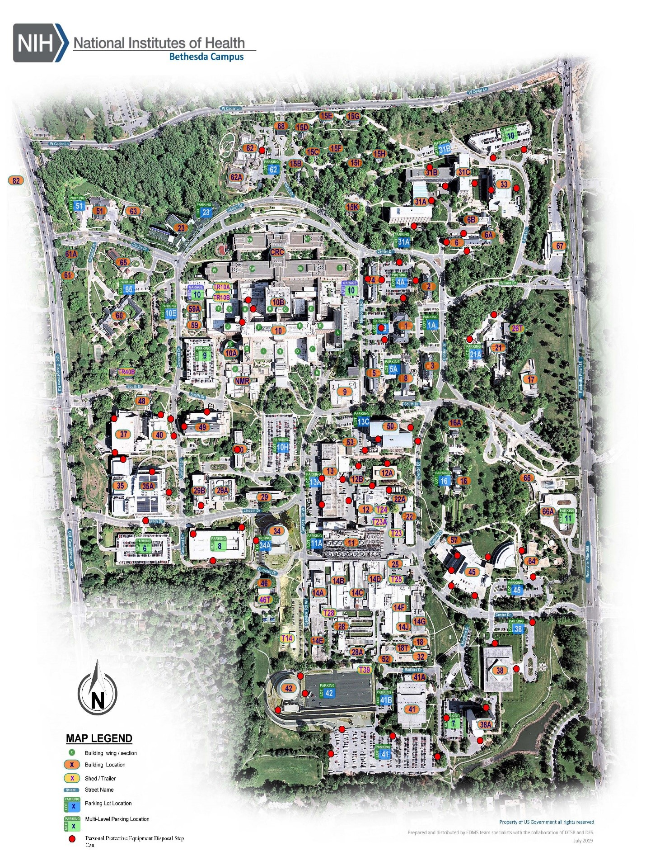

Appendix III

Reading Disinfectant Labels
It’s important to use a disinfectant that is listed on the EPA List N: Disinfectants for Use Against SARSCoV-2 (COVID-19) https://www.epa.gov/pesticide-registration/list-n-disinfectants-use-against-sars-cov2-covid-19
When reviewing a disinfectants label, take note of the following:
- Active ingredients
- List of microorganisms the disinfectant is effective at killing
- Contact time for the organism of interest (coronavirus)
- EPA registration number (this can be cross-checked for effectiveness against coronavirus using the link above)

