Document Management System (DGS)
User Manual
Document Module
Current as of 3/21/2019

Table of Contents
Log In 1
Browser Requirements Google Chrome is the recommended browser. 1
Log In Site Information 1
Log Out 1
View Workload 2
Search for Documents 3
Create a Document 4
Delete a Document 5
Document Summary Screen 5
Document Detail Screen 6
Menu Icons and Functions 9
Detail Screen – Document Editing 9
Edit 9
Add 10
Restore 10
Delete 10
Property 10
Preview 11
Preview Document Tree 11
Locate in Tree 11
Tabs 11
Save Button 12
Cancel Button 12
Preview 12
Print 13
Filling in Input fields 13
Editing 14
General Instructions for opening an item in the DGS editor 14
Including/Excluding a Workform Item 14
Save a document changes 15
Add items 15
Add a Custom Item 15
To Include item in Table of Contents 15
Auto-Numbering 17
Move a Custom Item 17
Cut and Paste Method 18
Drag and Drop Method 18
Move a Template Item 19
Delete a Template Item 19
Delete a Custom Item 20
Edit Item Content 20
Add text 20
Pasting 20
Add/Edit Tables 22
Insert/Create a List: 24
Add a hyperlink 25
Edit a hyperlink: 26
To Undo or Remove a hyperlink: 26
Cut content 26
Copy content: 26
Print the content of the edit window: 26
Check Spelling 26
Undo or Redo edits 27
Align text: 27
Find text 28
Replace text 28
Bold, Italicize or Underline text 28
Create Subscript or Superscript 29
Format a Header 29
Add Attachments 29
Attach a File and Create a Hyperlink from the Attachment Manager 29
Adding an Attachment to Section J 29
Modify Section J Attachments 30
Additional Features 32
Reassign 32
Restore 32
Change Filter Criteria 33
Change Title/Control#/FP# 33
Change Number 33
Document Properties 33
Send Document for Review 34
Create a Folder on Your Computer 37
Receive Document Bundle through Email 38
WinZip Users 39
Non-WinZip Users 40
Review DGS Document 40
Help 41
Finalize a document 41
Execute a Document 42
List of Attachments 43
Download the Document files 43
Publish a Document (NCI OA only) 44
Un-Publish (NCI OA only) 45
Create a Copy of a Document 47
Copy Item Feature 47
Create a Contract Document from a Finalized RFP 48
DGS Help 48
About DGS 48
Miscellaneous 49
Helpful Hints 49
Session Timeout 49
Trouble Shooting 49
FAQ 53
Special Characters in Text 53
COAC Users 53
Merging PDF files outside of DGS 54
PDF Accessibility 54
Using Fillable PDFs as Attachments 55
Reducing the File Size of a DGS PDF Document 55
Reference Section 56
Application Icons 56
Glossary of Terms 57

Log In
All DGS users need to be set up with a DGS account. Accounts should be requested by supervisors through the DGS Help Desk (DGSHelp@maximus.com).

Browser Requirements
Google Chrome is the recommended browser.
- Browser and Settings
  - Google Chrome, Microsoft Internet Explorer 11, Microsoft Edge and Firefox
  - View, Text Size: Medium (To display html view properly).
  - Screen resolution: 1024 x 768 or higher.
- NIH Login utilized.
  - User must be defined in the NIH Enterprise Directory (NED) to use the DGS system
  - User must have defined application role(s) in the DGS NIH-Org database to use the DGS system. The DGS Administrator will handle this task.

Log In Site Information
- Run DGS Production Site using the DGS URL: https://dgs.nci.nih.gov/dgs
- Use your NIH login (or PIV card) credentials to log into the application.
- You may see a Security Alert window pop up – this is to inform you that you will be accessing your work over a secure connection.
- Click OK to continue.
- DGS will display the View Documents screen (unless you are an Administrator). This is the applications “Home Page”.
- If you have trouble logging into DGS contact the DGS Help Desk (DGSHelp@maximus.com).

Log Out
- To log out of DGS: go to the top-level navigation bars and click the “Logout” hyperlink (yellow text).
- It is important that you log out properly to end your session and not just close the window.
- After clicking the Logout hyperlink, a screen will pop up notifying you that you have successfully logged out of DGS.
- Click the “Close” button to close the window.

View Workload
This is the application’s “Home Page”.
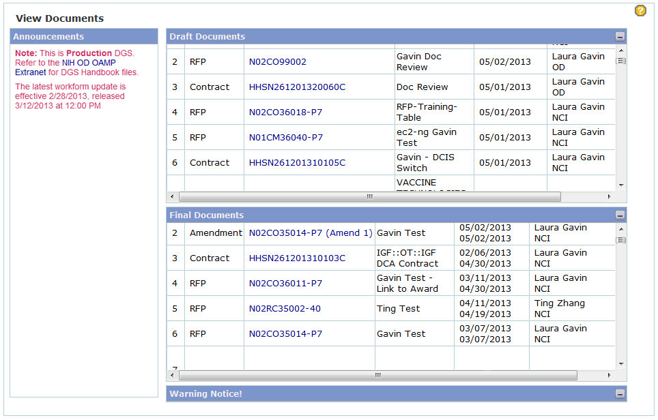
- Draft/Final
This page displays the current workload. However, Team Leaders/Section Chiefs will be able to see all team/section documents, Branch Chiefs and Directors will be able to see all branch/IC documents.
  - Draft documents area displays the Documents in progress.
    - Users can click on any document number in this area and continue working on this document.
    - User will be taken to Document Summary screen.
  - Final documents area displays Finalized RFPs, Finalized RFP Amendments, Finalized Contracts from RFP and Executed Contracts.
    - These documents are in Final status and will be accessible as read-only.
    - Clicking on the document number will take user to Document Summary screen.
  - Warning Notice: this is informational and is required for all NIH web sites. The warning defaults to open when the application is entered but it can be minimized by clicking on the icon in the upper right corner. This will give the screen more viewing space for Draft and Final documents
    - Contract Specialist/ Contracting Officers: These users will only see their own documents listed in the Draft and Final Workload list
    - Team Leaders/Section Chiefs: These users will see their own document, plus all the documents for users within their team/section.
    - Branch Chiefs and above: These users will see their own documents, plus all the documents for users within their branch.
- Announcements Area
  - Notice of the Workform updates will be posted here and a link to the current Workforms will be displayed.
  - Note any software upgrade or other notices in regard to system downtime will be posted here. Please take note of this since the system becomes unavailable for short durations.

Search for Documents
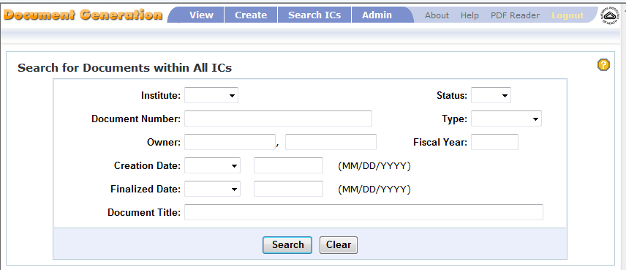
- Users will only have search access to documents within their ICs or COAC if applicable.
- Provide information for any field on the screen to search documents in DGS; such as document number, type, or document title. The text field search locates a word or string of words starting with the string provided.
  - Click the “Search” button to activate the search.
  - Click the “Clear” button to clear the form (input boxes).
- All documents matching the search criteria will be displayed beneath the search pane.
  - Select the desired document by clicking on the specific Document Number.
  - The Document Summary screen will be displayed for the selected document.
- Documents not owned by the user performing the search will be available as read-only.

Create a Document
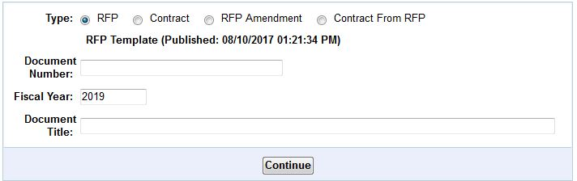
- To create a new document go to the top navigation bar and click “Create”.
- Select the Document Type by clicking on the designated radio button for an RFP, Contract, an RFP Amendment or Contract from RFP.
- Select the Document Type by clicking on the designated radio button for an RFP, a Contract or an RFP Amendment.
  - RFP Amendments may only be created for RFPs that preexist in DGS, that are in “Final” status and that are owned by the user.
  - Any RFP Amendment in Draft status must be finalized before another RFP Amendment can be created.
  - Only one amendment may be in Draft status.
  - Contract from RFP may only be created for RFPs that preexist in DGS, that are in “Final” Status

- Select or provide the document number and provide the document title.
    - RFP: Type in the Document Number and Document Title. Keep the default Fiscal Year which has the current fiscal year, if correct.
    - RFP Amendment: Select the RFP number from the dropdown list and the next amendment number will be automatically supplied.
    - Contract: Type in the Contract Number (PIID), Reference Number (optional) and Document Title; keep the default Fiscal Year which has the current fiscal year, if correct.
- Click the “Continue” button.
- This will take you to the Filter Criteria screen (for RFP and Contract documents only).
  - Check all the boxes beside the listed criteria that are applicable to your document language.
  - The only required criterion on this page is “Type of Requirement”; R&D and/or Non R&D must be checked. If both of these values are checked, the majority of items from the workform will be preselected for you as shown in the detail page.
  - Button options:
    - The “Create” button will generate the draft document.
      - Once clicked the user cannot cancel the document creation process.
      - If a user needs to delete a document; contact the DGS Help Desk and provide the full document number, title and reason for deletion. Once a record is deleted, it CANNOT be recovered.
    - The “Reset” button will remove all checked selections.
    - The “Cancel” button will cancel any change, close the screen and return user to the Create New Document screen.
- Once the document is generated, the application opens to the “Details” screen where users can navigate, customize and edit their document or logout of DGS and resume work on the document at a later time.

Delete a Document
When a user needs to delete a document; contact the DGS Help Desk (DGSHelp@maximus.com) and provide the full document number, title and reason for deletion.

- Important Note: Once a document is deleted, it CANNOT be recovered.

Document Summary Screen
This screen provides users with information about the document.
- General Information - this area contains the main information about the selected document.
  - Users can now retrieve the specific document template used to create their document.
  - Next to the label “Template” the document type is now an active link that will allow users to download a Word document of the template used to create their document. The date of the Word document will match the date of the template listed on the Summary screen.
Click on the link (circled below) to download the original template.
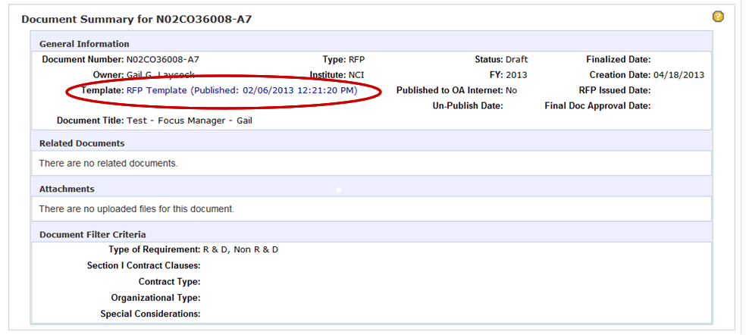

  - Users will be prompted to open or save the Word file.
  - After the document has been downloaded, users will need to close the screen with the message “Reviewing Template in Word. Please wait…” To Close: Click the X in the top right corner of the browser window.
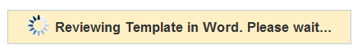
- Related Documents – this area will list any documents that are related to the selected document. For Example:
  - An RFP Amendment will have the parent RFP and any other RFP Amendments that exist listed (the RFP Amendment documents do not have to be Final to be listed here).
  - An RFP document will have any created RFP Amendments listed (the RFP Amendment documents do not have to be Final to be listed here).
- Attachments – this area will list all files that have been attached to this document.
- Document Filter Criteria – this area will display all the user’s selected document criteria based on selections made using the Filter Criteria screen.

Document Detail Screen
This is the screen where users will be doing custom editing of their document.
Documents in Final status will appear in read-only mode. Documents in Draft status will be fully editable by the document’s owner but will appear as read-only to others in the IC.
The left side panel represents the document in a tree format. Each topic is an item in the tree. Users will navigate the tree to find the items that need editing or an area where they would like to insert a custom item.
The right side panel represents the content of the document. Users can select an item in the tree (left panel) and see the item content in the right panel.
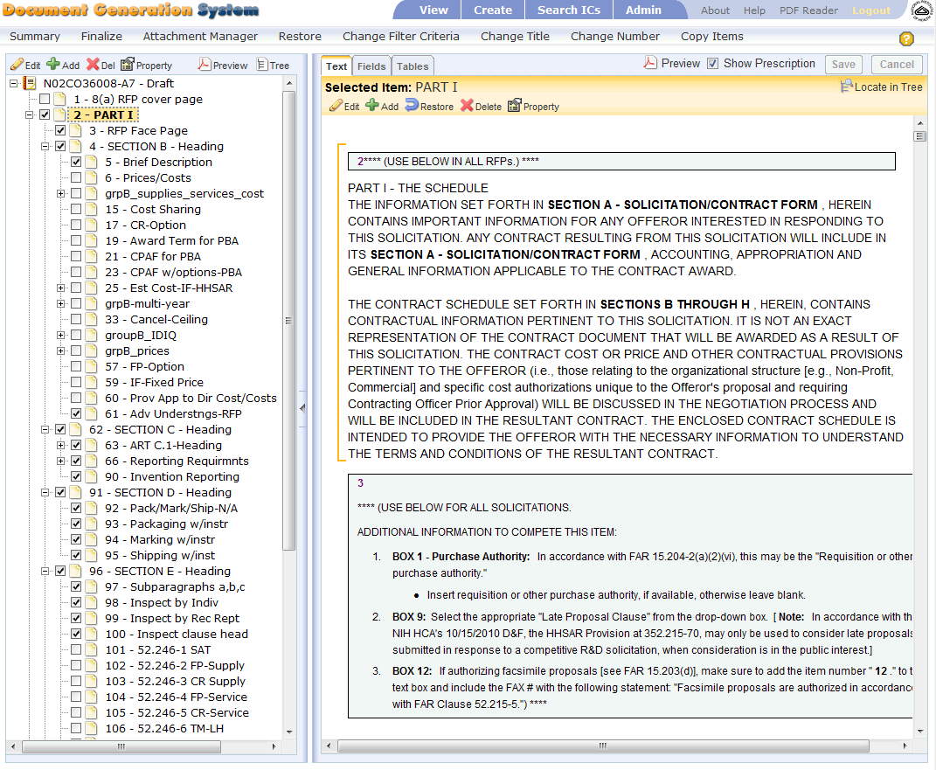
- Navigating the document: This is the area of the application where users will be editing and customizing their document. All parts of the Draft document can be accessed in the left pane’s document tree or in the right pane’s text view.
  - The left pane displays the document in tree format, which includes preselected items based on the selections made in the Filter Criteria Selection Screen. Items checked are included based on selections made. Items not checked were not included based on NCI logic. User may check any item to include in the document and user may uncheck any item to exclude in the document.
    - The document tree will be in collapsed view initially.
    - The “plus sign” icon indicates an expandable area of the document tree; the “minus sign” icon indicates a collapsible area of the document tree.
    - Click on “plus sign” or double click any item to expand the tree. If this action is performed from the top of the tree or on, the document number or on sections, please allow a good 20 seconds or more to allow the tree to expand. There is no way for the application to inform user when tree has finished fully expanded. This will display the document tree’s branches with more detailed content of the document.
    - Clicking or selecting any item in the tree will highlight the item in yellow and display it along with any sub-level items in text view in the right pane
    - When an item is selected the user has various functions in the toolbar from which to choose from: see Details Screen Toolbar Icons section for details on toolbar functions
      - Edit
      - Add
      - Delete
      - Property
      - Preview
      - Preview Document Tree
    - The same functions that appear in the toolbar plus a few more are available by clicking on an item in the document tree and then using the right mouse click to display a pop-up menu of options. These menu options will pertain to the selected item only
      - Edit Item – most items may be edited. Some FAR based items are non-editable and user will be informed via a pop up window message stating ‘No editing allowed on this item.’ A new item may be added below a FAR based item to add custom text.
      - Add item - add a custom item on the same level or sub level of the current selected item in tree.
      - Restore - restore text of selected item from the Workform used to create the document originally. This would be used when a user updated the wrong item by mistake or completely messed up the formatting of document and wants to start over.
      - Delete Item - delete custom items only. These are items created by user.
      - Item Properties - edit selected item properties. This is where an item is configured to appear in the table of contents or to force a page break in the document before the item.
      - Preview Item - preview/review selected item(s) or entire document in PDF format
      - Expand Branch - Expand document tree from selected item and downward
      - Collapse Branch - Collapse document tree from selected item and upward
      - Refresh Item - Used to reload and synchronize the sub level items of the selected item from database. In cases:
        - something goes wrong so that the tree is not updated after changing the sub level items
        - someone else makes changes to the sub level items
        - any other scenarios that may affect sub level items
  - The right pane displays a text view of the document based on item selection in left pane and contains editing functionality described below.
    - You must start by selecting an item in the document tree in the left pane.
      - By clicking on the top of the tree (the document number) in the left pane, the entire document is displayed in the right pane.
      - Users may navigate the document tree and select an item to view its content in the right pane
    - Tabs: At the top of the right pane you will see a menu bar with three tabs and various viewing options for each tab
      - Text tab
        - The application by default will open the Details screen with the Text tab pre-selected
        - The content of the item selected and any of its sub level items in the document tree will be displayed in full text
        - Users have two options:
          - Preview the item in PDF: click PDF icon to preview item in PDF format
          - Control the visibility of the Prescription: checkbox beside Show Prescription label may be checked or unchecked
      - Fields tab- there are several filter options for displaying various document input fields
        - Required: Shows only the input fields that are required to complete the document although the application does not mandate they be provided
        - Optional: Shows only the input fields that are optional to complete the document
        - All: Shows all input fields in the document (defaulted value)
        - Blank fields only: May be checked along with any other filter options to show Required Blank fields, Optional Blank fields or All Blank fields
      - Tables tab
        - Display any document item(s) with tables contained in the content. These are data inputs that may be required that are not input fields but areas of a large volume of text or tables.
        - To add text to a table: user will need to open the editor and add the text to the table
        - Users have two options:
          - Preview the item in PDF: click PDF icon to preview item in PDF format
          - Control the visibility of the Prescription(s): the checkbox beside the Show Prescription label may be checked or unchecked
    - The document can be navigated in the right pane as well as the left pane.
      - In the right pane, use the scroll bar to find the area of the document you want to select.
      - With your mouse hover over the area of text you are interested in editing, you will notice a blue bracket to the left side of the text (a vertical line). Click on the text and you will notice the bracket has turned gold.
      - To locate the selected item in the document tree: with the text selected click on the “Locate in Tree” icon
      - With the text selected you may also use the toolbar to customize your document: (see Editing a Document section)
        - Edit the text
        - Add a new item to the document
        - Restore the edited text to the original template’s text
        - Delete an added item
        - Change the topics properties (i.e. add a page break)
    - All input fields can be filled in directly in the Details screen’s right pane
      - After inputting data into a field, users will notice that most of the screen becomes inactive; sections of the screen will appear faded out.
      - Users must click on the “Save” or “Cancel” button to reactivate screen
        - To save data input – Click “Save” in upper right pane
        - To cancel data input – Click “Cancel” in the upper right pane

Menu Icons and Functions

Detail Screen – Document Editing

Edit
- To edit an item it must be included in the document; the item’s checkbox in the document tree needs to be checked.
- Select the item in the document tree (in left pane) and click the Edit icon in the toolbar above the left pane to bring up the item in the edit window.
-OR-
- Select the item in the text view (in right pane) and click on the Edit icon in the toolbar above the right pane to bring up the item in the edit window.
-OR-
- Select the item in the document tree (in the left pane) and right click the mouse to bring up toolbar, select Edit Item from list to bring up item in editor window.

Add
- Select the item in the document tree (in left pane) and click the Add icon in the toolbar above the left pane to bring up the Add Item window.
-OR-
- Select the item in the text view (in right pane) and click on the Add icon in the toolbar above the right pane to bring up the Add Item window.
-OR-
- Select the item in the document tree (in the left pane) and right click the mouse to bring up toolbar, select Add Item from list to bring up the Add Item window.

Restore
- Restores the text of selected item from the Workform used to create the document originally.
- This would be used when a user updated the wrong item by mistake or completely messed up the formatting of document and wants to start over.

Delete
- Only allowed for user created item(s) (custom).
- Select the item in the document tree (in left pane) and click the Delete icon in the toolbar above the left pane to delete the user added item.
-OR-
- Select the item in the text view (in right pane) and click on the Delete icon in the toolbar above the left pane to delete the user added item.
-OR-
- Select the item in the document tree (in the left pane) and right click the mouse to bring up toolbar, select Delete Item from list to delete the user added item.
Note: To remove a Workform item from the document, uncheck the check box in front of the items title in the document tree. This will remove the item from the document. Only checked items will show up in the document preview.

Property
- In this option an item’s properties can be configured:
  - Properties available for custom items (user created) only
    - Have the item appear in the document’s Table of Contents.
      - TOC Indentation Level: determines indentation of the item in the TOC.
    - Have the item’s TOC title NOT appear in the document’s output (PDF).
  - Property available for all items (Workform and custom)
    - Force a page break before this item in the document.
- Select the item in the document tree (in left pane) and click the Property icon in the toolbar above the left pane to edit the properties of the item.
-OR-
- Select the item in the text view (in right pane) and click on the Property icon in the toolbar above the right pane to edit the properties of the item.
-OR-
- Select the item in the document tree (in the left pane) and right click the mouse to bring up toolbar, select edit Item from list to edit the properties of the item

Preview
Users must have Abode Reader or Acrobat installed on their machine. This option allows users to preview or review the document in PDF format at any time. Users may save the PDF locally.
- To preview or review the entire document: Select the document number at top of the document tree and click on the Preview icon in the above toolbar.
- To preview part of document: Select the Part/Section or Item in the document tree and click on the Preview icon in the above toolbar OR Select the item in the text view (right pane) and click on the Preview icon in the above toolbar.
- Important! Close the PDF window when finished reviewing the document.
  - If clicking on the Preview does not activate the PDF window properly, make sure there are no PDF windows open from previous viewings.
  - Close the PDF window using the red X icon in the upper right corner of the window.
  - After closing the PDF window, the DGS application will remain open and users may continue to work on the document.
- The PDF window open with a Bookmarks pane on the left and the document content in the right pane.
- The Bookmarks pane shows the document in a TOC format. Clicking on any item in this pane will take the user to that specific item in the document (quick hyperlinks).
- User can close the Bookmarks pane by clicking on the X in the left pane’s top right corner.
Preview Document Tree
Users must have Abode Reader or Acrobat installed on their machine. This option allows users to preview or review the document tree in PDF format at any time. Users may save the PDF locally or print it out.
- Click on the Preview Document Tree icon in the left pane's toolbar.
- Users will have the option of creating a “black” document tree or a “selected” document tree.
  - A blank document tree will have all document items included in the tree with unchecked checkboxes beside each item.
  - A selected document tree will have all document items included in the tree with checked checkboxes beside all selected items (generated from the selections made on the Filter Criteria screen) and unchecked checkboxes beside items that have not been selected.
- Select the type of document tree you want and click on the appropriate button to generate the desired PDF or click “Cancel” to close the window.
- The document tree PDF file will be generated in a new window. Users can save the PDF file or print it out.
- To close the PDF window; click on the X in the upper right corner of the screen. It is important to close this window when you are done viewing the PDF to insure smooth generation of your next PDF.

Locate in Tree
- This function will allow users that navigate the document in the right pane to find or locate the item in the document tree (left pane) even if the tree is in the collapsed state.
- Select an item in the right pane by clicking on the text of the item.
- Click on the “Locate in Tree” icon.
- The document tree will expand, if necessary, to display the item in the tree with a yellow highlighted background.

Tabs
- Text tab
  - The application by default will open the Details screen with the Text tab pre-selected.
  - The content of the item selected and any of its sub level items in the document tree will be displayed in full text.
  - Users have two options:
    - Preview the item in PDF: click PDF icon to preview item in PDF format.
    - Control the visibility of the Prescription: checkbox beside Show Prescription label may be checked or unchecked.
- Fields tab- there are several filter options for displaying various document input fields.
  - Required: Shows only the input fields that are required to complete the document although the application does not mandate they be provided.
  - Optional: Shows only the input fields that are optional to complete the document.
  - All: Shows all input fields in the document (defaulted value).
  - Blank fields only: May be checked along with any other filter options to show Required Blank fields, Optional Blank fields or All Blank fields.
- Tables tab
  - Display any document item(s) with tables contained in the content. These are data inputs that may be required that are not input fields but areas of a large volume of text or tables.
  - Users have two options:
    - Preview the item in PDF: click PDF icon to preview item in PDF format.
    - Control the visibility of the Prescription: checkbox beside Show Prescription label may be checked or unchecked.

Save Button
Save data in the Detail screen
- All document input fields can be filled in directly in the right pane of the “Details” screen (input fields are not edited in the DGS editor).
- Once a fields value has been typed in or selected from a dropdown, the user needs to click the “Save” button in the top right corner of the Detail screen.
- The data put into the input fields will only be saved after the “Save” button is clicked.

Cancel Button
Cancel data input in the Detail screen
- Remove any updates, typed into the input fields, since last save.
- The Cancel button will also “re-enable” the Detail screen.

Preview
This menu option will open a new window and display the selected document in PDF format for review. The user must have Adobe Reader or Acrobat installed.
- The PDF may be saved or printed from this window.
- Important! Close the PDF window when finished reviewing the document.
  - If clicking on the Preview does not activate the PDF window properly, make sure there are no PDF windows open from previous viewings.
    - Examples of PDF not activating properly:
      - A blank window appears.
      - No window appears.
  - Close the PDF window using the red X icon in the upper right corner of the window.
  - After closing the PDF window, the DGS application will remain open and users may continue to work on the document.
- The PDF window opens with a Bookmarks pane on the left and the document content in the right pane.
- The Bookmarks pane shows the document in a TOC format. Clicking on any item in this pane will take the user to that specific item in the document (quick hyperlinks).
- User can close the Bookmarks pane by clicking on the X in the left pane’s top right corner.
- Important Note: If “Preview” is selected from the Summary screen, the entire document will be created/displayed in PDF. If the “Preview” is selected from the Detail screen, the PDF will be produced from the selected item level in the document tree (left panel).

Print
- In the Detail screen
  - Complete Document –
    - select the document number in the tree in the left panel
    - Select Fields View on the right panel
    - Click on the Print menu option.
  - Specific section of document
    - Select an entire Section or individual item in the document tree
    - Click the Print menu option

Filling in Input fields
The RFP and Contract documents contain many input fields. Data for these fields will be typed directly in the Details screen’s right pane. This data is handled differently from the custom content changes a user makes in the document via the DGS editor.
- Important Note: These fields must be filled in from the Detail screen and cannot be filled in within the edit window.
- Rules for input:
  - If the Detail screen’s Text View (right pane) shows an input field, the user can input data directly in the right pane. Samples of these fields are as follows:
    - input field (enter text directly by typing)
    - text area (enter text directly by typing)
    - In order to view the content in a “Text Field” in the DGS Editor with all the non-text field data, open the Editor and click on the “Source” icon twice and it should make the text appear.
    - drop down (click downward arrow to right and select from the list)
    - checkbox (click on the box to check it)
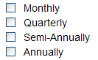
  - Tables
    - Tables may not be input in the right pane. User must go into the editor. User will know this since he/she will not see the cursor appear in the table until they open the item in the DGS editor. An example of a table is the following.
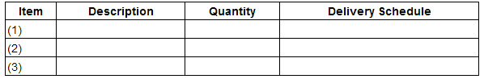
    - Note that if the table needs to be revised to add or remove either a column or row, go into the editor to perform this task.
    - RFP Face Page is unique in that it is a table that uses input fields so the user can type directly in the right pane. Use the tab key to jump from one input field to the next.
- When any input field has been updated, the user must click the “Save” button in the upper right of the Text View pane (right pane) to save the data and continue in the application. If user does not want to save the update to the input field, they may click the “Cancel” button.

Editing
Requirement to Edit: The document needs to be owned by the user and in “Draft” status.

General Instructions for opening an item in the DGS editor
- Find the document in the “View” screen under Draft Documents section of screen.
- Click the document number of the document you wish to edit.
- Summary screen will open.
- Continue by clicking on “Details” in the menu bar at top of screen.
- Important Note: Most of the items from the Workform are editable by the user, however, there are some items that contain FAR language and are not editable. If the user tries to edit a FAR item, a message will be displayed letting the user know the item is not editable.
- View a specific item (topic) in your document by navigating the document tree in the left pane or by clicking on the top level of the document tree and viewing the entire document in the right pane of the screen.
- To edit an item: navigate to the document item you wish to edit and select it
- Click on the Edit icon above the tree.
Including/Excluding a Workform Item
All items contained in the Workform will be represented in the Details Screen’s document tree (left pane). The items that have been preselected from the Filter Criteria Screen will have a checked checkbox adjacent to it in the document tree. The items that have not been preselected will have an unchecked checkbox adjacent to it in the document tree. Only the items checked will appear in your document. Users may add or remove any item from their document while the document is still in Draft. Any changes to the state of a checkbox (checking or unchecking) in the document tree will be saved immediately.
To Include (add) an item in the document that was not preselected:
- Navigate the document tree in the left pane to the item you wish to add
- Click on the unchecked checkbox in front of the item name to check it.
- The change will automatically be saved.
- The contents of the item will now be included in your document.

To Exclude (remove) an item in the document that has been selected:
- Navigate the document tree in the left pane to the item you wish to remove
- Click on the checked checkbox in front of the item name to uncheck it.
- The change will automatically be saved.
- The contents of the item will no longer appear in your document.

Save a document changes
- Change to the state of a checkbox in the document tree will be saved immediately.
- Change to an input field must be saved by clicking on the “Save” button in the Detail screen’s Text View (right pane) before user can continue work.
  - In the Text tab – user may fill in one or more field(s) in the Text View and save once.
  - In the Fields tab – user may fill in one or more field(s) in the Fields View and save once.
- Changes to the content of an item performed in the DGS Editor must be saved in the edit screen by clicking on the “Save” button at the bottom of the screen.
- If the application “Times out”, the connection is terminated and any unsaved changes will be lost. It is a good practice to save your work frequently. (See Session Timeout)

Add items
Template Items

Add a Custom Item
DGS users can add a custom item anywhere in their Draft document. Open the document and go to the Details screen.

To Include item in Table of Contents
See below under “Add Item Properties” Show TOC title in table of contents.
There are two ways to add an item to the document.
- Add a new item from the left pane navigating the document tree.
  - Select an item in the tree that you want your new item to follow.
  - Click the Add icon in the toolbar above.
  - An Add Item window will pop up.
    - Select whether you want the item to appear at the same level as the item selected in the document tree OR whether you want your new item to appear as a sub-item of the selected item in the document tree.
    - Fill in the new item’s Short title (this is the text that appears in the document tree)
    - Fill in the new item’s Long title (this is the text that appears when the mouse hovers over the item in the document tree.
    - Fill in the new item’s TOC title (this is the text that appears in the document text and the TOC).
    - In the large edit screen at the bottom of the screen – add the content of your new item.
    - Click the “Save” button to save your new item or click the “Cancel” button to cancel and close the window.
  - After you have saved your new item, the Details screen will show the item highlighted in the document tree and displayed in full text in the right pane.
  - Add Item Properties: at this point, you may want to further customize your new item by setting a few item properties.
    - With the new item selected in the document tree - click the Property icon in the above toolbar.
    - This will pop up an Item Properties window – the item’s short title will be displayed at the top of the window.
      - Insert page break before option: when checked a page break will be added to the document right before this new item. If you want your item to start on a new page, this should be checked.
      - Do not output TOC Title in PDF or HTML option: By default, the TOC title of your new item will appear in your document. If you want the content of the item to appear in your document with no title –check this option.
      - Show TOC title in table of contents option: By default your new item will not appear in the document’s Table of Contents. If you want your new item to appear in the Table of Contents – check this option.
      - If you checked the Show TOC title in table of contents checkbox, you should fill in the TOC Indentation Level. This will determine the indentation level of your new item in the final Table of Contents. If it is not clear to you what level your new item should be, you can set it, preview the document and return to the item Property in the Details screen and change the level until you are satisfied with the output.
      - Click the “Save” button to save your property selections or click the “Cancel” button to cancel and close the window.
  - Users may delete this custom item by selecting it and clicking on the Delete icon in the toolbar above.
- Add a new item from the right pane (text view)
  - Select an item in the text view that you want your new item to follow.
  - Click the Add icon in the toolbar above.
  - An Add Item window will pop up.
    - Select whether you want the item to appear at the same level as the item selected in the text view OR whether you want your new item to appear as a sub-item of the selected item in the text view.
    - Fill in the new item’s Short title -this is the text that appears in the document tree Note: the Short Title cannot have any blanks within the name. Limit size of field to 20 characters.
    - Fill in the new item’s Long title - this is the text that appears when the mouse hovers over the item in the document tree.
    - Fill in the new item’s TOC title - this is the text that appears in the document text and the TOC, if applicable.
    - In the large edit screen at the bottom of the screen – add the content of your new item
    - Click the “Save” button to save your new item or click the “Cancel” button to cancel and close the window.
  - After user has saved the new item, the Details screen will show the item highlighted with a yellow bracket in the text view pane and also highlighted in document tree in the left pane.
  - Add Item Properties: At this point users may want to further customize the new item by setting the item properties.
    - With the new item selected in the text view (notice the yellow bracket) - click the Property icon in the above toolbar.
    - This will pop up an Item Properties window – the item’s short title will be displayed at the top of the window (User may not see all options available for all items).
      - Insert page break before option: when checked a page break will be added to the document right before this new item. If you want your item to start on a new page, this should be checked.
      - Do not output TOC Title in PDF or HTML option: By default the TOC title of your new item will appear in your document. If you want the content of the item to appear in your document with no title –check this option.
      - Show TOC title in table of contents option: By default your new item will not appear in the document’s Table of Contents. If you want your new item to appear in the Table of Contents – check this option.
      - If you checked the Show TOC title in table of contents checkbox, you should fill in the TOC Indentation Level. This will determine the indentation level of your new item in the final Table of Contents. If it is not clear to you what level your new item should be, you can set it, preview the document and return to the item Property in the Details screen and change the level until you are satisfied with the output.
      - Click the “Save” button to save your property selections or click the “Cancel” button to cancel and close the window.
  - Users may delete this custom item by selecting it and clicking on the Delete icon in the toolbar above.

Auto-Numbering
To add a new item in Section L users will want to make sure the item is numbered properly within the document. Section L is a good example of DGS’s auto-numbering feature.
Users do not need to renumber items if they are added, deleted or moved within the document. All Items will be automatically numbered in both the document and Table of Contents.
Follow the steps above to add a custom item.
Once you have added your new item and saved your work, preview your document. Pay close attention to the new Section L item(s).
Section L items must be configured to appear correctly in the document. If you preview the item and it does not appear to be formatted properly, for example it may have double numbering or it is not showing up in the Table of Contents or the indentation in the Table of Contents is not correct, try the following steps.
- Go back into the Detail screen and select the new item in the document tree
- Click on the Property icon in the toolbar
- In the Property pop-up window
  - Check the checkbox next to “Do not output TOC Title in PDF or HTML”
Section L is an area of the RFP that we don’t want the TOC Title to appear in the content of the document.
  - Check the checkbox next to “Show TOC Title in the table of contents.
  - Type in the suggested TOC Indentation Level in the input box.
This will insure that the new item appears in the table of contents and that it is indented properly.
  - Click the “Save” button
- Preview your document again to confirm the new item is auto-numbered properly and appears in the document’s table of contents.

Move a Custom Item
Any user created (custom) item may be moved in the document tree (located in the left pane). No items from the Workform can be moved.

Cut and Paste Method
This feature offers users another method to move a Custom item only to another location in the document. A two-step process may make it easier for some users to relocate an item.
- In the document tree, locate the custom item to be moved and select the item with a left click of the mouse.
- Now right click the mouse to display several menu options.
- Select menu option “Cut Item” next to the icon (users will see a scissors image next to the cut item in the document tree until item has been pasted in new area of document).
- Move the mouse cursor to the location the cut item will be placed
- Select the item in the document tree that the cut item will become a sub-level item of OR an on level item of.
- Right click the mouse to display menu options
  - To paste the item as an on-level item in the tree, click on the “Paste Item On-Level” icon.
This option will relocate the cut item to a position above the selected item in the document tree.
  - To paste the item as a sub-level item in the tree, click on the “Paste Item Sub-Level” icon
This option will relocate the cut item to a position under (sub-level) the selected item in the document tree.
- A confirmation window will tell users the exact location in the document tree that the pasted item will appear. It is important to read and understand where the pasted item will be placed.
- If the location is correct, click on the “OK” button in the confirmation window, if the location is NOT correct, click on the “Cancel” button to cancel the cut and paste action.

Drag and Drop Method
This is the standard drag and drop functionality that you may be familiar with from using other applications (Microsoft Explorer, WORD, etc.)
- Select the item to be moved by clicking the left mouse button on the item in the tree.
- While holding down the left mouse button move your mouse cursor to the location in the tree you wish the item to appear.
  - A black bar between two items indicates that your item will be moved between the items.
  - If you move your cursor on an item and it is highlighted, then release the left mouse button, the item will become a child item of this item. You will see it in the tree as a sub-item.
If while moving your item, you move the cursor outside of the document tree area, the background color of the tree will turn yellow. If you release your left mouse while outside the documents tree area you will be notified with an error message and any move will be cancelled.
- Once you have placed the mouse cursor in the location you want the item, release the left mouse button.
- A window will pop up confirming the location the item will be moved to. Make sure you read the new location message before you click the OK button.
The confirmation message will tell you where the item will be moved to by giving you the new parent item’s number and the item’s number that your item will be placed before in the document tree.
*Sometimes the item may not be placed exactly where you want it. If the location in the confirmation message is not the correct location – click on the “Cancel” button. This may happen if you move your item to an area of the tree that is not fully expanded.
If the location in the message is correct – click on the “OK” button

- Important Note: Moving a custom item in Section L of your RFP document may be a little more difficult then moving an item in other sections of your document. Section L has a large number of items and a more complicated formatting structure. The following tips may be helpful.
Tips for moving items in the document tree:
- Always read the new location message in the move confirmation window before clicking the “OK” button. If the new location in the message is not correct, click on the “Cancel” button.
- Expand the document tree in the area you are moving the item too. This will give you a clear view of the tree and may make it easier for you to relocate your item.
- If the expanded section of the tree is very long and you cannot view the area where you plan to move the item, you may have to move the item in increments. Move the item, scroll the document tree and them move the item again to the correct location.
- If while moving your item, you move the cursor outside of the document tree area, the background color of the tree will turn yellow. If you release your left mouse while outside the documents tree area you will be notified with an error message and any move will be cancelled.
- Items can be moved as many times as you need. If you move it to the wrong location, you can always move it again to the correct location.

Move a Template Item
In special circumstances, the user may need to relocate a template item from one section to another section of the document. The two methods, detailed above, for moving a custom item will not work for template items.
To relocate a template item, the user will need to copy it and paste it into a newly created item with the same title. Once an identical copy has been created, the user must go back and de-select or uncheck the original item in the tree to avoid having the item appear twice in the document.
- Select the item to be moved and open in the DGS editor
- In the edit window click on the Source icon in the toolbar
- Copy all code in the window
  - Select all text in the window
  - Right click the mouse and select copy
- Click the Cancel button to close the edit window.
- Select the location in the document tree where the new will be located (click on the item nearest to the desired location)
- Click on the Add icon
- Fill in the fields for the Short/Long and TOC Title to match the original copied item (from step 1)
- In the edit portion of the screen click on the Source icon in the toolbar
- Paste the copied code into the Source screen
  - Place cursor in the screen
  - Right click the mouse and select paste
- Click the “Save” or “Save & Exit” button at the bottom of the edit screen
- Remember to go back to the original item and de-select it in the document tree to avoid having the item appear twice in the document.

Delete a Template Item
Template items cannot be deleted but they can be removed from your document. In the document tree (Detail Screen), Click on the checkbox that appears before the item name. Clicking on the checkbox will uncheck it. An unchecked item will not show up in the document.

Delete a Custom Item
Any user created item can be deleted. No items from the Workform can be deleted, but can be “unchecked” to remove it from the document.
- From the document tree (left pane)
  - Select the item to be deleted.
  - Click on the Delete icon in the toolbar or right click mouse and select delete from menu.
  - User will be asked to confirm deletion.
  - Click the “OK” button to complete deletion or “Cancel” button to cancel deletion
- From the text view (right pane)
  - Follow the above steps a-d using the Delete icon in the right pane’s toolbar.

Edit Item Content
The DGS Editor allows users to edit any part of their document to add or delete existing text. It allows for special formatting of text and the option to paste tables and graphs from external sources such as word and excel. Furthermore, it allows the option to create hyperlinks.

Add text
      - Place cursor in edit screen where you wish to add new text.
      - Hit the “enter” key on keyboard.
      - Begin typing.
- To start a new paragraph:
Hit the Enter key
-OR-
Select the text and in the toolbar, go to Format and click on Paragraph
- To start a new line without a new paragraph: hold down the Shift key + hit the Enter key
      - Click the “Save” button in the edit window to save changes.
      - You will see your changes in the text view pane of the “Details” page.

Pasting
- To Paste text from another source:
Important Note: Any text longer than 2-3 pages should be added as an attachment (see FAQ)
  - Copy the text from the source document.
  - Place cursor where you wish to paste text.
  - Click on the “Paste” icon in the Editor’s toolbar.
  - The Paste window box will appear
  - Paste inside the box using the keyboard (Ctrl/Cmd+V) and hit OK
  - Most formatting will be lost and user will need to reformat the text (*Copy and pasting of tables will cause content to lose all table formatting. To retain table formatting: see Paste Table from Word instructions below).
  - Click “Save” button in the edit window to save changes.

- To Paste a table from a WORD document
Important Note: Any table longer than 2-3 pages should be added as an attachment (see FAQ). The source table must be copied from MS Word document only. The table passes Section 508 formatting requirements.

The DGS application allows users to paste a table from Word into DGS and retain most of its formatting. This feature is for TABLES ONLY and is not designed to handle any other formatted text, such as lists or complicated indentation structure. Tables pasted from Word do not need to have the table columns defined after paste unless the user wants to change them.
Remember the table needs to fit in the document in the portrait orientation. If your table is very wide and needs to be in landscape orientation, you should add this table as an attachment to your DGS document.
  - Create your table in Word or copy a table from another Word document.
  - Select the entire table and hit CTRL+C keys to copy the table.
  - In the DGS Detail screen: Navigate your document to locate the item that you want to insert the table
  - Select the item by clicking on it.
  - Open this item in the DGS Editor by clicking the Edit Item icon
  - In the edit screen, place your cursor in the position you want the table to be pasted.
  - Go to the toolbar at the top of the edit screen and click on the “Paste Table from Word” icon
  - The paste window box will open, place your cursor inside the window and hit the CTRL+ V keys on your keyboard.
  - Once the table appears in the screen, click on the “OK” button.
Defining a table header in a “Pasted from Word” table:
- After pasting the table into the editor, right click the mouse inside the table.
- Select Table Properties from the options.
- In the Table Properties window, locate the Header input box.
- Click the drop down and select “first Row”.
- Click on the “OK” button to save.
This will define the first row of your table as a table header making your document more accessible.
  - This will take you back to the DGS edit window where the newly pasted table will appear, click on the “Save” or “Save & Exit” button to save the table and return to the Detail screen
  - The table has been inserted and can be edited in the DGS editor if necessary.

- To Paste a table from a EXCEL document
  - Create your table in Excel or copy a table from another Excel document.
  - Select the entire table and hit CTRL+C keys to copy the table.
  - In the DGS Detail screen: Navigate your document to locate the item that you want to insert the table
  - Select the item by clicking on it.
  - Open this item in the DGS Editor by clicking the Edit Item icon
  - In the edit screen, place your cursor in the position you want the table to be pasted and hit the CTRL+ V keys on your keyboard.
Defining a table header in a “Pasted from Excel” table:
      - After pasting the table into the editor, right click the mouse inside the table.
      - Select Table Properties from the options.
      - In the Table Properties window, locate the Header input box.
      - Click the drop down and select “first Row”.
      - Click on the “OK” button to save.
This will define the first row of your table as a table header making your document more accessible.
  - Click on the “Save” or “Save & Exit” button to save the table and return to the Detail screen

Add/Edit Tables
- To Create a table:
  - Place cursor in the edit screen where you wish to add table.
  - Click on the table icon in the Editor’s toolbar.
  - A small “Insert/Edit Table” pop up window will appear.
  - Fill in the number of rows and columns for the table.
  - Right click on the pasted chart and select “Table Properties” Under Header, select first row and hit OK.The user can set this to two or more rows if the table header has multiple rows.
- To keep table accessible (Section 508)a scope attribute is automatically added to each cell in the horizontal header row: scope=”col”
- If the table has vertical headers in the first column of the table, the user will need to set this attribute in the Cell Properties window for each vertical header table cell: scope=”row”
  - The border property, alignment and cell padding are standardized for all tables in the document and will not be applied from the Editor.
  - Add a table caption or summary if you would like.
  - The caption text will be displayed above the table in the final document. The summary text is used by screen readers for the visually impaired and will not be displayed in the final PDF document.
  - Click the OK button.
  - Add content to the table in the edit screen.
    - By right clicking the mouse inside the table – a menu of table options are available for editing the table.
      - Cell
        - Insert
        - Delete
        - Merge
        - Split
        - Cell Properties
      - Row
        - Insert
        - Delete
      - Column
        - Insert
        - Delete
      - Delete
      - Table Properties
    - Type any content directly into the table cells in the edit screen
    - Tips for adding text in table cells
      - Do not hit the “Enter” key unless you want extra spacing in the table cell. The Enter key will add paragraph formatting around the text, which will add spacing above and below the text, this may not be the desired formatting.
Example: see the table cell with text “15th of each month” This cell has extra space above and below the text
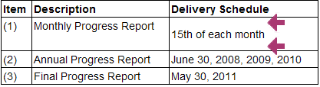
      - If you have extra spacing in the cell (See Example table image above) and want to remove it: Select the entire table cell contents (not just the text) and hit the “Delete” key on your keyboard. Then you can retype your text without hitting the “Enter” key.
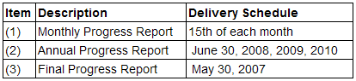
      - If you are still unable to remove the extra spacing in the table cell;
        - Delete the row:
          - Place cursor in the row
          - Right click on the mouse
          - Select “Row” and “Delete Row”
        - Then Insert a new row and retype your text.
          - Place your cursor in the row above where you want the new row
          - Right click on the mouse
          - Select “Row” and “Insert Row”
        - Retype your text

- Click the “Save” button in the edit window to save changes.
- Table Formatting Tips:
  - When creating a new table it is a good practice to set the widths of the table columns. This will insure you see the table columns sized properly in your final document.
  - Inside a table the width of the columns can be set/changed in the editor
    - Place cursor in first table cell in column
    - right click the mouse
    - Select “Cell” option
    - Select “Cell Properties” option
    - In width input field type in the width percentage for column
      - The percentage is based on a total sum of 100% for all table columns
      - The sum of the columns cannot exceed 100%
      - Examples:
        - 2 column table –
col #1 width=”20%”
col #2 width=”80%”
        - 4 column table –
col #1 width=”10%”
col #2 width=”20%”
col #3 width=”20%”
col #4 width=”50%”
    - If columns sum is over 100% - default column size is used in PDF output
    - Repeat steps 1-5 for each table column
  - The height of the table cell will automatically adjust for the content. If the user wants to add height to a table cell without additional content, they can put in blank line(s) by placing the cursor inside the table cell and hitting the “Enter” key as many times as necessary.

Insert/Create a List:
- Ordered list (numbers/letters)
  - Place cursor in the edit screen where you wish to add the list.
  - Click on the “ordered list” icon in the Editor’s toolbar.
  - The number 1 will appear in the edit screen.
  - Begin to type your list item.
  - Hit the return to continue with the next list item.
  - To create a sub-list:
    - Hit the return after the list item where you want the sub-list to appear.
    - When the new item number appears, place your cursor after the number and click on the indent icon in the Editor’s toolbar. This will create the sub-list and start the numbering at one.
  - To change from Numbers to Letters or Roman Numerals:
    - Place the cursor to the right of the number and right click on the mouse.
    - Select Numbered list properties
      - In the pop up window select the type:
        - Numbers (default)
        - Lowercase Letters
        - Uppercase Letters
        - Small Roman Numerals
        - Large roman Numerals
      - Then select the value to start the list, the default will always be one, a, A, I or I depending on what type you selected above.
- Unordered list (bullets)
  - Place cursor in the edit screen where you wish to add the list.
  - Click on the ‘unordered list” icon in the editor’s toolbar.
  - The bullet will appear and you may start to type in your list item.
  - Hit return to enter the next list item
  - To change the type of bullet;
    - Place the cursor to the right of the bullet and right click on the mouse.
    - Select the bullet type from the dropdown list
      - Circle
      - Disc
      - Square
    - Click the OK button
- To change the level of the list:
  - Place the cursor to the right of the number/bullet.
  - Click on the “indent” or “outdent” icon in the Editor’s toolbar.
  - Your list will move right or left accordingly.
- Reformat list – change the alpha/numeric/ numbering or bulleted format
  - In the editor place the cursor next to the list item you want to change.
  - Right click on the mouse:
    - For a numbered list select: Numbered List Properties.
    - For a bulleted list select: Bulleted List Properties.
  - In the Type dropdown list box, select the list format.
  - Another option for Numbered List is ‘Start With’.
    - The user may input a number other than one to start the list (a=one, b=two, c=three, and so on).
    - By default the list will start with the number 1.
- Click “Save” button in the edit window to save changes.

Add a hyperlink
Create a hyperlink with existing text
- Locate and select the item in the document where the hyperlink is to appear.
- Click on the Edit icon in the toolbar to open the DGS Editor.
- In the Edit screen, select the text that will become the hyperlink.
  - If the hyperlink text does not already exist in the item.
    - Place the cursor where the hyperlink should appear.
    - Type in the text that will become the hyperlink.
    - Select that text.
- Click the “Insert/Edit Link” icon in the toolbar.
- In the Link Type dropdown list – select URL.
- Select the Protocol for the URL (http:// is the default).
- Type the rest of the URL in the URL input box.
- Click on the “OK” button.
- The text in the edit screen will display as a hyperlink.
- Click the “Save” button in the Edit screen to save the edit.
Create a hyperlink without pre-existing text
- Locate and select the item in the document where the hyperlink is to appear.
- Click on the Edit icon in the toolbar to open the DGS Editor.
- In the Edit screen, place the cursor where the hyperlink should appear.
- Click the icon in the toolbar.
- In the Link Type dropdown list – select URL.
- Select the Protocol for the URL (http:// is the default).
- Type the rest of the URL (web address) in the URL input box – This URL is the hyperlink’s text that will appear in the text
- Click on the “OK” button.
- The hyperlink will appear in the Edit screen.
- Click on the “Save” button in the Edit screen to save the edit.
Create a Mailto hyperlink
This option allows users to create a hyperlink that will activate the reader’s email client and open a new preaddressed email window.
- Locate and select the item in the document where the email hyperlink is to appear.
- Click on the Edit icon in the toolbar to open the DGS Editor.
- In the Edit screen, place the cursor where the hyperlink should appear or highlight text that will become the hyperlink.
- Click the “Link” icon in the toolbar.
- Select E-Mail option from the Link Type dropdown list.
- In the E-Mail Address input box - type in the email address.
- In the Message Subject input box – type in the text that will appear in the email’s subject line.
- The Message Body input is optional.
- Click “OK” button to proceed or “Cancel” button to cancel.
- In the Editor Screen, click the “Save”, button to save the edit.

Edit a hyperlink:
- Select the hyperlink in the edit screen.
- Click the “Insert/Edit Link” icon in the toolbar.
- In the URL input box – retype the corrected URL (web address).
- Click the “OK” button.
- The hyperlink’s text may be edited in the edit screen.
- Click the “Save” button in the edit screen.

To Undo or Remove a hyperlink:
- Highlight text with the existing hyperlink.
- Click on the “Remove Link” icon in the Editor’s toolbar.
- In the Edit window, delete the link’s text if it is no longer required.
- The text has changed from a hyperlink to plain text.
- To remove the text also – select the text and hit the delete key on the keyboard.
- Click “Save” button in the edit window to save changes

Cut content:
- Highlight content you want to cut out.
- Click on the “Cut” icon in the Editor’s toolbar.

Copy content:
- Highlight content you want to copy.
- Click on the “Copy” icon in the Editor’s toolbar.

Print the content of the edit window:
- Click on the “Print” icon in the Editor’s toolbar
- Select the printer.
- Click on the “Print” button.

Check Spelling:
The DGS Editor includes a spell checker. It works similar to Microsoft Word in that it checks spelling and grammar of the text, using wavy red underlines to indicate possible spelling or grammatical problems. The spell checker will initialize a spell review of the text in the DGS edit window after the user has clicked on Save and then clicks on the “Check Spelling” icon in the DGS toolbar
- After making changes, click on “Save” at the bottom of the DGS Editor screen
- Click on the Check Spelling icon in the DGS Editor Toolbar.
- A wavy red line will appear under each questionable word in the text and a small pop up window will appear with options for user’s to correct the word.
- The Spell Checker will go through the user’s text and display each error one at a time in the window.
- Users will have several options to handle spelling errors:
  - Select the correctly spelled word from the list of Suggestions or type the correct spelling in the “Replace With” input box.
  - Replace - will replace a single occurrence of the word with the word selected from the list of Suggestions.
  - Ignore - will ignore this single occurrence of the word in the current window – no change in text will occur.
  - Learn – will add the word to library as spelled. Once a word is added to the library, it will not be flagged by the spell checker again.
  - Replace All – will replace all occurrences of the word with the word selected from the list of Suggestions.
  - Ignore All - will ignore all occurrences of this word in the current window only.

Undo or Redo edits
- Undo
  - The “Undo” icon on the editor’s toolbar will function similar to the Undo function in word processing applications like Word or WordPerfect. Clicking on this icon will undo or remove the last edit made.
  - The icon will only be active if there has been an edit made that can be undone. Otherwise, it will remain grayed out or inactive.
  - Click “Save” button in the edit window to save changes.
- Redo
  - The “Redo” icon on the editor’s toolbar will function similar to the Redo function in word processing applications like Word or WordPerfect. Clicking on this icon will redo an edit that had been previously undone by using the “Undo” icon.
  - This icon will only be active if there has been an edit that has been undone using the application. Otherwise, it will remain grayed out or inactive.
  - Click “Save” button in the edit window to save changes.

Align text:
- Select the text you wish to align by holding down the left mouse button and dragging the cursor over the text. Release the left mouse button (or place the cursor in the edit screen in front of text you wish to align).
- Click one of the “alignment” icons in the Editor’s toolbar.
  - Left align
  - Center align
  - Right align
  - Justified
- Click “Save” button in the edit window to save changes.
- This edit is a little tricky if you change the alignment more than once.
- Indent Tips
To indent a section of text inside the item content (i.e. an address):
- Select the content to be indented and click on the “Increase Indent” icon in the toolbar.
- If the entire item’s content indents instead of only the selected text:
    - Add a new line above the text you want to indent by placing cursor before the text and hitting the “Enter” key
    - If there is additional text below the area you want to indent, add a new line below the text by placing the cursor at the end of the text and hitting the “Enter” key
    - Now you can select the text to be indented and click the “Increase Indent” icon in the toolbar
- Click the “OK” button in the Internet Options window

Find text:
  - The “Find” function is represented by a magnifying glass. This function allows the user to find or search for a specific letter set, word or group of words in the items text.
  - Click on the icon and in the small pop up window type in the text you wish to find.
  - There are two options to make the search more focused.
    - Match case: will match case specifically typed in the Find what box – to use, check the checkbox beside the “Match case” text.
    - Match whole word: will match complete word only, no partial letters of words matched – to use, check the checkbox beside the “Match whole word” text
    - Match Cyclic: Checking this option means that after the DGS Editor reaches the end of the document, the search continues from the beginning of the text. This option is checked by default.
  - Click the Find button to initiate the text find.
  - The found text will be selected in the edit window - you may edit the text
  - Cancel will close the window.
  - Click “Save” button in the edit window to save changes.

Replace text:
- The “Replace” function is represented by the letter A and B and two dotted arrows.
- To replace text in the edit window, click on the “Replace” icon.
- In the pop up window “Find what” text box type in the text you want replaced
- In the “Replace with” text box type in the text you want.
- There are two options to make the replace more focused.
- Match case: will match case specifically typed in the Find what box – to use, check the checkbox beside the “Match case” text.
- Match whole word: will match complete word only, no partial letters of words matched – to use, check the checkbox beside the “Match whole word” text.
- Match Cyclic: Checking this option means that after DGS Editor reaches the end of the document, the search and replace continues from the beginning of the text. This option is checked by default.
- Click “Replace” to replace once – “Replace All” to replace all occurrences of replaced text.
- Click “Save” button in the edit window to save changes.

Bold, Italicize or Underline text
- Bold
- Select text you want to bold (place cursor at beginning of text and hold left mouse button down, drag the cursor over text and release left mouse button).
- Click on the “Bold” icon in the toolbar.
- Click “Save” button in the edit window to save changes.
- Italicize
- Select text you want to italicize (place cursor at beginning of text and hold left mouse button down, drag the cursor over text and release left mouse button).
- Click on the “Italicize” icon in the toolbar.
- Click “Save” button in the edit window to save changes.
- Underline
- Select text you want to underline (place cursor at beginning of text and hold left mouse button down, drag the cursor over text and release left mouse button).
- Click on the “Underline” icon in the toolbar.
- Click “Save” button in the edit window to save changes.

Create Subscript or Superscript
- Subscript
  - Select text you want subscripted (place cursor at beginning of text and hold left mouse button down, drag the cursor over text and release left mouse button).
  - Click on the “Subscript” icon in the toolbar.
  - Click “Save” button in the edit window to save changes.
- Superscript
  - Select text you want superscripted (place cursor at beginning of text and hold left mouse button down, drag the cursor over text and release left mouse button).
  - Click on the “Superscript” icon in the toolbar.
  - Click “Save”.

Format a Header
      - Select the text for the header in the edit window (place cursor at beginning of text and hold left mouse button down, drag the cursor over text and release left mouse button).
      - In the “Format” dropdown box, select the desired Header format.
      - Click “Save” button in the edit window to save changes.

Add Attachments
Use the Menu Item: Attachment Manager (For Draft documents only)
This menu option allows the users to attach separate files for use in Section J and other areas of the document. Once a file has been uploaded to the Attachment Manager, it is available for creating a link within your document. It is strongly recommended that attached documents be converted to PDF format.

Attach a File and Create a Hyperlink from the Attachment Manager
Files can be uploaded in the Attachment Manager window and in the item content a hyperlink to that attached file may be created in the Editor with the Insert/Edit Link feature (see: Adding an Attachment In the Editor screen).
- From the Summary screen or the Details screen, open the Attachment Manager by clicking on the “Attachment Manager” hyperlink in the menu bar.
- To add a file to be attached to the document.
  - Use the “Choose File” feature to locate the file.
  - Click on the “Upload” hyperlink to the right of the Browse feature.
  - The file will now appear in the Attachments list and may be linked to from anywhere in the document.
  - Close the Attachment Manager.

Adding an Attachment to Section J
To attach a file to a predefined Section J Attachment (i.e. Statement of Work, Packaging and Delivery of Proposal and Government Property Schedule)
- Open the Attachment Manager from the Summary screen or Detail screen
- Add the file that will become the attachment (upper portion of screen)
  - Use the Browse feature to locate the file.
  - Click on the “Upload” hyperlink to the right of the Browse feature.
  - The file will now appear in the Attachments list, once it is listed here it can be attached to the predefined Section J attachment
- In the Section J Attachments section of the Attachment Manager (lower portion of screen)
  - Go to the Document Topic in the table
  - Under the Attachments column use the dropdown list to select the desired file
    - All files uploaded will be displayed here and available
    - To select click on the file name in the dropdown list
    - If the file you want does not appear in the list then it must be uploaded in the Attachments section of the Attachment Manager (upper portion of screen)
  - Click on the Attach hyperlink to the right
  - The newly attached file will be listed under the Current Referenced File column
  - To remove the attached file simply click on the Remove hyperlink

Users may want to add a custom attachment to Section J: List of Attachments.
- Create a new item in Section J (See adding a custom item).
  - Add new Section J item in the document tree (left pane).
  - Add new Section J item in the text view (right pane).
- In the Add Item window.
  - Fill in the Short Title: this is the text that will appear in the document tree.
  - Fill in the Long Title: this is the text that will appear when mouse hovers over item in document tree.
  - Fill in the TOC Title: this is the text that will appear in Section J of the document.
  - In the edit screen below the user may insert a hyperlink to the new attachment or add text to direct the reader (a combination of a hyperlink and text is also allowed).
    - Create a hyperlink.
      - Type in the hyperlink text.
      - Select the text using the cursor (if no text is selected the URL becomes the text displayed as the hyperlink in the item).
      - Click on the “Insert/Edit Link” icon in the toolbar.
        - If the hyperlink will reference an outside document.
          - Select “URL” in the Link Type.
          - Select Protocol.
          - Type in the URL.
          - Click the “OK” button to save or “Cancel” button to cancel.
        - If the hyperlink will be to an attached document.
          - Select “Attach” in the Link Type.
          - Browse to find the file to be attached.
          - Click the “Upload” hyperlink.
          - Select the file in the Attachments list.
          - Click “OK” button to attach or “Cancel” button to cancel.
    - Add text to direct the reader to attachment.
      - Type any desired text in the edit window.
      - Click the “Save” button in the edit window.
- Click the “Save” button to save the new item as part of Section J’s List of Attachments.

Modify Section J Attachments
- Select the Section J attachment (item) from the document tree by clicking on the item.
- Click the “Edit” icon.
- In the edit window
  - Remove the hyperlink to an outside referenced file:
    - Select the hyperlink text.
    - Click “Remove Link” icon (text is no longer blue/underlined).
    - Delete the text.
    - Click the Save” button in the edit window.
  - Remove the hyperlink to an attached file
    - Open the Attachment Manager in the menu bar
    - Find the Attachment listed in Section J area
    - Click on the “Remove” link under the attached file name
    - Click “Save”
    - The attached file link will be removed – however the attached file will still be attached to the document
    - To remove the file completely: go to the top area of the Attachment Manager screen and check the checkbox next to the file you want to remove.
    - Click on the “Delete” link above
    - Click “Save”
    - The file is no longer attached in any way to the document. If you want to use it again you must attach it again in the Attachment Manager.
  - Change the hyperlink reference (URL).
    - Select the hyperlink text.
    - Click the “Insert/Edit Link” icon.
    - Edit the URL in the URL input box of the Insert/Edit Link window.
    - Click the “OK” button
    - If the URL is the actual text for the hyperlink: the URL’s text must be edited in the edit window to match the updated link
    - Click the “Save” button in the edit window
  - Add a new hyperlink to an outside reference:
    - Type the hyperlink text in the edit window and select the text
    - Click the “Insert/Edit” icon in the toolbar.
    - Select the Link Type “URL”.
    - Select the Protocol.
    - Type in the URL (web address).
    - Click the “OK” button.
    - Click the “Save” button in the edit window.
  - Add a new attached file to a custom attachment (not pre-defined):
    - Type the hyperlink text in the edit window and select the text.
    - Click the “Insert/Edit” icon in the toolbar.
    - Select the Link Type “Attach”.
    - Browse to locate file to be attached.
    - Click the “Upload” hyperlink.
    - Select the file in the table below the Browse feature.
    - Click the “OK” button.
    - Click the “Save” button in the edit window.
  - Add a note in the Location column of the attachment to direct the reader.
    - Type any desired text in the edit window.
    - Click the “Save” button in the edit window.
    - Other Sections of Document
    - Predefined Attachments

Additional Features

Reassign
This option is visible for users defined as: Team Leader/Section Chief, Branch Chief or Director. Specialist can contact the DGS Help Desk (DGSHelp@maximus.com) if they need to have a document reassigned.
- A document may be reassigned to another staff member only if that staff member has a Document role in DGS.
  - A Team Leader/Section Chief may reassign a document to another DGS user in his/her team/section or to a DGS user in another team/section within the Branch.
  - A Branch Chief may reassign a document to another DGS user within their Branch or Institute
  - A Director may reassign a document to any DGS user in any Institute.
- Click on “Summary” menu option
- In the document summary view, click on “Reassign” menu option
- Select the new document Owner from the dropdown list
  - Branch Chief and Director level users will select Institute first – this will populate the Owner dropdown list with personnel from selected Institute.
- Click the “Change Owner” button to complete the reassignment or click “Cancel” to return to the Summary screen.
- All documents related to the reassigned document will also be reassigned at the same time.

Restore
This menu option allows users to restore any modified items to their original state based on the Workform used to create the document. Several options for restoring the document are available. The default selections are: (1) Selected Item Only and (2) Restore text of modified items.
- Target: Select the appropriate radio button, only one option may be selected.
  - Selected Item Only – restores a single item.
  - Selected Item and all its Sub Level Items – restores the item selected and all sub level items to their original state.
    - Entire Document – this option restores the entire document.
Important Note: All modifications performed on the document will be lost. This is the equivalent of deleting a document and starting again. Not recommended!
- Option: Users may check more than one option here.
  - Restore text of modified items – will restore any text that has been edited in the application’s editor.
  - Remove added items - will remove any custom items added by user. For this option to be available the user must select “Entire Document” or “Selected Item and all its Sub Items” in the Target area.
  - Remove user tree selections – will remove any items the user manually selected.
  - Remove field values – will remove any values user has added to form fields in item.
- After user has selected restore options – click the “Restore” button or “Cancel” button to cancel and close window.
- Note: The Restore feature DOES NOT apply to custom items. Custom items are any new items the user has added to the document and are not part of the original document Workform template. If users try to use the Restore feature on custom items they will get the following message: “Items you have created cannot be restored”

Change Filter Criteria
This menu option opens a new window with the original document filter criteria displayed. Here the user may modify the original filter criteria of the document.
- Check any criteria that apply to the document.
- Uncheck any criteria that may no longer apply to document.
- Button options
  - OK: this will recreate the document adding any items that apply to new criteria set
  - Reset: this will reset the checked boxes (criteria) to the original selections
  - Cancel: this will cancel any change and close the window.
- Note: Any items selected and edited will not be removed upon revision of filter criteria that affects these same items.

Change Title/Control#/FP#
This feature allows revision of the Title, NCI Control number and the number of pages in the Face Page.
- In the Document Title form field, type the new document title.
  - This will update any input fields in the document using the title.
  - This does not update any document content that contains the title, this item will need to be edited separately in the editor
- For Contract documents, the NCI Control Number and number of Face Page pages can be revised.
- Click “Save” button to save title change or “Cancel” to cancel and close window.

Change Number
When a document is in Draft status, the document’s owner may modify the document number, using the “Change Number” option from the menu bar.
- Open the Draft document in the Details Screen.
- Click on the “Change Number” option in the menu bar.
- In the pop-up window type in the new document number in the labeled input box.
- Click on the “Save” button to save change and exit window.

Document Properties
This option allows user to configure some item properties that relate to how the item appears in the document.
- Properties available for custom items only
  - Have the item appear in the document’s Table of Contents.
  - TOC Indentation Level: determines indentation of the item in the TOC.
  - Have the item’s TOC title NOT appear in the document’s output (PDF).
- Property available for all items (Workform and custom)
  - Force a page break before this item in the document.
- Select the item in the document tree (in left pane) and click the Property icon in the toolbar above the left pane to edit the properties of the item.
-OR-
- Select the item in the text view (in right pane) and click on the Property icon in the toolbar above the right pane to edit the properties of the item.
-OR-
- Select the item in the document tree (in the left pane) and right click the mouse to bring up toolbar, select edit Item from list to edit the properties of the item

Send Document for Review
DGS provides a document review feature to allow users to prepare a draft or final document for review outside of DGS. The “Doc Review” feature is available for RFPs and Contract documents. Upon selecting the menu item Doc Review, the system generates an archived/zipped file (filename using extension .zip) which includes the main document and all associated files (attachments).
- Select a draft or final RFP or a draft or final Contract document to review.
You can select a document from the View Documents screen, or you can perform a search and select a document from the search results.
- After selecting the document number, the document Summary screen displays.
- The Doc Review feature is available on the Summary screen.
Summary Screen for RFP Documents:
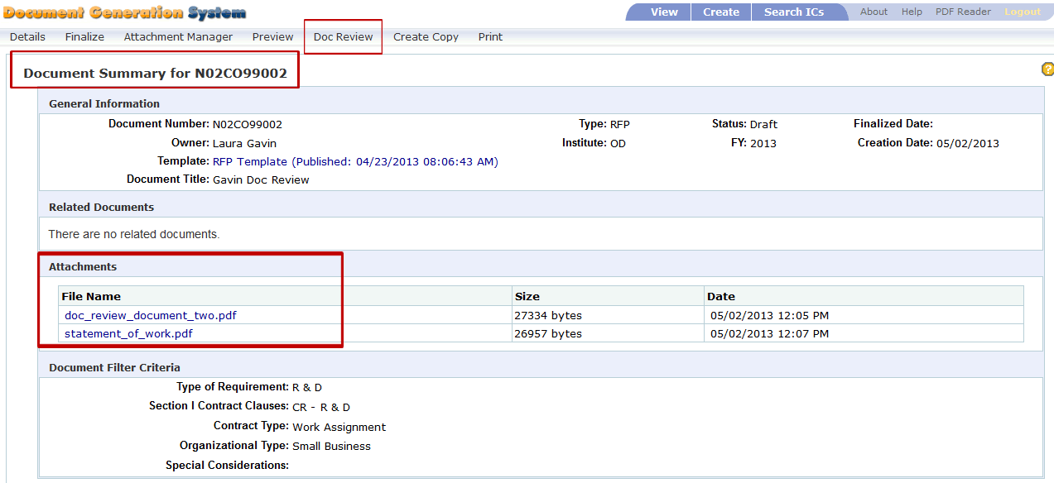
Summary Screen for Contract Documents
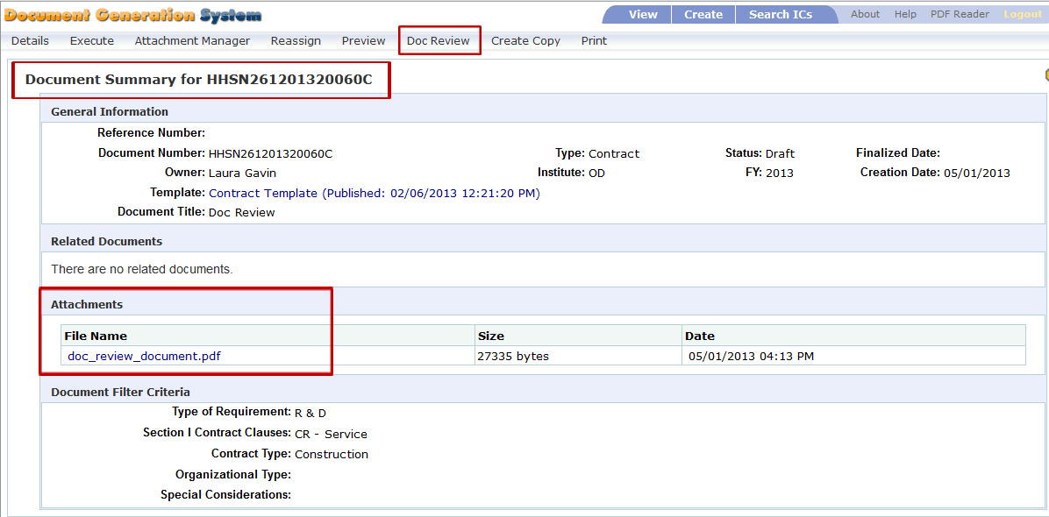
- Select Doc Review from the menu bar.
- The Document Review screen appears.
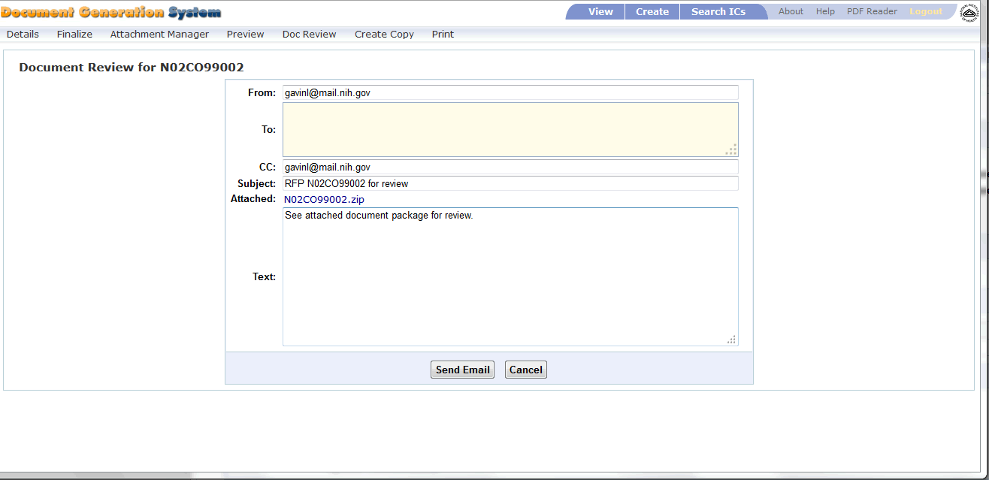
- Review data in the input fields. Modify and input needed information as follows:
  - From contains the document owner’s email address.
  - To is blank, but is a required field. You will need to input the email address(es) in which the Document Review bundle is being sent.
Separate multiple email address with a semi-colon and a space between each address. For example:
name@organization.gov; user@company.net
  - CC contains the document owner’s email address.
  - Subject contains the document type (RFP or Contract), the document number and the text “for review”. In the above image, the subject is listed as “Contract HHSN261201320060C for review.”
  - Attached provides a zipped file of the DGS document and all of the associated attachments. The file name is the document number with the zip extension.
  - Text defaults to “See attached document package for review.” You can modify this text as needed.
- Select Cancel to stop action.
- Select Send Email to generate and send document package for review.
- You may see this message after selecting Send Email:
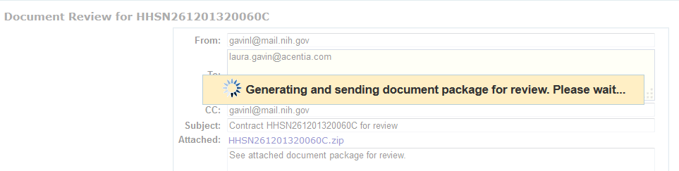
- Once the message is sent, the Document Review screen closes and a confirmation message displays on the Summary screen.
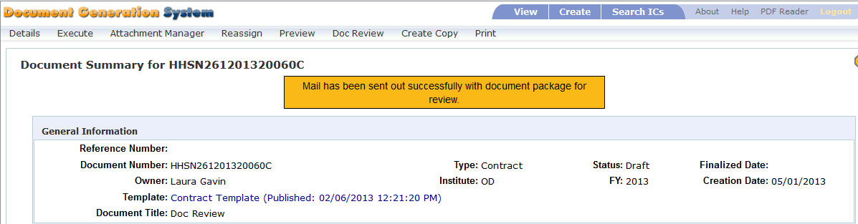
- The recipients defined in the To and CC fields receive an email with the DGS document bundle.

Create a Folder on Your Computer
- Before opening the DGS email, create a folder on your local computer to save the DGS files.
  - Open Windows Explorer.
  - Navigate to a location to create the folder.
  - Select New Folder.
  - You can label the folder any name, for example, you may want to label the folder “DGS_Doc_Review”.
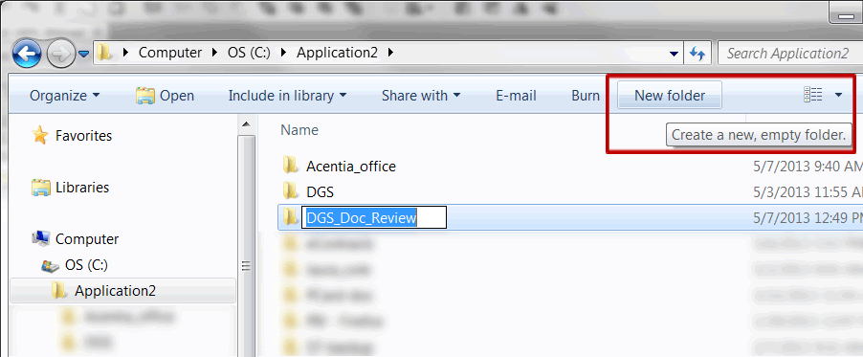
- Once the folder is created, proceed to your email inbox to review the DGS email.

Receive Document Bundle through Email
After selecting Send Email within DGS, an email is sent to each of the recipients.
- Open your mail Inbox. Locate the Document Review mail.
- The subject matches the data in DGS and, unless modified, should contain the document type (RFP or Contract), the document number and the text “for review”.
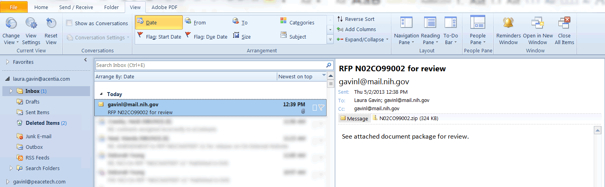
- Double-click on the attachment zip file. A message may appear asking if you want to Open or Save the file.
- Select Open.
- Important Note: The zipped files must be unzipped/extracted from zip file to properly open and view the files for review.

WinZip Users
If you are using WinZip, proceed with step 5. If you use a utility other than WinZip to unzip files, please proceed to step 13.
- After selecting Open, the WinZip software opens displaying the zip files.
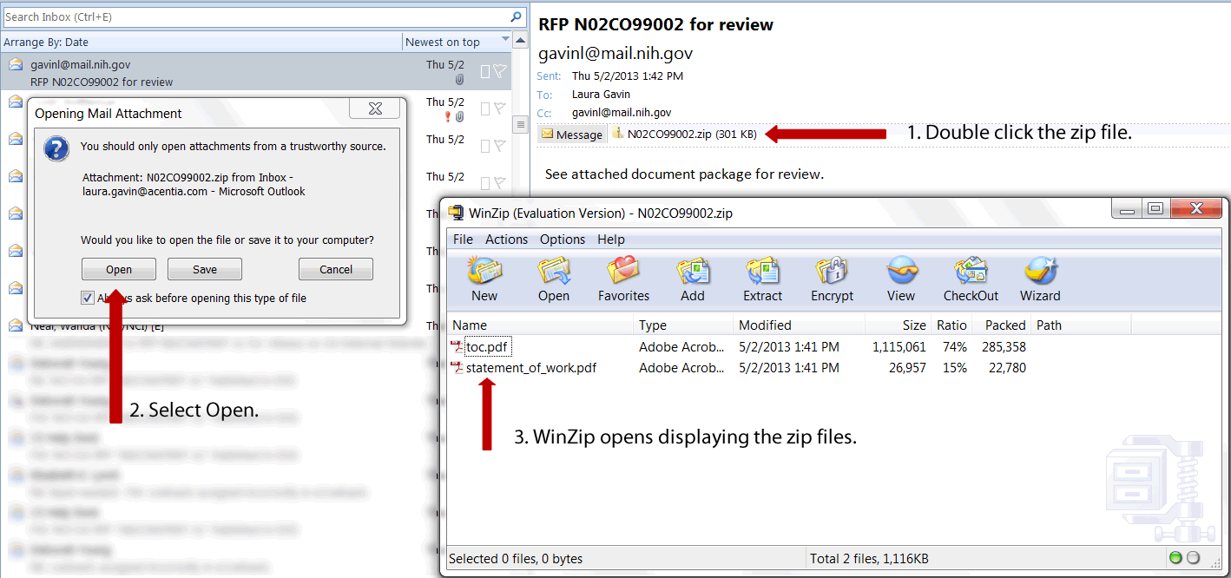
- Within WinZip, select Extract. Depending on your WinZip version, the icon may be labeled UnZip.
- The WinZip Extract screen displays.
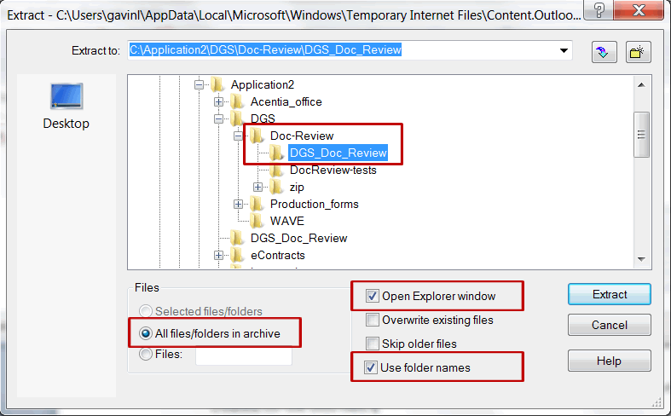
- Navigate through the folder tree and select the new folder you created for the DGS files.
  - Select the “All files/folders in archive” radio button. This will extract all the files at one time.
  - Select “Open Explorer window”. This option opens Windows Explorer immediately after the extraction is complete.
  - Verify the “Use folder names” checkbox is selected by default. If not, then select this checkbox.
- Select Extract.
- The files are extracted to the selected folder and Windows Explorer opens the folder for review.
- Double click the toc.pdf to review the DGS document.
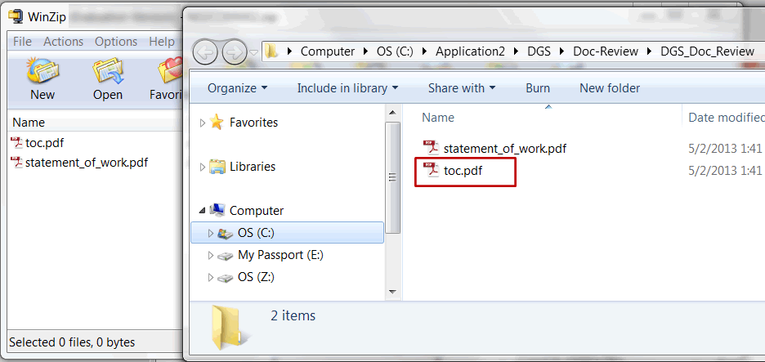
- When review is complete, close the files, Window Explorer, and the WinZip utility.

Non-WinZip Users
Perform the following steps if you are using the Windows Operating System built-in zip file support “Compressed (zipped) Folders”.
- From your email inbox, save the zip file to the newly created folder.
- Open Windows Explorer and locate the folder with the saved zip file.
- Click to select the zip file. Right click to view menu options for the zip file.
- Select Extract All. The Extract Compressed (Zipped Folders) screen appears.
- Select the folder in which you would like to save the extracted files. By default the Windows Compressed Folders adds a new folder with the file name.
- Select the checkbox for “Show extracted files when complete.”
- Select Extract.
- The extracted files in the new folder are displayed through Windows Explorer.
- When review is complete, close the files, Window Explorer, and the Compressed (zipped) Folders utility.

Review DGS Document
Once the files are successfully extracted, review the DGS document.
- Double click the file labeled toc.pdf to open the DGS document.
- After opening the toc.pdf file, the DGS document opens for review. Any attachments associated with the DGS document are also accessible for review.
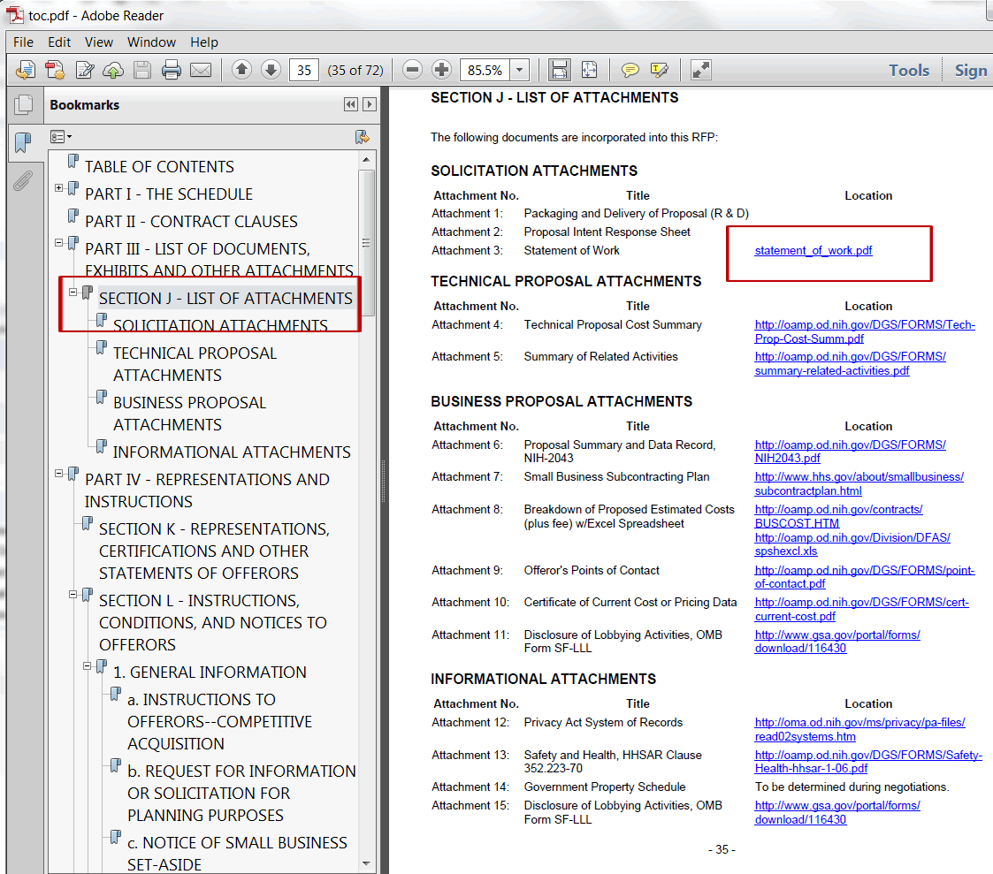

Help
If you experience any trouble unzipping the bundle or viewing the links within the toc.pdf document, please contact the DGS help team at DGSHelp@maximus.com.

Finalize a document
The option is visible for RFP and RFP Amendment documents only
Once an RFP document has been reviewed and is ready to be published, the user will finalize the RFP document. This function can be accessed from the Summary or Detail’s screen’s menu bar. Only the owner of the RFP document can finalize the document.
- Important Note: Documents must be Finalized for the links to the attachment documents to work properly.
- Locate the document in the View screen and select it (by clicking on the document number); if the user has the document already open in the Detail or Summary screen skip this step.
- Click on the “Finalize” hyperlink in the menu bar.
- A small Finalize Document window will appear with the document number and title displayed.
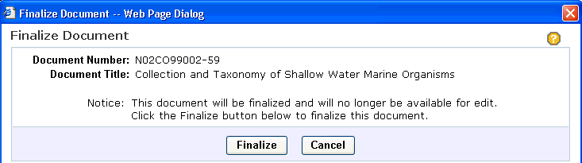
  - Click “Finalize” button to finalize the RFP or RFP Amendment.
  - Click “Cancel” button to cancel and close window.
- Upon successful finalization: The user is directed to the “Summary” screen.
  - At the top of the screen, users will see a message indicating a successful publication of document.
  - The document’s status will show as final.
  - The attachment section of screen will list the generated toc.pdf file.
- Once the document has been finalized, it is no longer editable. You may access it in read-only mode.
- All the files that comprise the document need to be saved and pushed out to FedBizOpps. To download files for use in publishing to FedBizOpps:
  - Select menu option List of Attachments.
  - Check all the checkboxes to the left of the file names (checking the top checkbox to the left of the File Name column “header” will check all the files below it).
  - Click the Download hyperlink.
  - A download window will pop up, Click on the “Save” button.
  - User may select a location to save the zip file and may rename the file (default file name will be the document number).
  - The file saved is a zip file that is comprised of the main document and all attached files.
  - Alternatively, users may download each file individually.
- NCI OA Users:
  - The screen below will show indicating the next step is to invoke the Publish.
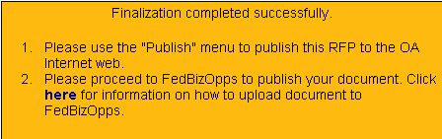

Execute a Document
This option is visible for Contract documents only
- The document should be Executed upon completion and final review.
- Click on the “Execute” hyperlink in the menu bar. A small Execute Document window will appear.
  - Click “Execute” button to finalize the Contract.
  - Click “Cancel” button to cancel and close the window.
- Once the document has been executed, it is no longer editable. You may access it in read-only mode.
- Upon successful execution: The user is directed to the “Summary” screen.
  - At the top of the screen, users will see a message indicating a successful execution of document.
  - The document’s status will show as final.
  - The attachment section of screen will list the generated toc.pdf file.
- To download files to local drive (folder):
  - Select menu option List of Attachments.
  - Check all the checkboxes to the left of the file names (checking the top checkbox to the left of the File Name column “header” will check all the files below it).
  - Click the Download hyperlink.
  - A download window will pop up, Click on the “Save” button.
  - User may select a location to save the zip file and may rename the file (default file name will be the document number).
  - The file saved is a zip file that is comprised of the main document and all attached files.
  - Alternatively, users may download each file individually.

List of Attachments
This option is visible for documents in Final Status only
This feature allows users to view any uploaded attachments to the Final RFP or Final Contract document.
- No modifications are allowed to a document after it is Final (has been Finalized/Executed). This is a read only screen and new attachments may not be added to document.
- The user may download the final document and all attachments from in this screen as a compressed zip file. To download:
  - Check all checkboxes beside the file names by clicking on the checkbox
OR
  - Check the checkbox next to the column header “File Name”; this will check all the file checkboxes at once.
  - Click the Download hyperlink above the Attachments table
  - When prompted click the “Save” button to save the compressed file.
  - Select a location to save the file in the Save AS window and click “Save” again

Download the Document files
Once the document is finalized in the DGS application the files need to be downloaded to the user’s local drive. After the complete zip file is downloaded the user must extracted all files and upload each file to FedBizOpps. All files need to be uploaded into one folder (directory) on FedBizOpps.
To download the RFP and any attached files:
- Click on the List of Attachments hyperlink in the menu bar.
- In the List of Attachments screen, the toc.pdf and any attached files will be listed.
- Check the checkboxes next to the file names. Checking the checkbox to the left of column header File Name will check all the checkboxes.
- With the checkboxes checked, click on the Download hyperlink above the list
- The user will be prompted to Open, Save or Cancel the download.
- To save the files to a user selected location, click the “Save” button.
- A Save As window will allow users to save the document’s zip file to a desired location. Users can rename the file; the default name will be the document number.
- The zip file is a compressed data file that contains all the selected document files
  - To open the zip file with WinZip:
    - Locate the file in explorer and right click on the downloaded zip file.
    - On right click, if the user has WinZip application, it will appear as the first choice in the menu, “Open with WinZip”.
    - The WinZip window will open with the individual files listed.
  - To Extract the files from the compressed zip file with WinZip.
    - Select all the files (click on the first file, hold down the Shift key and click on the last file in the list).
    - Click on the “Extract” icon in the WinZip toolbar.
    - User will be prompted to provide a location for the files.
    - After providing the location for the individual files, click the “Extract” button on the right.
    - All the individual document files will now be found at this location.
    - Users will need to upload all files to FedBizOpps to complete the publication process.
  - If the user does not have WinZip,
    - Locate the file in explorer and right click on the downloaded zip file.
    - Select the “Open With” option
    - A list of utilities will be listed to allow users to open the zip file.
    - Users may select any utility listed here to open the zip file.
    - In the Windows operating system the Microsoft’s built in Zip file support utility will be listed: Compressed (zipped) Folders.
      - To extract a single file or folder, double-click the compressed folder to open it. Then, drag the file or folder from the compressed folder to a new location. Users may select all the files and drag all of them at once to a new folder.
-OR-
      - To copy a single file or folder, double-click the compressed folder to open it. Select the files or folder in the opened compressed folder. Right click and select copy. Navigate to a new location and paste the files or folders into the new location
-OR-
      - To extract all files or folders right-click the compressed folder, and then click Extract files…. In the Compressed (zipped) Folder Extraction Wizard, specify where you want to store the extracted files.
- Important Note: After finalizing an RFP on DGS the user must download the zip file from DGS to their local drive, extract the individual files and upload each file to one single folder (directory) on FedBizOpps for publication.

Publish a Document (NCI OA only)
Instructions to publish RFP/Amendments to the NCI OA Internet:
- Documents must be Final in DGS. The publish feature operates the same way on amendments as for the base RFP. Each amendment must be published separately and in order.
- Open the RFP in the Summary screen.
- Click on the “Publish” option in the top sub-menu bar.
- The following screen will appear.
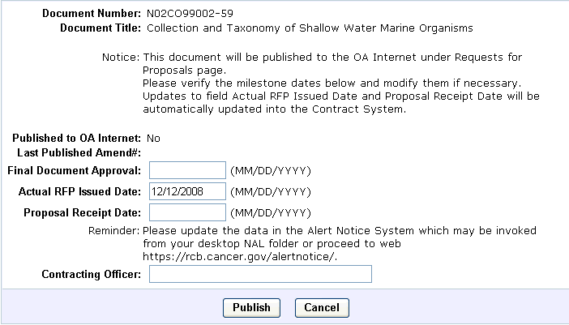
- Input the "Final Document Approval" date.
- Update the required CSS milestones. On Publish, this data will be updated back into the Contract System. The RFP must have a valid Actual RFP Issued Date and a valid Proposal Receipt Date in order to proceed.
- Input the Contracting Officer name.
- Click the "Publish" button to continue.
- The following screen will appear.
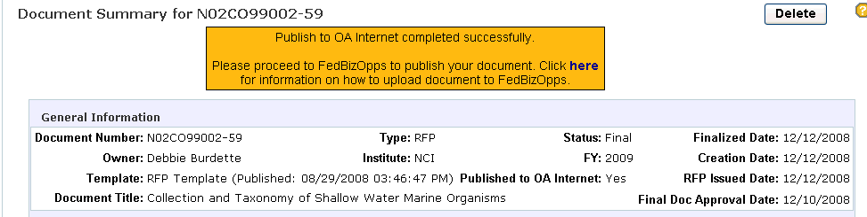
- Users will see a message indicating that the "Publish to the OA Internet" was successful.
- The field "Published to OA Internet" will show Yes to imply the document was published.
- The fields "RFP Issued Date" and "Final Doc Approval Date" will be displayed.

Un-Publish (NCI OA only)
Instructions to Un-Publish RFP/Amendments from the NCI OA Internet

- Important Note: Use of this feature removes the RFP and all associated amendments from the OA Internet. There is no need to use this unless the RFP has expired or needs to be removed from the site for another reason. Just keep publishing documents in order.
- Documents must be Final in DGS.
- Open the RFP in the Summary screen.
- Click on the “Un-Publish” option in the top sub-menu bar.
- The following screen will appear:
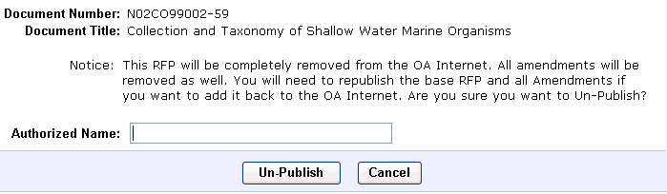
- Input the name of the person performing the action in the "Authorized Name" field.
- Click the “Un-Publish” button to continue.
- The following screen will appear.
- Click OK to proceed or Cancel to abort.
- After the document has been un-published/removed from the OA Internet, user is returned to the DGS Summary screen.
- A sample screen displays.
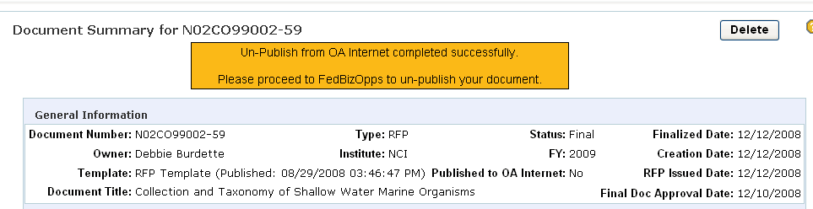
- The value in the "Published to OA Internet" field is changed to "No".

Create a Copy of a Document
- Locate the document to be copied
  - Select from the View screen - Draft or Final document list
  - Select from the Search screen – Search Result list of documents
- Open the “Master Document” by clicking on the Document Number
- In the Summary screen’s menu bar (second level navigation), click the “Create Copy” option.
- In the Create Copy screen, the “Master” document’s number and title are at the top of the screen.
Change the Document Number and the Document Title of the new document
- By default, the copy function will copy all field values to the new document. If this is not desired, check the checkbox next to “Do not copy values of fields”
- By default, the copy function will copy any attached files to the new document. If this is not desired, check the checkbox next to “Do not copy attachment files”. If this option is selected the user will need to go into the document and remove the hyperlinks from the document’s content manually. When the attached files are not copied, the links in the document to those files will be broken.
- Select the “Create Copy” button to create the new document
-OR-
the “Clear” button to clear the screen’s input fields
-OR-
the “Cancel” button to discontinue the copy function and return to the Summary screen
- Once the new document has been created, the application opens in the Summary screen with the new document’s information. The new document will be in Draft status regardless of the “Master” document’s status. Note: In the Related Documents section, the Master document (original) will be listed with the relationship of “Copy From”.
- The document can now be modified as you would any newly created document. Click on the “Details” link in the menu bar to edit the document.

Copy Item Feature
The Copy Item feature allows users to copy a single item or an entire Section from another document into their draft document.
Important Note: An exact copy will be made from the originating document. The originating document may have been created from a template that now contains outdated language. Users must be careful to check for any language that may require updating in the copied items In the Detail screen:
Select “Copy Item” from the menu
- In the right pane, search for the document containing the content you wish to copy.
  - Enter search criteria in the form fields to locate desired document.
  - Click the “Search” button to the right.
  - Select the desired document from the dropdown list.
Users may return to the Document Search screen and change the search criteria by clicking on the “Return to Search” button.
- Once a document is selected, the document tree will be displayed beneath.
- Navigate the tree to locate the section or item to be copied.
The tree branch can be expanded or collapsed by selecting an item and right clicking the mouse to view the menu options. Select the Expand Branch icon to expand the selected branch or the Collapse Branch icon to collapse the selected branch.
To view the contents of the selected item or section, go to the toolbar above and select the HTML Preview icon to view in HTML or select the PDF Preview icon to view in PDF format. Users may also access the preview features by right clicking the mouse on a selected item and then selecting the preferred preview option from the menu.
- Select the item to be copied by left clicking the mouse on the item (a blue dotted line will appear around the item in the tree).
- While holding the left mouse button down, drag the item to the desired location in your document tree (left pane).
- A confirmation window will pop up asking user to confirm the location the item will be placed.
If the location is correct, click on the “OK” button.
If the location is not correct, click on the “Cancel” button
- The new item or section will appear in your document tree with a copy icon identifying it as a copied item.
- The new copied item becomes a custom item and can be moved anywhere in the tree or it can be deleted.
To delete:
  - Simply uncheck the checkbox in the tree by left clicking on the mouse inside the checkbox to remove the checkmark (recommended method).
-OR-
  - Select the item and click on the Delete icon in the toolbar
This action will remove the item and its contents will not be recoverable.

Create a Contract Document from a Finalized RFP
- To create a new document go to the top navigation bar and click “Create”.
- Select the Document Type by clicking on the designated radio button for a "Contract from RFP".
- Select a finalized RFP from the RFP dropdown. You will see the document filter criteria that was used to create the RFP.
- Enter the desired Document Number for the new draft contract in the box at the top.
- Enter the NCI Control Number (if required), Fiscal Year, Document Title, and Face Page Count.
- Click Create. The finalized RFP will be displayed in the document detail screen. The RFP will have sections L and M removed, and all amendments will be appended to the RFP in chronological order at the end of the RFP.
- Edit the draft contract to keep/edit/remove amendment sections and any other data, and click Save at the top right corner to save it.

DGS Help
This hyperlink will invoke the DGS Online Help System in a new window.
- The DGS Help window is similar to the DGS Details screen.
- The left pane is used for navigating the help content – think of it as a table of contents.
- The right pane displays the help item content.
- Select the item in the left pane and it will be displayed in the right pane.

If further help is required, users can contact the DGS help team at DGSHelp@maximus.com

About DGS
- This hyperlink will pop up an informational window.
- Information includes:
  - Current DGS software release version.
  - User login data.
  - Roles assigned to the current user.
- Click on the “Close” button to close window.

Miscellaneous

Helpful Hints
- Press F5 to refresh screen when the left navigation tree is not displaying correctly.
  - In the Detail screen, the document tree may not appear at the top of the screen or it may not render completely.
  - Users can find the F5 key on the top row of their keyboard.
- Use the Shift + Enter keys within the DGS editor to force a line break in the text.
  - In text, this key combination will force the cursor to the next line without adding a new paragraph with extra spacing.
  - This can be used in straight text input or inside table cells to add extra lines.
  - It can also be used in lists to create a new line without creating a new list item.
- Use the application’s “Logout” to exit the DGS application.
  - Do not use the browser’s close button in the top right corner.
  - Using the application's “Logout” will free up valuable server resources that will not be released when the user simply closes the browser window.
  - The DGS "Logout" is located in the application window's top right, next to the "Help" menu option.

Session Timeout
When a user has the DGS application open but is not actively using it for approximately an hour, the user’s connection will be lost and the session will end. To continue to work in the DGS application, the user will need to log into the NIH login screen again.
There may be times when you are actively working and the application prompts you to log in again. This can be caused by a server configuration that cannot be over-ridden. Users will need to log into the application when prompted.
You have timed out of DGS when:
- The NIH login screen replaces the DGS screen in the browser window.
  - Log into the NIH login screen to continue working.
  - After logging back in, DGS should return to the area of the application user was working in before the timeout occurred.
-OR-
- The right pane of the Detail screen is replaced with the NIH login screen.
  - Refresh the browser window to open the NIH login screen in the entire window.
  - Log into the NIH login screen to continue working.

Trouble Shooting
The DGS Help Desk will need the following information to help resolve problems.
What operating system are you using?
- IBM Compatible (i.e. Microsoft)
- Mac
What browser and version are you using?
In Internet Explorer:
- Click on the “Help” link in the top menu bar
- Select the “About Internet Explorer”
- The version information will appear in the first line
In Firefox:
- Click on the “Help” link in the top menu bar
- Select “About Mozilla Firefox”
- The version information will be directly under the Firefox name

In Google Chrome:
- Click on the 3 lines button next to the URL bar.
- Click on Help.
- Click on About Google Chrome.
- Your Chrome browser version number can be found here.

How are you connecting to the DGS application?
- On-site within the NIH network
- Remotely through the NIH VPN
It is always a good idea to get screen shots for any error messages you receive and send them along with the request to the DGS Help Desk for help
TO SEND A SCREEN SHOT
In Windows Operating Systems
- While screen is displayed on the monitor:
- Hit the “Print Screen” key on your keyboard (usually found in the top-right area of keyboard)
- Open new email message and in the message area right click your mouse and select paste from the
pop-up menu.
- Send to DGS Help Desk at dgshelp@maximus.com
OR
2. While screen is displayed on the monitor:
  - Hit the “Print Screen” key on your keyboard (usually found in the top-right area of the keyboard)
  - Open word-processing application such as Word and in a new document, right click mouse and select paste from pop-up menu. Save file.
  - Open new email and attach saved file with screen shot.
  - Send to DGS Help Desk at dgshelp@maximus.com

Browser Requirements
Google Chrome is the recommended browser.
- Browser and Settings
  - Google Chrome, Microsoft Internet Explorer 11, Microsoft Edge and Firefox
  - View, Text Size: Medium (To display html view properly).
  - Screen resolution: 1024 x 768 or higher.
- NIH Login utilized.
  - User must be defined in the NIH Enterprise Directory (NED) to use the DGS system
  - User must have defined application role(s) in the DGS NIH-Org database to use the DGS system. The DGS Administrator will handle this task.
Pop-Up Windows Blocked
If the users has Pop-Up Windows blocked in the browser it may cause problems for the DGS application.
Some typical error messages the user might encounter will be:
- "Object doesn't support this property or method."
- “It was not possible to open the dialog window. Make sure all popup blockers are disabled”
- Important Note: If you have pop-up windows blocked in your browser then you must add the DGS URL to the list of trusted sites.
To fix this problem in both IE and Chrome user will need to follow the steps below:

Internet Explorer:
- Go to the I.E. 6 browser’s “Tools” menu (at the top of the window)
- Select “Internet Options” from the menu list (usually last option in list)
- Select the “Privacy” tab in the Internet Options window
- In the bottom portion of the screen in the Pop-up Blocker section:
  - Block pop-ups checkbox may be checked or unchecked- this is OK and does not need to be changed
  - Click on the “Settings…” button to the right
  - In the Pop-up Blocker window Exceptions; type in the web site of DGS:
    - For the Production DGS site type: dgs.nci.nih.gov
    - For the Test DGS site type: app1-ws1-test.nci.nih.gov
  - Click on the “Add” button (you will see the site appear in the Allowed Sites list)
  - Click on the “Close” button
- Click on the “OK” button in the Internet Options window

Google Chrome:
- Click on the 3 lines button next to the URL bar.
- Click on Settings.
- Click on the Show advanced Settings... link at the bottom of the window.
- Click on the Content settings... button under the Privacy section.
- Scroll down in the Content settings window to the Pop-ups section.
- Click on the Manage exceptions... button.
- Enter the website domain in the Hostname pattern box and make sure that the Behavior is set to Allow.
- Click Done.
- Click Done.
- Close the Settings tab

Firefox:
- Open Firefox.
- Click the menu button ( ), then select Options.
- Select Privacy & Security.
- Uncheck the box to the left of Block pop-up windows.

Clearing the Browser’s Cache
It is a good practice to clear your browser’s cache routinely.
Google Chrome:
- In Chrome browser window click the Options menu (3 dots on right top sidebar).
- From the dropdown list, select History Option.
- In theHistoryOptions window in the ‘Temporary Internet files’ section click the “Clear Browsing Data” button.
- In the Clear browser data popup, check off the first four box next to if not already checked.
- Click the “OK” button in the Delete window.

Internet Explorer 11:
- In IE browser window click the Tools menu (top menu bar).
- From the dropdown list, select Internet Options.
- In the Internet Options window in the “temporary Internet files” section, click the “Delete Files” button.
- In the Delete files popup, check off the the box next to “Delete all offline content”.
- Click the “OK” button in the Delete window.
Firefox:
- Click the menu button and choose Options.
- Select the Privacy & Security panel.
- In the Cookies and Site Data section, click Clear Data.
- Remove the check mark in front of Cookies and Site Data.
- With Cached Web Content check marked, click the Clear button.

Screen Resolution Requirement
The DGS application was designed to run with monitor display set to resolution 1024 X 768
To check or set your screen resolution:
- Go to the Start menu in the lower left corner of the screen
- Select Control Panel
- In the Control Panel window select Appearances and Themes
- In the Appearances and Themes window select Display
- In the Display window select the Settings tab
- In the Screen resolution slide-bar move the pointer to 1024 X 768
- Click on the “OK” button
- Close the Display window

The DGS application will work at other screen resolutions but 1024 X 768 or higher is recommended for best user experience.
Opening PDF document in the browser with Adobe Reader or Acrobat Professional
- Important Note: You should NOT have both Adobe Reader and Acrobat Professional loaded on your machine. If you have both remove the Reader, it is not necessary and can cause problems rendering PDF documents.
To check your PC to see if you have both Reader and Acrobat Professional installed:
- Go to your Start menu and click on “All Programs”
- In the Programs list look for Adobe Acrobat Professional and/or Adobe Reader.
- If both applications are installed you will need to go to the Add or Remove Programs
  - Go to the Start menu and click on the Control Panel link
  - In the Control Panel window click on the Add or Remove Programs link
  - In the Add or Remove Programs window scroll to Adobe Reader
  - Click on the Change/Remove button
  - Confirm that you want to remove the program
  - You may need to restart your computer after removal of program. Your computer will prompt you.
- Close all windows
- You may need to restart your computer after removal of program. Your computer will prompt you.
Whether you are using Adobe Reader or Adobe Acrobat Professional, you need to set the Web Browser Options in the applications Preferences window.
To set the Web Browser Options in Adobe Reader or Adobe Acrobat Professional:
  - Go to your computer’s Start menu and open the Adobe Acrobat or Reader application
  - Click on the “Edit” menu at the top of the screen and select “Preferences” from the options
  - In the Preferences screen look at the Web Browser Options
    - Make sure that “Display PDF in browser” option is checked
    - Make sure that “Allow fast web view” option is checked
    - Make sure that “allow speculative downloading in the background” option is checked
  - Click the “OK” button to save

FAQ
See the OAMP Extranet web site.
DGS Frequently Asked Questions: http://oamp.od.nih.gov/DGS/DGSfaq.html

Special Characters in Text
When users paste text into the DGS editor, any text containing special characters (those not on the standard keyboard) will not be recognized. This includes characters that have been typed using a combination of keys from the keyboard (i.e. using CTRL+SHIFT+HYPHEN instead of the regular hyphen key).
There are two scenarios that may occur when a special character is pasted in to the DGS editor:
- The character will be immediately removed at the time of pasting. It will show up as a blank space in the text.
- The character will show in the DGS view screen but will be converted to a # sign in the preview PDF
Review all text in the Preview PDF after pasting into the DGS editor.
- If a character in missing in the editor, type in a replacement character from the keyboard.
- If a character is displaying in the view screen but is replaced with a # in the preview PDF, go back into the editor and replace the character with a standard character or text.
  - Example: the less than or equal to symbol “ ≤ “ would need to be replaced with <= or spell out the words “less than or equal to” in your text
When text contains special characters or formulas, it is strongly recommended that users utilize the Attachment feature of DGS instead of pasting the text into the editor. In addition, if the text to be added is more than 2-3 pages, an attachment is advisable. The source document can be uploaded into DGS in the Attachment Manager and a simple link can then be added. This is less work for the user and if the document contains many special characters, the original content can remain unchanged.

COAC Users
- Language is selected from the Workform/template for all customer ICs in the COAC per NIH business rule.
- Users in the COAC can search to see all documents in customer ICs
- COAC documents that do not belong directly to the user will be available to view in Read-only mode
- Only the director of the COAC can reassign documents to personnel in the customer ICs.

Merging PDF files outside of DGS
Some users may want to physically merge their attachments with the document produced in DGS. This process is done outside the DGS application after the document (toc.pdf) has been generated and will require PDF software such as Adobe Acrobat Professional. The free Adobe Reader does not have the functionality to insert pages. To insert attachments at the end of the document using Adobe Acrobat follow the steps below.
- Open the DGS generated RFP/Contract document in Adobe Acrobat.
- Scroll to the end of your DGS generated PDF document.
- In the top menu bar locate and click the “Document” option / from the dropdown menu select “Insert Pages”.
- In the “Select File to Insert” window, locate the PDF file to be inserted.
- Once file is located, click on the “Select” button in the “Select File to Insert” window.
- The “Insert Pages” window will now appear; select “After” in the Location dropdown box, select the “Last” radio button.
These selections will add the inserted PDF pages to the end of the document.
- Save the updated document with the added pages inserted.
- Check the documents accessibility (See below: PDF Accessibility)

Important Note: Make sure any reference in the document to the inserted pages directs the reader to the end of the document where the pages have been added. Do not create a hyperlink to the inserted PDF pages in the DGS editor. Pages that are inserted after DGS document generation and not attached will not be accessible with a link created in DGS.
Example:
Statement of Work See Attachment at the end of RFP
Important Note:
- The accessibility of any custom PDF attached in Section J Attachments is the responsibility of the document owner.
- When a PDF produced outside of DGS is merged with a DGS Final PDF document outside of the DGS application, the owner is responsible for the resulting PDF’s accessibility.
- Any Word table pasted into a document needs to have a table header defined: See “To Paste Table from Word” instructions in the Editing Document section above.

PDF Accessibility
All PDF documents posted to the WEB should be tested for accessibility. The current NIH requirement for accessibility requires the PDF to pass the Adobe Acrobat 7.0 Professional (or higher), Accessibility- Full Check test. The PDF documents produced in DGS meet this requirement.
To test the PDF for Accessibility:
- Open PDF document in Adobe Acrobat 7.0 Professional (or higher).
- Go to "Advanced" in the top menu bar in Acrobat.
- Select "Accessibility" from the dropdown options.
- Select Full Check from the options.
- In the Accessibility Full Check pop-up window, click on the “Start Checking” button on the bottom of the screen.

Using Fillable PDFs as Attachments
After generating PDFs that were created using a fillable PDF template, users should make sure that the form fields are no longer editable before publishing the document. An example is the Packaging and Delivery of Proposal form (pd.pdf); this is a fillable PDF that should be made read-only before attached in Section J of the RFP document.
There are two ways users can save their PDF as read-only:
To save a fillable PDF and remove all the editable form fields (form values will be retained):
- Fill in the PDF form fields with the desired data
- Save the PDF
- Select the “Print” option from the File menu
- In the Print pop-up window, select “Adobe PDF” from the Printer Name dropdown list
- Click on the “OK” button at the bottom of the screen
- In the “Save PDF File As” window, users can rename the file and save it.
- This new PDF file will display the data from the form fields, but will no longer contain the editable form fields.
- OR-
To set each of the form field’s property to read-only:
- Fill in the PDF form fields with the desired data
- Save the PDF
- In the Advanced menu, select Forms, then Edit Fillable Forms
- In the “Edit Fillable Form” window, select Acrobat’s Form Tools radio button
- Click on the “OK” button at the bottom of the screen
- The form fields will be displayed with a black border to show that the form field’s properties are now editable
- Right click the mouse in a form field
- Select “Properties”
- Select the “General” tab in the “Text Field Property” window
- In the Common Properties section of the screen, check the “Read-only” option
- Click on the “Close” button at the bottom of the screen
- Repeat steps 7-11 for each form field (even if the form field is not filled in)
- Save the document

Reducing the File Size of a DGS PDF Document
The DGS documents will be generated in PDF format. Users must be careful if they attempt to reduce the PDF file size after downloading the document to a local drive. The DGS application produces a tagged PDF, which is compliant with the HHS –Section 508 requirements for PDF documents.
Reducing the document size must be done using the full Adobe Acrobat application (Adobe Acrobat Professional 8.0 or above). Adobe Acrobat Professional has a feature that allows the user to reduce the overall size of the document without stripping the required tags from the document.
- Go to Adobe Acrobat’s Document menu.
- Select Reduce File Size option from the menu.
- In the dropdown, “Make compatible with” select “Acrobat 8.0 and later”.
- Click on the “OK” button.
- In the Save As window, navigate to the location you want to save the reduced size file and rename it if desired.
Important Note: If you try to resize your document by printing to a PDF printer (recreating the PDF) and saving it again, the document will be reduced in size but the tags will be removed and the document will no longer be compliant with HHS requirements.

Reference Section

Application Icons
- Edit
- Add
- Delete
- Property
- Preview
- Preview Document Tree
- Edit Item – most items may be edited. Some FAR based items are non-editable and user will be informed via a pop up window message stating ‘No editing allowed on this item.’ A new item may be added below a FAR based item to add custom text.
- Add item - add a custom item on the same level or sub level of the current selected item in tree.
- Restore - restore text of selected item from the Workform used to create the document originally. This would be used when a user updated the wrong item by mistake or completely messed up the formatting of document and wants to start over.
- Delete Item - delete custom items only. These are items created by user.
- Item Properties - edit selected item properties. This is where an item is configured to appear in the table of contents or to force a page break in the document before the item.
- Preview Item - preview/review selected item(s) or entire document in PDF format
- Expand Branch - Expand document tree from selected item and downward
- Collapse Branch - Collapse document tree from selected item and upward
- Refresh Item - Used to reload and synchronize the sub level items of the selected item from database. In cases:
        - something goes wrong so that the tree is not updated after changing the sub level items
        - someone else makes changes to the sub level items
        - any other scenarios that may affect sub level items
  - Descriptions of Tabs (with screen shots)
  - Descriptions of Menus (with screen shots)

Glossary of Terms
Attachment – Any document user uploads to DGS and then creates a link to in their RFP, Contract or RFP Amendment document being created in DGS
COAC - Consolidated Operations Acquisition Centers
Custom Item - Any user created item that is not included in the Workform Template published by NIH OD OAMP
DGS - An acronym for the NIH Document Generation System application
Document Number – A number representing an RFP or Contract Number (PIID)
FedBizOpps – Federal Business Opportunities
Hyperlink – A segment of text or a graphical item that serves as a cross-reference between parts of a hypertext document or between files or hypertext documents
Link - see “Hyperlink” above
Template Item - Any item/topic that is included in the Workform Template published by NIH OD OAMP
URL - An Internet address (for example, http://rcb.cancer.gov/rcb-internet/forms/), usually consisting of the access protocol (http), the domain name (rcb.cancer.gov), and optionally the path to a file or resource residing on that server (rcb-internet/forms/)
Workforms – Documents published by NIH OD OAMP. The RFP and Contract Workforms incorporate the latest FAR language required for each document.
Zip File - The ZIP file format is a popular data compression and archival format. A ZIP file contains one or more files that have been compressed, to reduce their file size

