Document Generation System (DGS)
Doc Review User Guide 5/6/2013

Table of Contents

1. Overview 1
2. Login to DGS 1
3. Doc Review 1
4. Create a Folder on Your Computer 3
5. Receive Document Bundle through Email 4
6. Review DGS Document 7
7. Help 7

Overview
The Document Generation System (DGS) provides a document review feature to allow users to prepare a draft or final document for review outside of DGS. The Doc Review feature is available for RFPs and Contract documents. Upon selecting the menu item Doc Review, the system generates an archived/zipped file (filename using extension .zip) which includes all files associated with the document.

Login to DGS
- Open Internet Explorer browser and type in the URL http://dgs.nci.nih.gov/ in the address bar of your browser. The NIH Login screen appears.
- Enter your NIH user name and password or PIN followed by clicking on the Log in button.
- After successful login, the View Documents screen displays.

Doc Review
- Select a draft or final RFP or a draft or final Contract document to review.
You can select a document from the View Documents screen, or you can perform a search and select a document from the search results.
- After selecting the document number, the document Summary screen displays.
- The Doc Review feature is available on the Summary screen.
Summary Screen for RFP Documents:
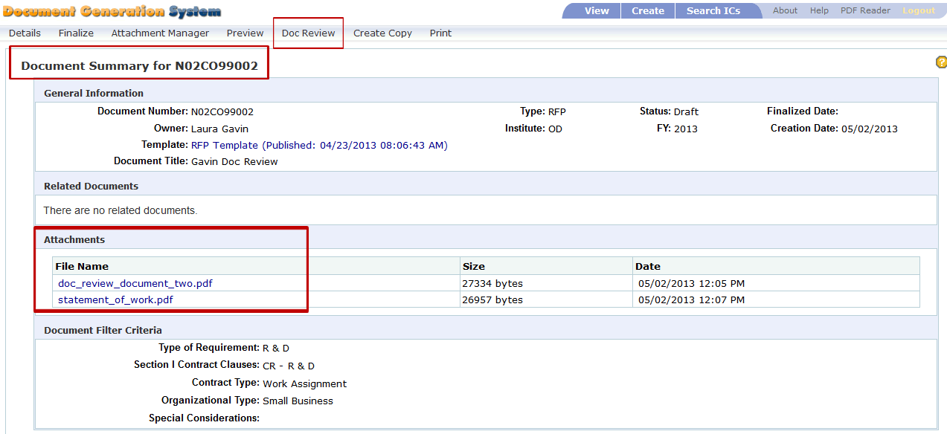
Summary Screen for Contract Documents
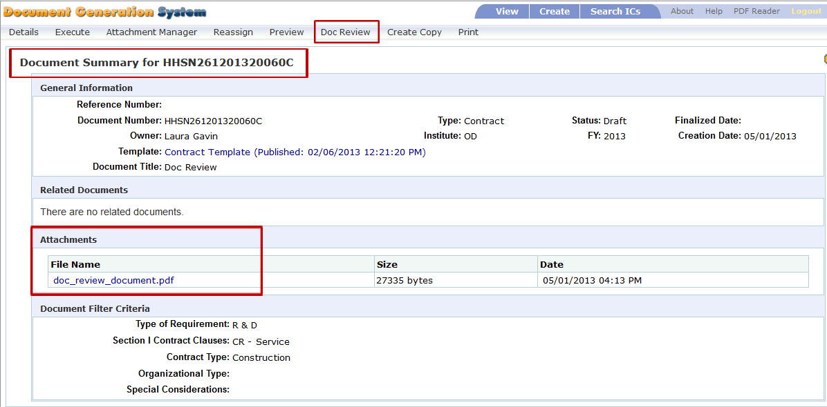
- Select Doc Review from the menu bar. The Document Review screen appears.
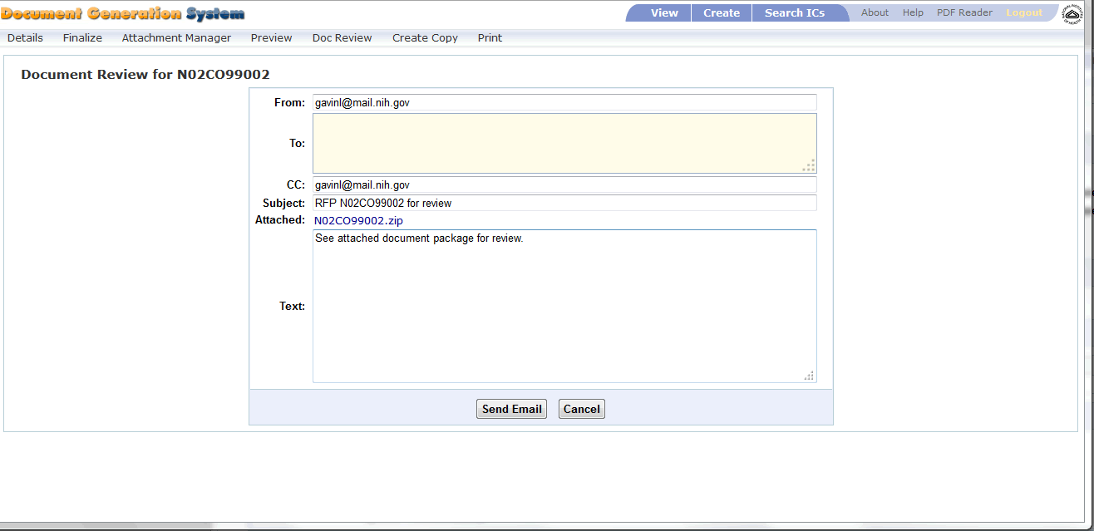
- Review data in the input fields. Modify and input needed information as follows:
  - From contains the document owner’s email address.
  - To is blank, but is a required field. You will need to input the email address(es) in which the Document Review bundle is being sent.
Separate multiple email address with a semi-colon and a space between each address. For example:
name@organization.gov; user@company.net
  - CC contains the document owner’s email address.
  - Subject contains the document type (RFP or Contract), the document number and the text “for review”. In the above image, the subject is listed as “Contract HHSN261201320060C for review.”
  - Attached provides a zipped file of the DGS document and all of the associated attachments. The file name is the document number with the zip extension.
  - Text defaults to “See attached document package for review.” You can modify this text as needed.
- Select Cancel to stop action.
- Select Send Email to generate and send document package for review. You may see this message after selecting Send Email:
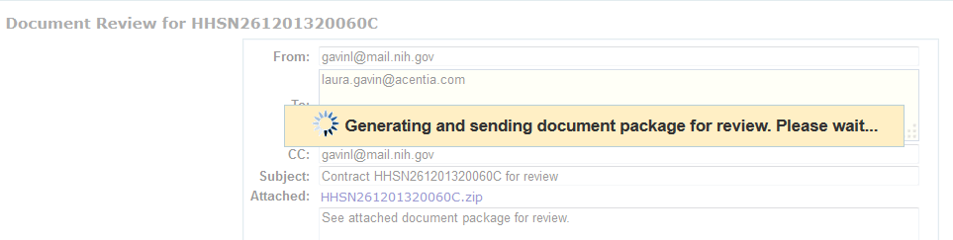
- Once the message is sent, the Document Review screen closes and a confirmation message displays on the Summary screen.
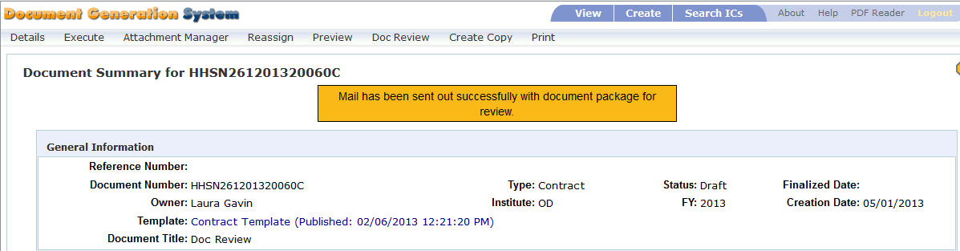
- The recipients defined in the To and CC fields receive an email with the DGS document bundle.

Create a Folder on Your Computer
- Before opening the DGS email, create a folder on your local computer to save the DGS files.
  - Open Windows Explorer.
  - Navigate to a location to create the folder.
  - Select New Folder.
  - You can label the folder any name, for example, you may want to label the folder “DGS_Doc_Review”.
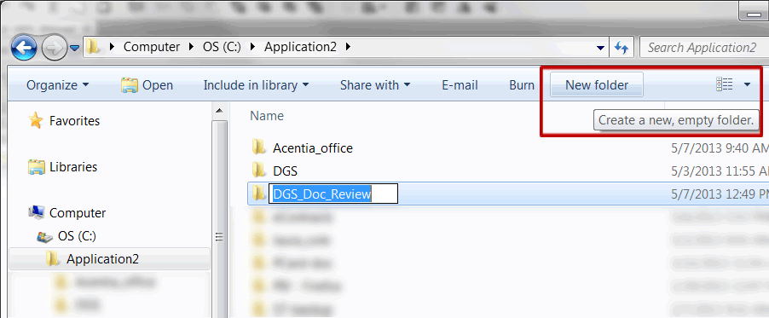
- Once the folder is created, proceed to your email inbox to review the DGS email.

Receive Document Bundle through Email
After selecting Send Email within DGS, an email is sent to each of the recipients.
- Open your mail Inbox. Locate the Document Review mail.
- The subject matches the data in DGS and, unless modified, should contain the document type (RFP or Contract), the document number and the text “for review”.
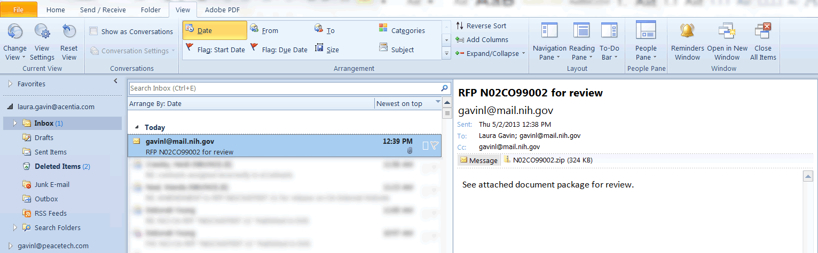
- Double-click on the attachment zip file. A message may appear asking if you want to Open or Save the file.
- Select Open.
NOTE: The zipped files must be unzipped/extracted from zip file to properly open and view the files for review.
WinZip Users
If you are using WinZip proceed with step 5. If you use a utility other than WinZip to unzip files, please proceed to step 13.
- After selecting Open, the WinZip software opens displaying the zip files.
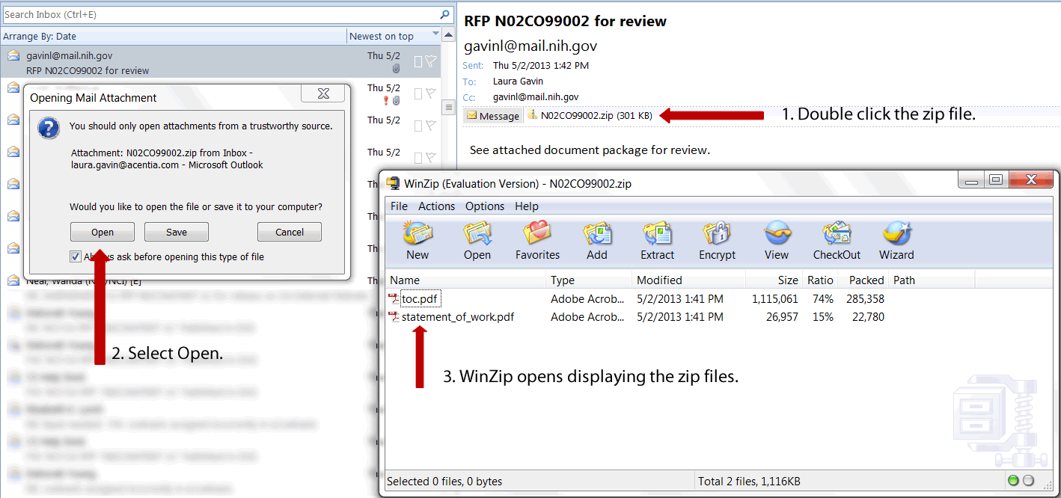
- Within WinZip, select Extract. Depending on your WinZip version, the icon may be labeled UnZip.
- The WinZip Extract screen displays.
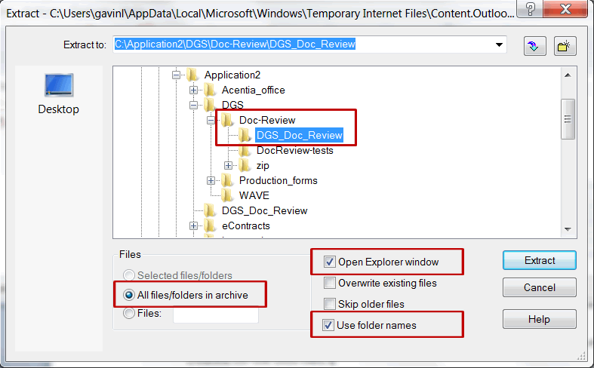
- Navigate through the folder tree and select the new folder you created for the DGS files.
  - Select the “All files/folders in archive” radio button. This will extract all the files at one time.
  - Select “Open Explorer window”. This option opens Windows Explorer immediately after the extraction is complete.
  - Verify the “Use folder names” checbox is selected by default. If not, then select this checkbox.
- Select Extract.
- The files are extracted to the selected folder and Windows Explorer opens the folder for review.
- Double click the toc.pdf to review the DGS document.
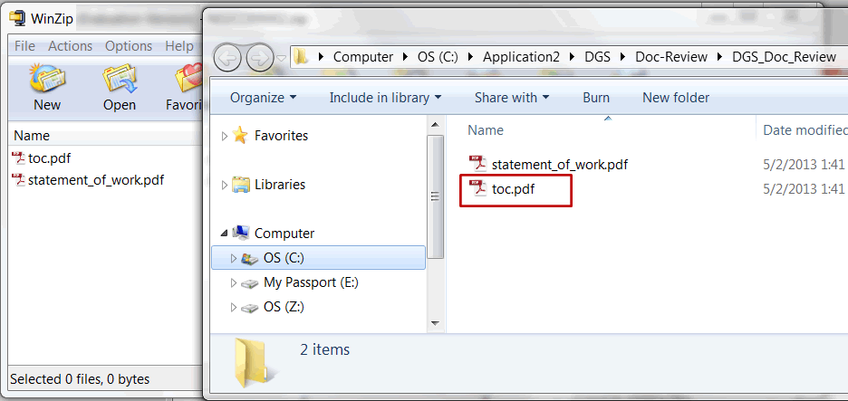
- When review is complete, close the files, Window Explorer, and the WinZip utility.

Non-WinZip Users
Perform the following steps if you are using the Windows Operating System built-in zip file support “Compressed (zipped) Folders”.
- From your email inbox, save the zip file to the newly created folder.
- Open Windows Explorer and locate the folder with the saved zip file.
- Click to select the zip file. Right click to view menu options for the zip file.
- Select Extract All. The Extract Compressed (Zipped Folders) screen appears.
- Select the folder in which you would like to save the extracted files. By default the Windows Compressed Folders adds a new folder with the file name.
- Select the checkbox for “Show extracted files when complete.”
- Select Extract.
- The extracted files in the new folder are displayed through Windows Explorer.
- When review is complete, close the files, Window Explorer, and the Compressed (zipped) Folders utility.

Review DGS Document
Once the files are successfully extracted, review the DGS document.
- Double click the file labeled toc.pdf to open the DGS document.
- After opening the toc.pdf file, the DGS document opens for review. Any attachments associated with the DGS document are also accessible for review.
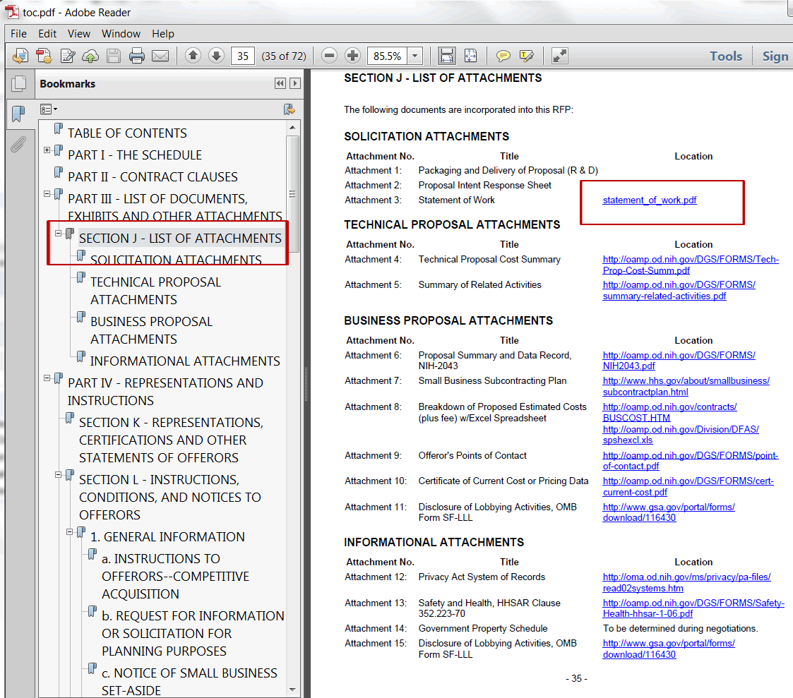

Help
If you experience any trouble unzipping the bundle or viewing the links within the toc.pdf document, please contact the DGS help team at DGSHelp@peacetech.com.

