Document Generation System (DGS)
Doc Review Zip Guide 5/6/2013

Table of Contents

1. Document Review 1
2. Receive Document Bundle through Email 1
3. Review DGS Document 4
4. Help 4

Document Review
The Document Generation System (DGS) provides a document review feature to allow users to prepare a RFP or Contract document for review outside of DGS. DGS users can bundle the DGS document and any associated files in a compressed/zip file and send to reviewers via email.

Receive Document Bundle through Email
Once the DGS user sends an email with the bundled file, you will receive an email with the subject line of RFP (or Contract) Number for review, for example, the subject may read as “RFP N02CO99002 for review”.
- After you receive the email with the bundled files, create a folder on your local computer to save the DGS files.
  - Open Windows Explorer.
  - Navigate to a location to create the folder.
  - Select New Folder.
  - You can label the folder any name, for example, you may want to label the folder “DGS_Doc_Review”.
  - Once the folder is created, proceed to your email inbox to review the DGS email.
- Open your mail Inbox. Locate the Document Review mail.
- The subject may contain the document type (RFP or Contract), the document number and the text “for review”.
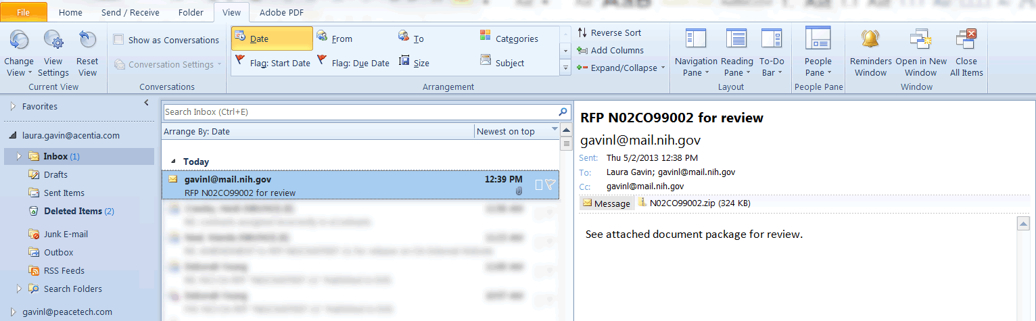
- Double-click on the attachment zip file. A message appears asking if you want to Open or Save the file.
NOTE: The zipped files must be unzipped/extracted from zip file to properly open and view the files for review.
WinZip Users
If you are using WinZip proceed with step 5. If you use a utility other than WinZip to unzip files, please proceed to step 13.
- Select Open. The WinZip software opens displaying the zip files.
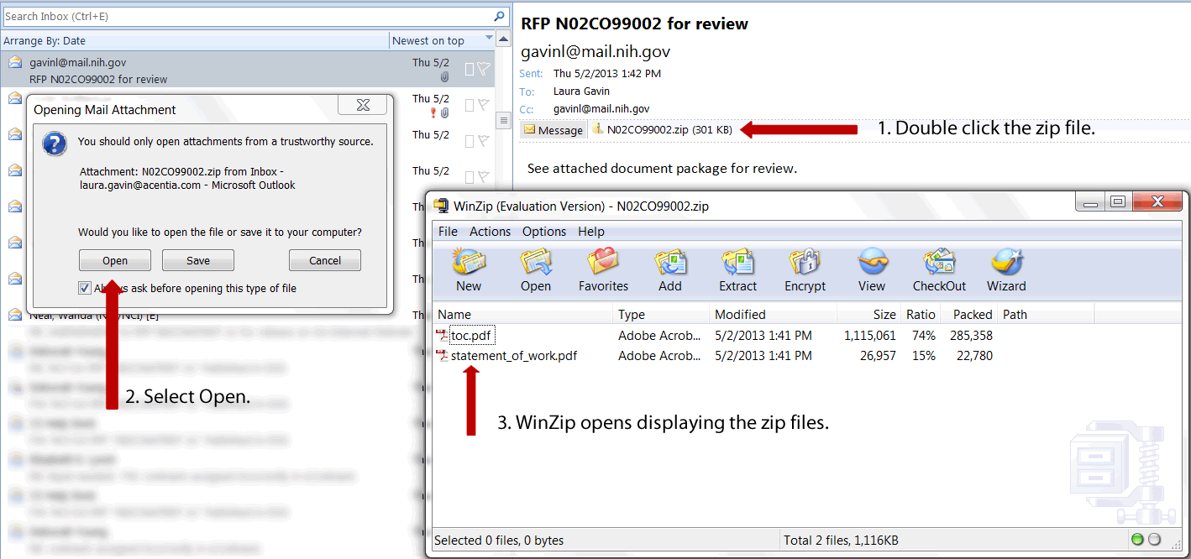
- Within WinZip, select Extract. Depending on your WinZip version, the icon may be labeled UnZip.
- The WinZip Extract screen displays.
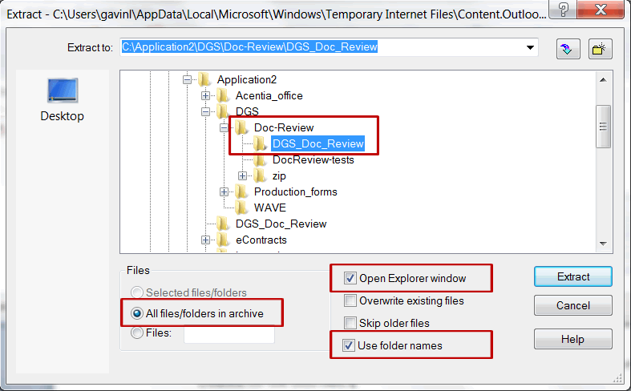
- Navigate through the folder tree and select the new folder you created for the DGS files.
  - Select the “All files/folders in archive” radio button. This will extract all the files at one time.
  - Select “Open Explorer window”. This option opens Windows Explorer immediately after the extraction is complete.
  - Verify the “Use folder names” checbox is selected by default. If not, then select this checkbox.
- Select Extract.
- The files are extracted to the selected folder and Windows Explorer opens the folder for review.
- Double click the toc.pdf to review the DGS document. Be certain you are opening the extracted toc.pdf rather than the file within the zipped folder.
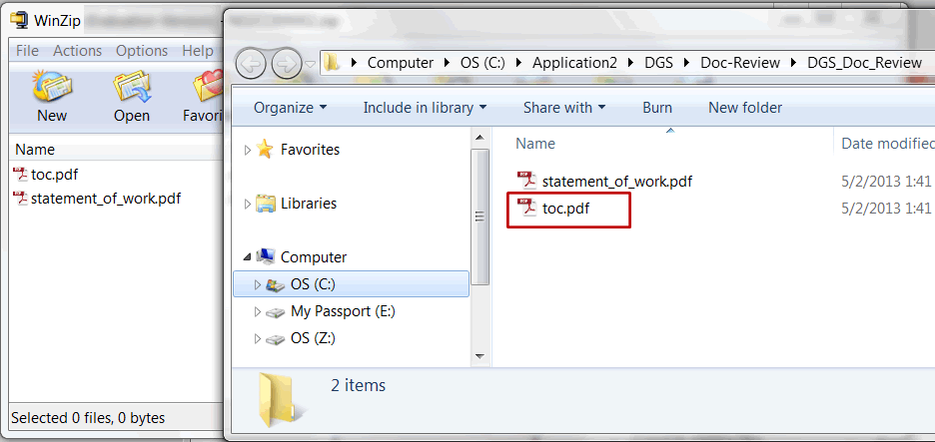
- When review is complete, close the files, Window Explorer, and the WinZip utility.
Non-WinZip Users
Perform the following steps if you are using the Windows Operating System built-in zip file support “Compressed (zipped) Folders”.
- From your email inbox, select Save to save the zip file to the newly created folder.
- Open Windows Explorer and locate the folder with the saved zip file.
- Click to select the zip file. Right click to view menu options for the zip file.
- Select Extract All. The Extract Compressed (Zipped Folders) screen appears.
- Select the folder in which you would like to save the extracted files. By default the Windows Compressed Folders adds a new folder with the file name.
- Select the checkbox for “Show extracted files when complete.”
- Select Extract.
- The extracted files in the new folder are displayed through Windows Explorer.

Review DGS Document
Once the files are successfully extracted, review the DGS document.
- From the folder created in Windows Explorer, double click the file labeled toc.pdf to open the DGS document.
- Be certain you are opening the extracted toc.pdf rather than the file within the zipped folder.
- After opening the toc.pdf file, the DGS document opens for review. Any attachments associated with the DGS document are also accessible for review.
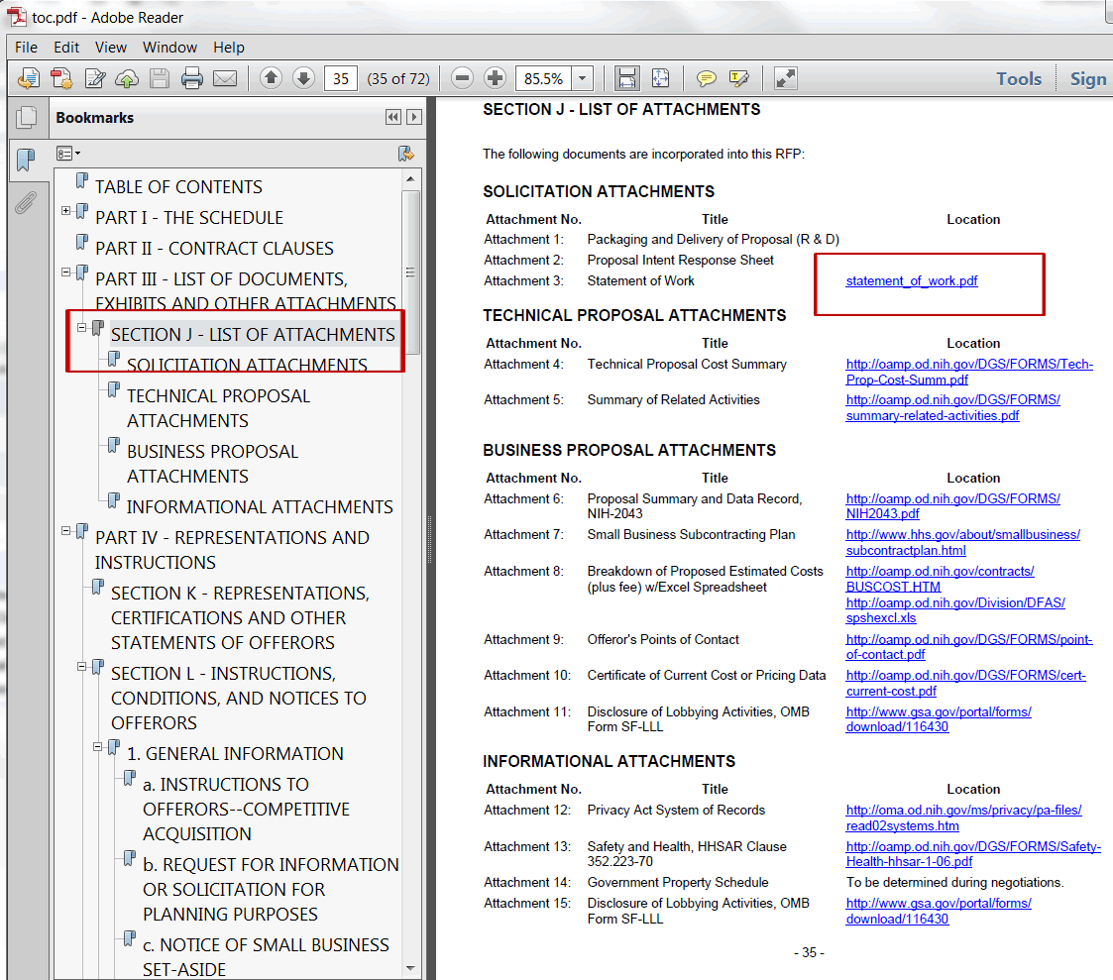

Help
If you experience any trouble unzipping the bundle or viewing the links within the toc.pdf document, please contact the DGS help team at DGSHelp@peacetech.com.

