4 Steps to Create the Invoice Submission Email
Step 1:
Send invoices to the following email address:
invoicing@nih.gov

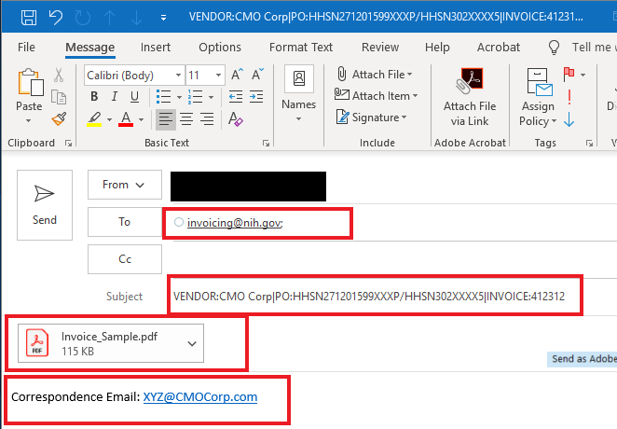
Step 3:
Attach the invoice to the email as either a PDF or Word document. See Reminders below.

Step 4:
In the body of the email, type “Correspondence Email:” followed by your email address.

Step 2:
Subject line must follow this format for the invoice you are submitting
(see note* below)

PLEASE READ THE BELOW INSTRUCTIONS THOROUGLY BEFORE SUBMITTING YOUR INVOICE ELECTRONICALLY.
*Note: The key words (Vendor, PO, and Invoice), Colon (:) character following the keywords and the PIPE (|) character must be present to identify the information. The pipe (|) character is entered by pressing and holding the shift key and the backslash (\) key at the same time. The term “PO” is being used as a generic term to identify the award number [purchase order, contract, Blanket Purchase Agreement (BPA) call, task or delivery order] and must be used in the subject line, regardless of the specific type of your award.

How to Properly Format the Subject Line of Your Email
EXAMPLE 1 – If Your Contract Includes a Contract Number AND an Order Number or Call Number:
Vendor: Name of the Contractor or Vendor|PO:Contract Number/Order Number or Call Number|Invoice:9999999
EXAMPLE 2 – If Your Contract ONLY Includes a Contract Number:
Vendor: Name of the Contractor or Vendor|PO:Contract Number|Invoice:9999999
EXAMPLE 3 – If Your Contract ONLY Includes an Order Number:
Vendor: Name of the Contract or Vendor|Order Number|Invoice:99999999

Screenshot of How to Locate the Contract Number and Order Number on Your SF 1449 (SOLICITATION/CONTRACT/ORDER FOR COMMERCIAL ITEMS Form)
The screenshot below shows where the Contract Number and Order Number are located on the SF 1449. The SF 1449 is provided to you by the NIH Contracting Officer upon awarding the contract. Please use the information on your SF 1449 to populate the correct Contract Number and Order Number in the subject line of your email invoice submission.
The Contract Number is required in order to process all invoices. The Contract Number is the same as the “PO” on the invoice email subject line. The Order Number is only applicable for certain contracts and can be found in field number 4, on the SF 1449 form. If your SF 1449 does not include an Order Number, then follow EXAMPLE 2 above to ensure the Subject line of your email is properly formatted.

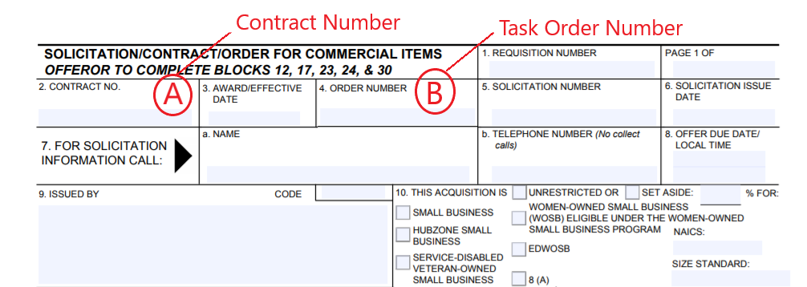

Screenshot of How to Locate the Contract Number on Your SF 1447 (SOLICITATION/CONTRACT Form)
The screenshot below shows where the Contract Number is located on the SF 1447. The SF 1447 is provided to you by the NIH Contracting Officer upon awarding the contract. Please use the information on your SF 1447 to populate the correct Contract Number in the subject line of your email invoice submission.
The Contract Number is required in order to process all invoices. The Contract Number is the same as the “PO” on the invoice email subject line.
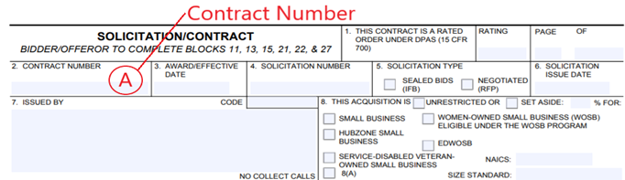
Screenshot of How to Locate the Contract Number and Release Number on Your OF 347 (ORDER FOR SUPPLIES OR SERVICES Form)
The screenshot below shows where the Contract Number and Order Number are located on the OF 347. The OF 347 is provided to you by the NIH Contracting Officer upon awarding the contract. Please use the information on your OF 347 to populate the correct Contract Number (if any) and Order Number in the subject line of your email invoice submission.
The Order Number is required in order to process all invoices. If there is no Contract Number, the Order number is the same as the “PO” on the invoice email subject line. The Contract Number is only applicable for certain contracts and can be found in field number 2, Contract Number, on the OF 347 form. If your OF 347 does not include a Contract Number, then follow EXAMPLE 3 on page 2 to ensure the Subject line of your email is properly formatted.

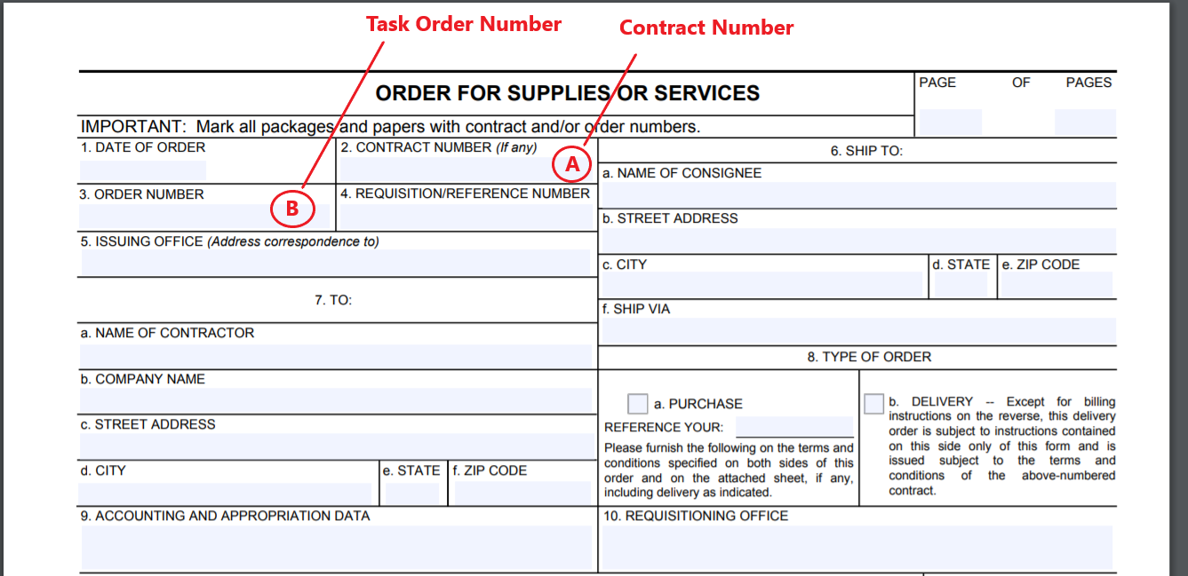
Subject Line | Correct | Incorrect
Vendor: XYZ Corp|PO:HHSN299202000053J/75X98019S00848|Invoice:XYASAD
XYZ Corp|PO # HHSN299202000053J \75X98019S00848|Invoice # XYASAD
XYZ Corp| HHSN299202000053J \75X98019S00848|Invoice # XYASAD
XYZ Corp| HHSN299202000053J \75X98019S00848| XYASAD
Vendor: XYZ Corp,PO: HHSN299202000053J \75X98019S00848,Invoice:XYASAD
Vendor: XYZ Corp|PO:HHSN299202000053J|Invoice:XYASAD
Vendor: XYZ Corp|PO:HHSN311201600011U|Invoice:XYASAD
Subject Line Examples
For your reference, below is a chart listing examples of the correct and incorrect subject lines. Note: These are just examples, you must enter the applicable information for the invoice you are submitting.

Reminders
- Effective December 1, 2020, OFM will no longer accept hard copy vendor invoices sent to the OFM billing office via any shipping services (i.e., USPS, FedEx, UPS, DHL, etc.) or those delivered by any in-person drop off. OFM will not accept any invoices postmarked and/or delivered in-person on/after December 1, 2020. Please follow the electronic submission instructions on page 1. Failure to follow the above electronic submission instructions will result in invoice processing delays.
- Only invoices should be sent to the following mailbox: invoicing@nih.gov. Please do not send emails to this mailbox requesting a status of your invoice(s) and do not include the invoicing@nih.gov email address in your correspondence with NIH Institutes/Centers.
- You must submit only one invoice per email.
- Follow the system size limits that apply to the email and each invoice: individual email attachments cannot exceed 5 megabytes each; and the email plus all attachments cannot exceed a total of 30 megabytes.
- Clearly identify a valid and complete contract number on each invoice.
- Clearly identify an accurate DUNS number on each invoice.
- DO NOT include confidential information such as Social Security Numbers (do not include TIN if it is a Social Security Number).
The invoice attached to the email must be in a PDF or Word format. The date/time that a valid invoice is submitted electronically to the email box (invoicing@nih.gov) will be the same date/time logged as the invoice is received by NIH.

Questions?
Please direct inquiries regarding the status of invoices such as receipt of invoices, due date, or payment of invoices to the OFM Commercial Accounts Branch, Customer Service Office. The OFM Customer Service contact information and of methods to contact are available at the following OFM website https://ofm.od.nih.gov/Pages/Customer-Service.aspx and below.
The Customer Service Office is open Monday – Friday from 8:30 am to 5:00 pm (Eastern Standard Time) and is closed daily between 12:00 pm to 1:00 pm (Eastern Standard Time). The Customer Service Office phone number is 301-496-6088.
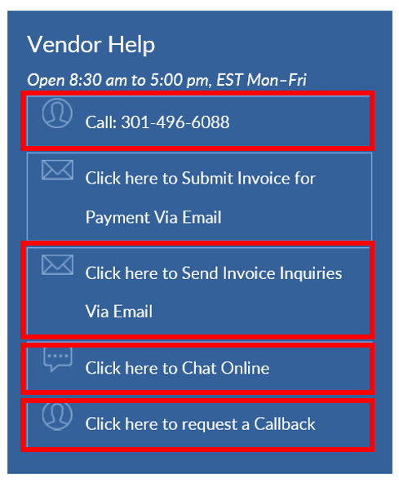
Instructions for Contractor/Vendor Courtesy Copy Electronic Invoice Submission to the Contracting Officer (CO):
The Contractor/Vendor shall send a cc: copy to the NIH Contracting Officer and the NIH Contracting Officer’s Representative (COR) stated in the award and the NIH Program point of contact when submitting the invoice to NIH/OFM for payment.

