New and Enhanced PRISM Document Creation Functionality to Succeed DGS in December 2023

After an extensive analysis of alternatives (AOA) for the succession of NIH’s Document Generation System (DGS) system, it has been decided that OALM’s most viable option is to fully implement the Clause Logic functionality in NBS PRISM. Using NBS PRISM to create complete, compliant documents for solicitations, contracts, and amendments will let users take advantage of integrated, enterprise-wide solutions.
In NBS PRISM, staff will select the appropriate clause template(s) to build their documents. Once the documents are created, PRISM provides a new set of tools that will help users complete, review, validate, route, and approve their documents. The PRISM Clause Logic module will automatically recommend clauses based on the information provided in the solicitation or contract and will check completed documents for accuracy.
In December 2023 the new document generation features in PRISM will be activated, extending PRISM to provide enhanced solicitation & contract creation functionality. NIH Business System (NBS), the Office of Acquisition and Logistic Management (OALM), and OALM’s Office of Acquisition Management and Policy (OAMP) will be working in collaboration to prepare the DGS user community for a smooth transition.
OALM will continue to share its transition progress throughout the year, and we look forward to providing you with the enhanced document creation functionality in PRISM. Please be on the lookout for updates and opportunities to be involved in helping us bring forward this new functionality for the Acquisition Community.
OALM will also continue to communicate with the NIH community to keep others informed, raise awareness, educate, and provide training for a smooth & successful transition.
If you have any questions, please feel free to reach out to Veenu Varma, the Acquisition Document Generation System lead, at veenu.varma@nih.gov.

Do Not Grant CPARS Access to NIH Contractors

A government employee must perform the user role of Focal Point, Alternate Focal Point, Assessing Official Rep, Assessing Official, and Reviewing Official.
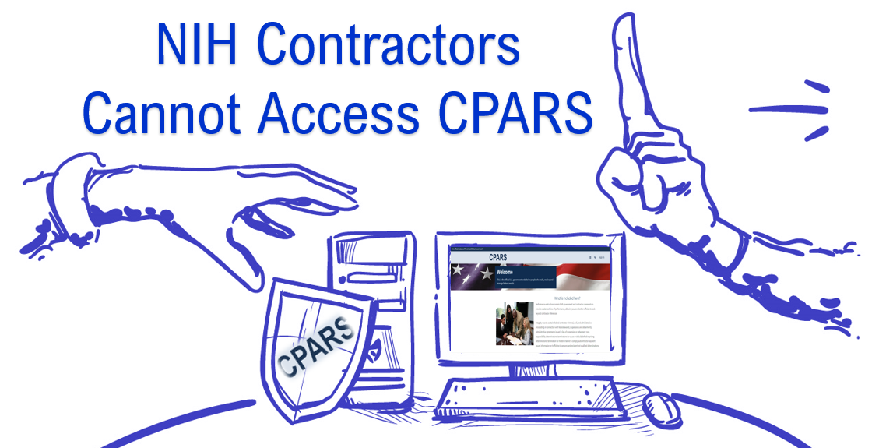

Please be mindful that whenever you assign a user role designated for a government employee in CPARS, a notice will appear –
‘I certify that the user to whom I am authorizing access is a government employee.’
Conversely, a government employee cannot fill the Contractor Rep (CR / Vendor) role.
Ensure system access does not result in a conflict of interest or the appearance of a conflict of interest. A government employee is not assigned/authorized to sign an Evaluation on behalf of the Contractor who is the subject of the Evaluation.
Source: CPARS Guidance - https://www.cpars.gov/help.htm

NIH Supply Center Product Catalog Additions:

Refrigerators and Freezers:
The NIH Supply Center is beginning to add products from the recently dissolved DSEIS Program! Below, you will find all items added so far. Please visit our website often, as we are adding to the Product Catalog every week. You may also subscribe to our email list, NIHSC-OUTREACH@LIST.NIH.GOV, through https://list.nih.gov/ to get the latest information and updates on all of our products and events.

Stock Number | Product | Price
411006S013050 | PHCbi MDFU731MPA -30 Upright Freezer (Manual Defrost) | $6,165.17
411007S013050 | PHCbi MDFU731PA -30 Upright Freezer (Automatic Defrost) | $6,165.17
411016S013050 | PHCbi MDFDU702VHPA -86 Freezer (220v) | $12,669.96
411017S013050 | PHCbi MDFDU502VHPA -86 Freezer (220v) | $11,180.79
411020S013050 | PHCbi MDFDU502VHAPA -86 Freezer (115v) | $11,180.79
411021S013050 | PHCbi MDFDU702VHAPA -86 Freezer (115v) | $12,669.96
411008S013010 | PHCbi MC0170AICUVLG-PA C02 Incubator | $5,383.50
411004S013010 | PHCbi MCO-170AICUVDL High Heat Decon co2 Incubator, 5.8 cu.ft. | $6,640.93
411025S013050 | PHCbi MDF-DU 901 VHA-PA upright -86 Freezer, 29.8 cu ft. | $15,155.60
411042S013050 | PHCbi MPR-722-PA Single Door Refrigerator 24.2 cu ft | $5,084.06
411028S013050 | PHCbi MDF-MU539HL-PA -30 Upright Freezer Manual defrost W X D X H Exterior 31.2 x 30.3 x 70.9, Interior 25.6 x 24 2 x 49.7, Bins not included | $5,194.00
411024S013050 | Thermo Fisher Scientific TSX50086A -86 Freezer (115V) | $11,920
411022S013050 | Thermo Fisher Scientific TSX2330FA -30 (-35°C to -15°C) Automatic Defrost Upright Freezer (115v) ENERGY STAR® certified | $6,271
411023S013050 | Thermo Fisher Scientific TSX2320FA -20 (-25°C to -15°C) Manual Defrost Upright Freezer (115v) ENERGY STAR® certified | $5,918
411051S013050 | Thermo Scientific TSX2305SA High-Performance Solid door Refrigerator. 23 cu ft, Single Solid door. | $4,941
411045S013050 | Thermo Fisher TSX40086A ULT FZ Freezer 115V/60hz, Ext. 37.6x28.3x 78in. 19.4 cu. Ft. Manual Defrost | $11,090
669501S122010 | Eppendorf 5425 Micro Centrifuge – w/24 place rotor | $2,449.33
669507S122010 | Eppendorf 5425R Refrigerated Micro Centrifuge w/24 place rotor | $5,912
669500S122010 | Eppendorf 5810 Non-Refrigerated Centrifuge tissue culture | $8,259.78
669512S122010 | Eppendorf 5810 R Refrigerated centrifuge tissue culture | $11,241.78
411010S013010 | Eppendorf C170 CO2 Incubator 120v CellXpert, Item# 6734010015 | $7,516.44
411030S013050 | Eppendorf CryoCube F740hi 5DL | $15,093.89
668500N235818 | UNDERCOUNTER ULT FREEZER 3.7CF SU105UE | $9,238.96
668500N239420 | Innova U101, 101 L, ULT freezer, with LED interface,  classic cooling liquids, and air-cooling, 2 shelves, 115  V/60 Hz. | $10,326.53
668500N239423 | THERMOSCI 5CF FRZR 120/60 | $1,591.74
668500N239428 | 5 CF VALUE REF. 115V/60HZ | $2,040.35
668500N239424 | 5 CF VALUE FMS REF. 115V/60H | $3,606.34
668500N239427 | ISOTEMP 5CF VALUE FRZR 120/60 | $905.54
668500N232425 | 5 CF ISOTEMP REF 115V/60HZ | $868.59
668500N239426 | 5 CF ISOTEMP FMS REF. 115V/60H | $1,910.91
668500N239421 | Futura Silver Series PRIME 4.6 Cu. Ft. Built-In Undercounter  Solid Door Refrigerator | $1,750.50
668500N239422 | PHCbi PR Series 5.0 Cu. Ft. Solid Door Undercounter Medical Refrigerator | $1,656.92

We thank you for always supporting the NIH Supply Center, and for keeping us updated on the items you need! We are excited for this new endeavor and look forward to serving you. Thank you and remember, we are OneNIH!

Take the Guesswork out of Fair Opportunity with NITAAC

According to Bloomberg, information technology (IT) continues to be a large source of federal market growth, accounting for more than $76.4 billion dollars. Most of these dollars are typically spent through commodities, solutions, and services purchased from a myriad of companies operating within the United States. But, with so many vendors competing for federal dollars, how can government agencies ensure fair opportunity in government contracting? Before we answer this question, let’s first examine what fair opportunity is and why it is important.

What is fair opportunity?

The concept of fair opportunity is mandated by Federal Acquisition Regulation (FAR) 16.505(b). It is intended to level the playing field so that agencies cannot give an unfair advantage to one contractor over another. Fair opportunity is a mandatory requirement and is applicable to all federal agencies purchasing IT products and services when using a multiple-award contract. According to the (FAR) 16.505(b), fair opportunity must be exercised when a purchase exceeds the $10,000 micro-purchase threshold. When this happens, an agency must give every company that holds that contract an equal opportunity to respond to a request for proposal (RFP).

Why is fair opportunity important?

Encouraging competition has a myriad of benefits. Competitive contracting often results in lower overall costs for the government as contractors are more likely to submit more competitive bids to win the business. This results in lower direct public service costs and reduced internal costs. Additionally, competition opens the door for everyone to participate in contracting. According to a recent survey by Zippia, 70.6 percent of most government contractors are white. In 2021, only two percent of federal contracts were awarded to minority-owned firms. Although fair opportunity does not guarantee equity, it does ensure that every qualified offeror receives consideration. In fact, last year, the Biden administration set a goal of increasing the share of federal contracts going to small, disadvantaged businesses to 15 percent by 2023, a 50 percent increase from recent spending levels. This lofty goal has left many agencies wondering how they can achieve this goal. NITAAC can help.

Ensuring fair opportunity in federal contracting

Let’s face it. Most agencies do not have the time or manpower to sort through multiple contracts to ensure every eligible offeror is included. As a result, the federal government still struggles with ensuring parity in contracting. According to a January 2023 FedScoop article, the world’s largest software companies, received at least 25% to 30% of government sales over the last 10 years through less than fully competitive procurement processes. NITAAC has the solution for this problem. NITAAC has designed an electronic Government Ordering System (e-GOS) to ensure that fair opportunity is carried out correctly on every order. This web-based, secure system is fast and easy to use—allowing contracting professionals to walk through the entire solicitation process seamlessly. NITAAC’s commitment to fair opportunity does not stop there.

Leveling the playing field

NITAAC is committed to leveling the playing field for all contractors. In FY22, seven of the top ten performing CIO-SP3 Small Business contract holders were Service-Disabled Veteran-Owned Small Businesses (SDVOSB), 8(a) or Historically Underutilized Business Zones (HUBZone). NITAAC boasts one of the highest numbers of socioeconomic categories compared to most other GWACs. Agencies can award opportunities in a number of categories, including:
- 8(a) – 131
- Historically Underutilized Business Zone (HUBZone) - 22
- Service-Disabled Veteran-Owned Small Business (SDVOSB) - 53
- Small Business (SB) - 311
- Women-Owned Small Business (WOSB) – 21

Agencies looking to get fair opportunity done right, need to look no further than NITAAC. The three NITAAC GWACs, CIO-SP3, CIO-SP3 Small Business and CIO-CS are multiple award IDIQ contracts for IT that can be used by any federal agency. Our Electronic Government Ordering System (e-GOS) takes the guess work out of fair opportunity and ensures that fair opportunity is carried out correctly on every order. Be sure to click the “Yes I am an NIH Employee” prompt when you register, or if you have clients at other agencies, they should click the “not an NIH employee” prompt.
To learn more, visit https://nitaac.nih.gov/resources/e-gos.

CIO-SP4 - Slow and Steady Wins the Race

I am sure you are all familiar with the story of the tortoise and the hare. As the fable goes, the tortoise and hare were in a race. Considering himself a shoo-in for the win, the hare approached the race at full speed and, when he found himself well ahead of the tortoise, stopped to take a nap. Meanwhile, the tortoise kept running slowly, but steadily, until he passed right by the hare and, ultimately, won! The moral of this fable is simple: slow and steady wins the race. In the case of acquisitions, there is no truer statement.

The journey of bringing the Chief Information Officer-Solutions and Partners 4 (CIO-SP4) Government-Wide Acquisition Contract (GWAC) to market has admittedly been a long one, filled with all the expected growing pains of federal acquisitions. However, despite the growing pains, we are proud to say that NITAAC has held steady.

We have responded to customer and industry feedback, pivoted, revised when necessary, and, more importantly, kept forging ahead with one goal in mind – to bring to market what we believe will be an unsurpassed contracting vehicle – the $50 Billion CIO-SP4.

CIO-SP4 holds significant promise for federal agencies who want to access emerging information technology (IT) quickly, efficiently, and affordably — such as blockchain, cybersecurity, agile software development and “as-a-service” solutions. An added benefit is that it will reduce the administrative burden on competitive processes behind the GWAC, which is something we think industry and government alike, can all find value in.

We want to make sure CIO-SP4 is available for you without a break in service. With that in mind, the CIO-SP3 and CIO-SP3 Small Business vehicles have been extended through October 29, 2023. This six-month extension ensures there is no gap in contractual coverage between CIO-SP3 and CIO-SP4 and pushes the five-year performance period of CIO-SP3 Task Orders well into FY 2029, giving agencies plenty of runway to place their acquisitions through the remainder of the fiscal year, and get all the benefits and value-adds of FAR 16 flexibilities.

The extension also provides an ideal opportunity for you to submit any assisted acquisition packages. The deadline for submitting packages is July 15th for introductory discussions and August 1st for intake forms. NITAAC Assisted Acquisitions has expert IT Contracting Officers and Subject Matter Experts to help you award and administer your task and delivery orders. All our Contracting Officers are FAC-C, Level III, and already have their mandatory Digital Services (DS) certifications, now required for purchases above the FAR Subpart 13.500(c) commercial items threshold, which consist mostly of Digital Services.

We have not yet finished the race, but the finish line is near. In the coming weeks, we will begin issuing final notifications of apparent successful offerors for CIO-SP4 and start paving the way for the official kickoff. When it finally arrives, we are confident CIO-SP4 will be the easiest, fastest and most affordable way to get IT done in the federal government.

Thank you for your patience. The best is yet to come.

Earn Your CLPs with NITAAC Before the Year-End

Now that the busy fourth quarter is upon us, it is prudent to ensure you’ve met your CLP obligations to maintain your credentials. As a reminder, to keep a FAC-C or FAC-PPM, federal employees must earn 80 CLPs every two years. To maintain a FAC-COR, federal employees must earn 40 CLPs every two years. Level 1 CORs are the exception and only require eight CLPs every two years.

If you need to earn CLPs, NITAAC has the perfect solution. We conduct free monthly training sessions for all federal employees on how to procure IT products, services and customizable solutions using the CIO-SP3, CIO-SP3 Small Business and CIO-CS Government-Wide Acquisition Contracts (GWACs). The NITAAC training offers a nuts-and-bolts understanding of GWACs and the importance of FAR Part 16.505 in streamlining ordering procedures.

What’s more, participants earn two CLPs which can be applied towards any certification. To learn more about upcoming trainings, visit the NITAAC Trainings webpage on our website. Interested but can’t make it during any of the times listed? Email NITAACsupport@nih.gov or call us at 1.888.773.6542 to schedule a free training session.

Accessible PowerPoint Quick Tips

How to resolve issues found in the Accessibility Inspection Results.

Run the Microsoft Accessibility Checker
Click Review, and Check Accessibility. | 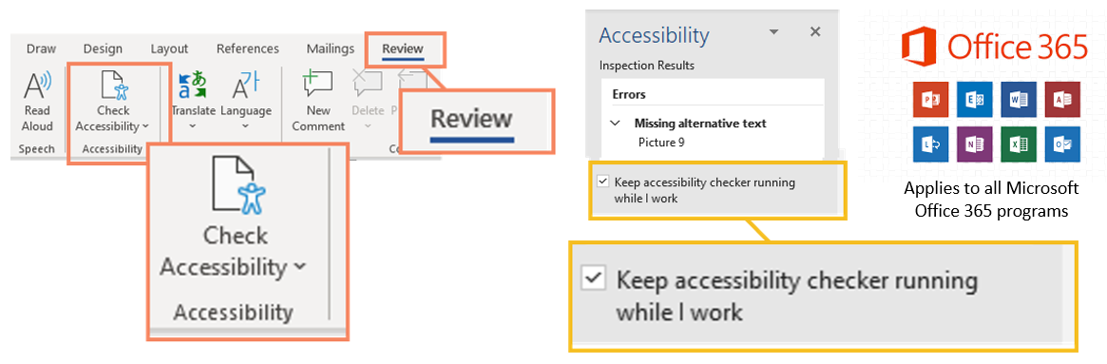

The process remains the same for each accessibility issue regardless of the program (i.e., MS Word). In the Accessibility Inspection Results panel, click on the caret (>) next to the appropriate accessibility issue to expand the selection. For example, Missing alternate text.
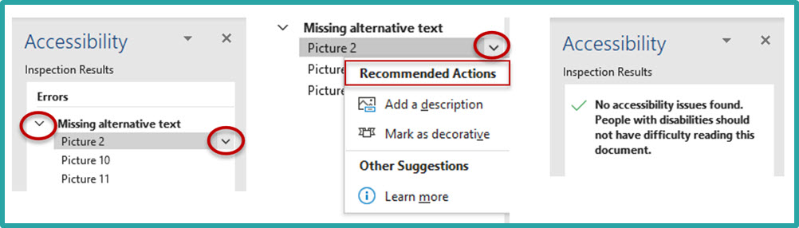
Next, click on the drop-down next to the first accessibility issue. This will take you to the slide that contains the errored element. Select the appropriate Recommended Action.
Please Note: Corrected actions are removed from the Accessibility Inspection Results. Once the document meets the Microsoft Accessibility Checker requirements, the Accessibility Inspection Results will display "No accessibility issues found. People with disabilities should not have difficulty reading this document."
Check Reading Order (Logical Reading Order)  People who cannot view the slide will hear the information contained in the placeholders read back to them in a specific order. Screen readers might read the text in an unexpected order.  - Click the caret (>) next to Check Reading Order,  - Click the down arrow next to the first action and click Verify Object Order.  - Within the Reading Order pane, click on a placeholder element.  - Next, use the up/down arrows to move the placeholder to its logical reading order | Example -Verify Order (Check Reading Order)  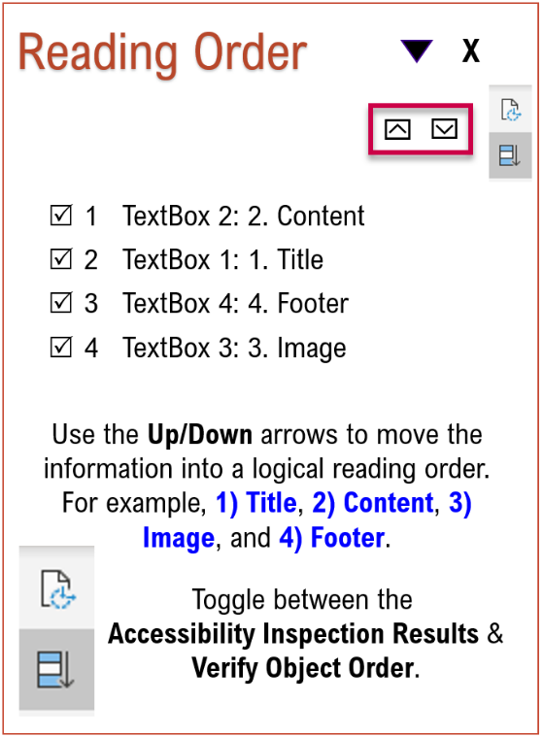
Default Section Name  Section names enable users to navigate more easily within a large presentation in the Thumbnail Pane, Slide Sorter View, and Grid View.  - Click the caret (>) next to the error message Default section name.  - Click on the down arrow next to the first action.  - Click Rename section.  - Enter the appropriate section name.  - Click Rename.  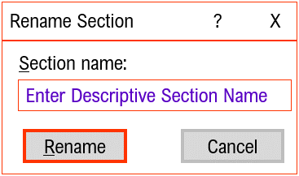 | Duplicate Section Name  Section names must be unique and should describe the contents of the section.  - Click the caret (>) next to the error message Duplicate section name.  - Click on the down arrow next to the first action.  - Click Rename section.  - Enter the appropriate section name.  - Click Rename.
Duplicate Slide Title  Slide Titles must display a unique name.  - Click the caret (>) next to the Duplicate slide title error message.  - Click on the first action and select the appropriate response next.  - Click Edit Slide Title.  - In the Title placeholder - enter the appropriate change. | Missing Slide Title – Set as Slide Title  Do not use Text Boxes within the slide layout.  - Click on the caret (>) next to the error message Missing slide title.  - Click on the down arrow next to the first action.  - Within the slide, click the text box that contains the “Slide Title”  - In the Accessibility Inspection Results and select Set as Slide Title.
Missing Slide Title – Add Slide Title  - Click on the caret (>) next to the error message Missing slide title.  - Click on the down arrow next to the first action. This will take you to the slide that contains the errored element.  - In the Accessibility Inspection Results and select Set as Slide Title.  - Type a unique descriptive Slide Title in the Title placeholder. | Missing Slide Title – Hidden Title  If you do not want the title to appear on the slide.  - Click on the caret (>) next to the error message Missing slide title.  - Click on the down arrow next to the first action.  - Next, select Add Hidden Slide Title –  - The Title placeholder will appear above the slide. In the Title placeholder, type a unique descriptive title.

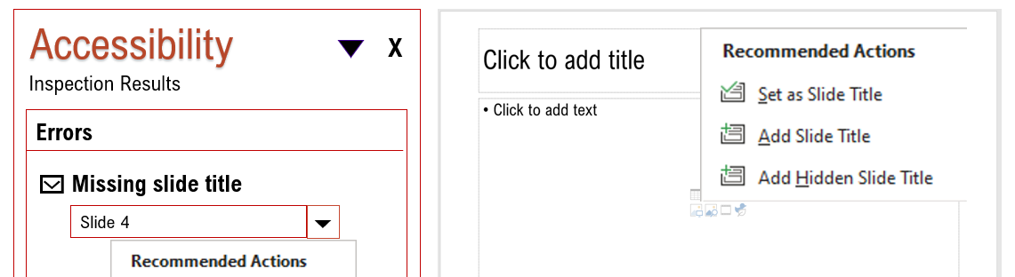
No Header Row (Tables)  - Click the caret (>) next to the error message No header row.  - Click the down arrow next to the first action.  - Click Use first row as header. | Missing or Suggested Alternative Text  - Click the caret (>) next to Missing Alternative Text’s error message.  - Click on the down arrow next to the first action.  - Click Add a Description or Mark as decorative, whichever is appropriate.
Missing Alt Text (Audio / Video)  Once you upload the transcript to the video, you can satisfy the Missing Alt Text error by stating – “Closed Captions Included for video (Title).”  - Click the caret (>) next to Missing Alternative Text’s error message.  - Click on the down arrow next to the first action.  - Click Add a Description. | Hard-to-Read Text Contrast (Colors)  - Click the caret (>) next to the Hard-to-read text contrast error message.  - Select a different color or modify a table style for the appropriate response.  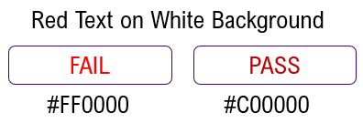
Use Closed Captioning for Audio and Video  Whenever you insert multi-media into Microsoft Office, it triggers two (2) accessibility issues – 1) Use Captions for audio and video and 2) Missing alternative text.  - Click the caret (>) next to the error message Use captions for audio and video.  - Click on the down arrow next to the first action.  - Click Insert Captions, and the file explorer menu box will open, select the applicable [.vtt] file, and click OK. | Merged Cells (Tables)  - Click the caret (>) next to the error message Table has merged or split cells.  - Click the first action. This will take you to the slide that contains the table (for example, Slide 1).  - Next, highlight the merged cells within the table.  - On the Main Menu, click the Layout tab and Split Cells.  - When the split cells dialogue box appears, select the appropriate number of columns/rows to unmerge the cells.  - Click OK.

Tips for Reducing or Eliminating PowerPoint’s Check Reading Order Accessibility Issue
The Check Reading Order refers to the logical reading order of the data elements on a specific slide. Multiple objects, lines, and connectors can trigger the Check Reading Order accessibility error. Flattening the content into a single image reduces or eliminates the Check Reading Order error.  Before you begin -Create a separate file for the original content in case changes are needed.  Flatten Images – Content with multiple lines and connectors; use third-party software such as Snagit (https://www.techsmith.com/screen-capture.html) to flatten the content.  Apply the alternative text to the single image.  Ensure the content meets the Color Contrast requirements.  - Do not flatten Bar, Line, Column, or Pie charts.  - Do not flatten interactive information, such as tables or dashboards. | 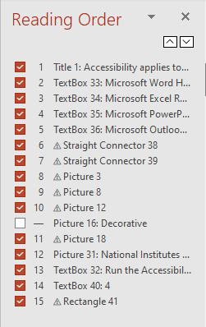
Flatten the content, then perform one of the following steps -
- Flatten the image, then apply the alternative text to the single image. Right-mouse, click on the content, and click Edit Alt Text. Enter the appropriate alt text. The Alt Text box holds 255 characters.
- Flatten the image, then place the alternative text behind the image in the slide layout (Title / Content placeholders). Then mark the non-textual content as decorative.
- Flatten the image, then add a link to an accessible version. To satisfy the missing alt text error, in the alt text box, “Click on the image for an accessible version.”

How to Flatten Content

Step 1: Save As
Best Practice – Save the original document under a different file name in case updates are needed.
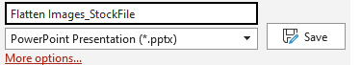

Step 2: Flatten the Content
Flatten Images – Use Snagit (https://www.techsmith.com/screen-capture.html) to capture content.
Use your best judgment when flattening content. Flatten the entire slide or specific content on the slide.
In the illustration below, the blue border surrounds the captured elements.
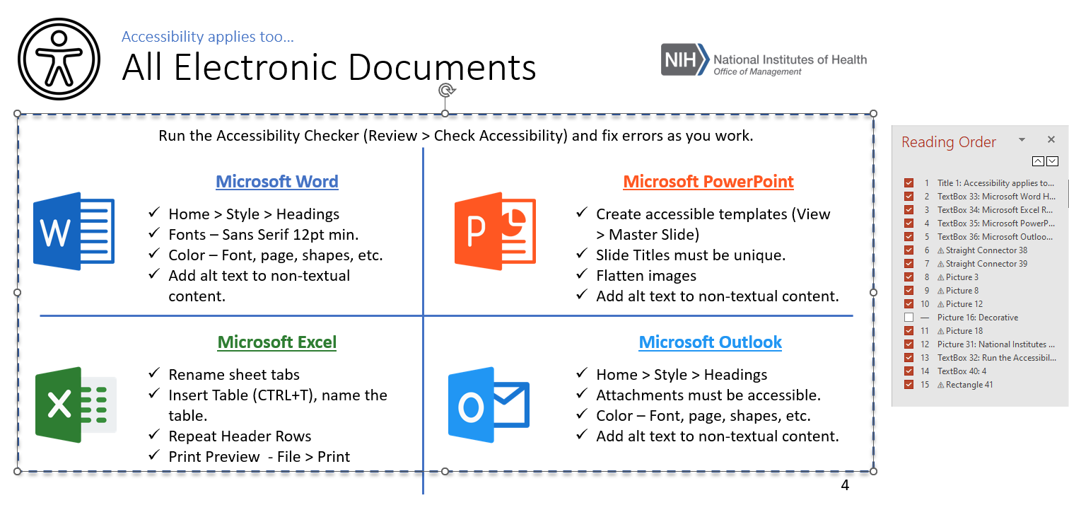

Step 3: Insert Slide Layout

Home > New Slide > Title and Content
In the title placeholder enter a unique descriptive title. In the content placeholder enter the alt text.
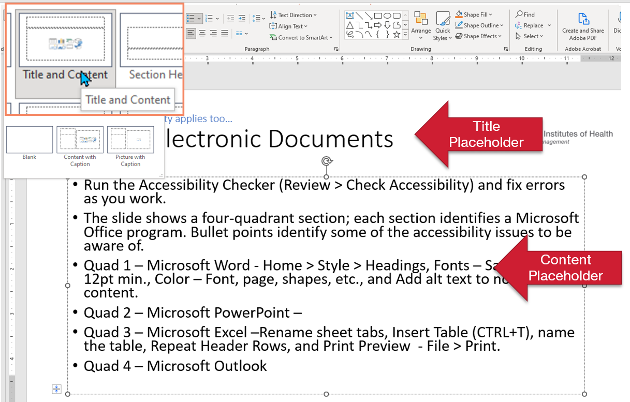
If the alt text will not fit in the content placeholder, add a link to an accessible version.
To satisfy, the missing alt text error - in the alt text box, enter “Click on the image for an accessible version.”

Step 4: Paste Image
Paste the image over the content on the slide. Then mark it as decorative to avoid redundant information.
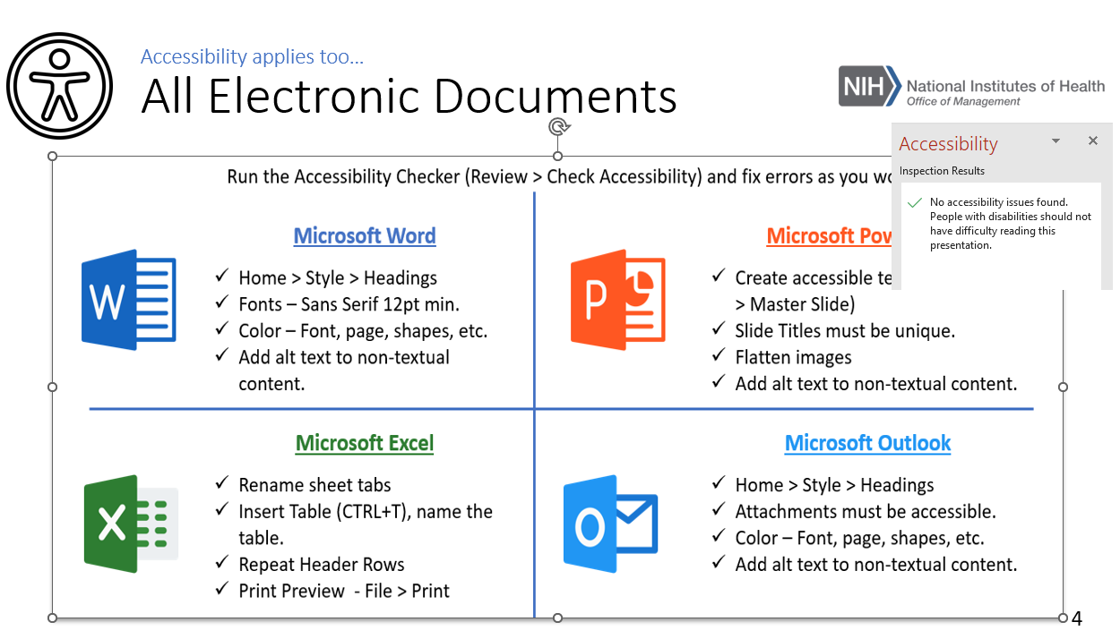
Repeat this process until all accessibility issues are addressed.
The benefits are having a visually appealing document while ensuring everyone can access the information presented.

Microsoft PowerPoint for Beginners – (video) - https://www.youtube.com/watch?v=KqgyvGxISxk&t=283s
The key to an accessible document is using the software as intended.

Accessibility Tools
Alternate Text - To learn how to describe non-textual content (i.e., images, charts, etc.), check out the POET Training Tool - https://poet.diagramcenter.org/how.html.
-To learn how to access the alt text box (i.e., SharePoint, Outlook, etc.), check out “Alternative (Alt) Text for Non-Text Content.’
Color Contrast – The Colour Contrast Analyser – CCA (https://www.tpgi.com/color-contrast-checker/) is a free downloadable color contrast checker that allows you to determine the color contrast ratio.
HHS Checklist - Apply the required HHS Accessibility Conformance Checklist requirements to the applicable document - https://webaim.org/resources/contrastchecker/
-HHS Checklist Cheat Sheet.
Snagit - Flatten Images – Content with multiple lines and connectors; use third-party software such as Snagit (https://www.techsmith.com/screen-capture.html) to flatten the image. Apply the alternative text to the single image.

Resources
Color Contrast Checker - https://webaim.org/resources/contrastchecker/
- The Color Contrast requirement refers to the document color (background) and the text color (foreground).
- The Use of Color requirement means you cannot use Color Alone to convey information, indicate an action, prompt a response, or distinguish a visual element.
- Step-by-step instructions for creating an accessible color palette.
To view step-by-step instructions for resolving Microsoft Office accessibility issues, check out ‘How to Correct Office 365 Accessibility Issues.’
Section 508 policy and management, acquisition, content creation, design and development, testing, and online training can be found on Section 508.gov - https://www.section508.gov/.
Section 508: Accessibility at the NIH provides a list of upcoming accessibility courses, a list of the Section 508 Coordinators by Institute or Center (IC) - https://ocio.nih.gov/ITGovPolicy/NIH508/Pages/default.aspx
The Web Accessibility Initiative (WAI) site Making Audio Video Media Accessible walks users through everything from planning audio and video to creating an accessible media player.
Section 508.gov offers video tutorials on how to Create Accessible Synchronized Media Content - https://www.section508.gov/create/synchronized-media. See also Section 508.gov Video, Audio, Social (https://section508.gov/create/video-social ) site.
Sign Language – The NIH Office of Research Services offers Sign Language Services - Sign languages use hand and arm movements, facial expressions, and body positions to convey.
Additional resources are available on the Contract Data Management Program - CDMP SharePoint Site. You must be connected to VPN. At sign-in, select Windows Authentication.

Acquisition Policy Zone
Additional OALM communications can be found on the CDMP SharePoint site.
HHS Policy Flashes can be found on the HHS Office of Acquisition Policy Max.gov site.
Date Issued | Policy Communication | Description
3/31/23 | Acquisition Alert 2023-08 - Sustainability Sections of HHS’ Acquisition Plan Template and HHS Affirmative  Procurement Plan (APP) | This acquisition alert issues a revised version of the HHS Acquisition Plan Template and the HHS Affirmative Procurement Plan of 2023 and rescinds the HHS Affirmative Procurement Plan of 2010.
4/19/23 | Policy Flash 23-03 – No TikTok on Government Devices Implementation Guidance | Provides information and guidance regarding Office of Management and Budget (OMB) Memorandum M-23-13 entitled, “‘No TikTok on Government Devices’ Implementation Guidance”, dated February 27, 2023.
4/24/23 | OALM Communication 23-120 - Rescinding Acquisition Flexibilities for COVID 19 Actions | The purpose of this communication is to announce the rescission of emergency flexibilities provided following the Presidential declaration of a national emergency due to COVID-19 on March 20, 2020.
5/2/23 | OALM Communication 23-125 - Pilot for Improving Data About R&D Contract Projects | NIH is working to improve public information about R&D contract projects by piloting a new process involving vendor entry of select data about extramural R&D awarded contract projects into eRA systems or for public display in RePORTER and the Categorical Spending page.
5/4/23 | OALM Communication 23-128 - OALM Acquisition Guidance (OAG)-FY23-01: Peer Review Evaluation Criteria in Clinical Trial Solicitations | This first OALM Acquisition Guidance (OAG), entitled, OAG-FY23-01: Peer Review Evaluation Criteria in Clinical Trial Solicitations, is being issued to assist the NIH acquisition community in the development of Technical Evaluation Criteria (TEC) for Research and Development (R&D) clinical trial solicitations.
5/5/23 | OALM Communication 23-129 - OALM Business Rules for Assignment of Claims for IPP and Non-IPP Vendors | The purpose of this communication is to inform the NIH acquisitions community about the business rules and processes applicable to the Assignment of Claims for vendors who use Invoice Processing Platform (IPP) for submitting invoices as well as for vendors who do not use IPP for submitting invoices.
5/17/23 | OALM Communication 23-139 - HHS Acquisition Oversight Program | HHS Acquisition Alert 2023-09 outlines a comprehensive oversight framework for ensuring the HHS acquisition functions, efficiently and effectively accomplishes the business needs of the Department. Please note that this alert formalizes an overarching approach to oversight from HHS but does not change any established policies.
5/19/23 | OALM Communication 23-144 - HHS OAP Policy Flash 23-04 Rescinding of AAs, PFs and Class Deviation related to End of COVID National Emergency | On April 10, 2023, the President signed into law the House Joint Resolution 7, which terminated the national emergency related to the COVID-19 pandemic. In addition, HHS announced that the Public Health Emergency for COVID-19 would expire at the end of the day on May 11, 2023. The President also issued an Executive Order 14099 entitled “Moving Beyond COVID-19 Vaccination requirements for Federal Workers”, which revoked EO 14042.  Please see HHS Acquisition Policy Flash 23-04 that lists the various acquisition alerts, policy flashes, acquisition flexibilities for COVID-19 Actions, and COVID-19 vaccine mandates for contractors that have been rescinded, effective immediately. This HHS Policy Flash supplements OALM communication 23-120 that was issued on April 24, 2023 (attached) which announced the impending end of the Public Health Emergency.
6/2/23 | OALM Communication 23-155 – Interim Rule Amending Federal Acquisition Circular (FAC) (2023-04) TikTok Prohibition | The purpose of this communication is to announce that DoD, GSA, and NASA are issuing an interim rule amending the Federal Acquisition Regulation (FAR) to implement a section of the Consolidated Appropriations Act, 2023, and its implementing guidance.
Issued 5/12/23  Revised 6/16/23 | Update to Guides Acquisition Alert 2023-09 - HHS Acquisition Oversight Program | This notice is intended to provide information to HHS Operating and Staff Division (OpDiv/StaffDiv) HCAs on a revision to two Guides issued in connection with Acquisition Alert 2023-09 – HHS Acquisition Oversight Program
6/29/23 | OALM Communication 23-168 - Instructions for Final Cancelling Lines Invoice Submission For PRISM Awards With A Quantity = 1 For Invoice Processing Platform (IPP) Contractors/Vendors | This Communication transmits the instructions for submission of a final cancelling lines invoice where rounding errors in IPP prevents a contractor/vendor from invoicing for the full amount on a PRISM line.
7/17/23 | Acquisition Alert 2023-10 - Required Training for Supply Chain Risk Management | The purpose of this Acquisition Alert is to provide notice of required training in the area of supply chain risk management (SCRM).

Acquisition Training Information

Acquisition Training at NIH
Acquisition training classes that are offered by the NIH Training Center can be accessed at the following link: Acquisitions Management Courses

Federal Acquisition Certification Coursework
CON courses and other Federal Acquisition Certification required courses can be found at the NIH Training Center, Federal Acquisition Institute, and Defense Acquisition University.
Section 508 Accessibility Training
Section 508 Accessibility Training courses can be accessed at: CIT Section 508 Accessibility Training Website.

Green Purchasing Training
Green Purchasing Training and other Green Training courses can be found at: OALM Green Purchasing Website.

THANKS!
We would like to thank all those who contributed to this and future editions of the OALM Newsletter.
The OALM Newsletter will be published four (4) times in calendar year 2023. We encourage staff to submit articles that would be of interest to our readers. We will do our best to include such articles in future editions of the OALM Newsletter.
Please address all correspondence to the editors: Alan Ambrose, AmbroseA@od.nih.gov, Jesse Lee, Jesse.Lee2@nih.gov, Luke Makenzie, Luke.Makenzie@nih.gov, or James Blue, James.Blue@nih.gov.

If you have any questions or comments regarding the information, policy and/or procedures published in this issue, you may contact Alan Ambrose at the e-mail address above. For future issues please contact the Simplified Acquisitions Helpline on 301-496-0400 or via e-mail at OALMnewsletter@mail.nih.gov and you will be referred to the appropriate editor.

