The Office of Acquisition and Logistics Management Newsletter – Third Quarter 2019

Biobased Products Guidelines Amended

The U.S. Department of Agriculture (USDA) is amending the Guidelines for Designating Biobased Products for Federal Procurement (Guidelines) to add 30 sections that will designate the product categories within which biobased products would be afforded procurement reference by Federal agencies and their contractors.

These 30 product categories contain finished products that are made, in large part, from intermediate ingredients that have been designated for Federal procurement preference. Additionally, USDA is amending the existing designated product categories of general purpose de-icers, firearm lubricants, laundry products, and water clarifying agents. This rule is effective August 5, 2019.

With this amendment, when USDA designates by rulemaking a product category for preferred procurement under the BioPreferred Program, manufacturers of all products under the umbrella of that product category that meet the requirements to qualify for preferred procurement can claim that status for their products.

To qualify for preferred procurement, a product must be within a designated product category and contain at least the minimum biobased content established for the designated product category. With the designation of these specific product categories, USDA invites manufacturers and vendors of qualifying products to provide information on the product, contacts, and performance testing for posting on its BioPreferred website, http://www.biopreferred.gov.

In the announcement, USDA says that procuring agencies will be able to use this website “as one tool to determine the availability of qualifying biobased products under a designated product category.” Once USDA designates a product category, procuring agencies are generally required to purchase biobased products within the designated product category where the purchase price of the procurement product exceeds $10,000 or where the quantity of such products or of functionally equivalent products purchased over the preceding fiscal year equaled $10,000 or more.

Some of the products that are categorized in biobased product categories that are designated for Federal preferred procurement under the BioPreferred Program may overlap with product categories that the U.S. Environmental Protection Agency (EPA) has designated under its Comprehensive Procurement Guideline (CPG) for products containing recovered (or recycled) materials. A list of EPA’s CPG program product categories may be found on its website (www.epa.gov/smm/comprehensiveprocurement-guideline-cpg-program) and in 40 CFR part 247. In this final rule, some products that are categorized in the product categories of concrete curing agents; concrete repair materials—concrete leveling; concrete repair materials—concrete patching; exterior paints and coatings; folders and filing products; other lubricants; playground and athletic surface materials; product packaging; rugs or floor mats; shopping and trash bags; soil amendments; and transmission fluids may also be categorized in one or more of the following product categories that are designated in EPA’s CPG program:

- Construction Products: Cement and Concrete; Consolidated and Reprocessed Latex Paint for Specified Uses;
- Landscaping Products: Compost Made From Recovered Organic Materials; Fertilizer Made From Recovered Organic Materials;
- Miscellaneous Products: Mats;
- Non-Paper Office Products: Binders, Clipboards, File Folders, Clip Portfolios, and Presentation Folders; Plastic Envelopes; Plastic Trash Bags;
- Paper Products: Paperboard and Packaging;
- Parks and Recreation Products: Playground Surfaces; Running Tracks; and
- Vehicular Products: Re-refined Lubricating Oil.

The Federal government’s sustainable purchasing program includes the following three mandatory preference programs for designated products: The BioPreferred Program, the EPA’s CPG program, and the Environmentally Preferable Purchasing program. The Council on Environmental Quality (CEQ) and the Office of Management and Budget (OMB) encourage agencies to implement these components comprehensively when purchasing products and services.

Federal procurement officials should also note that many biobased products may be available for purchase by Federal agencies through the AbilityOne Program. Under this program, members of organizations including the National Industries for the Blind (NIB) and SourceAmerica offer products and services for preferred procurement by Federal agencies.

Some biobased products that are categorized in the product categories of adhesives; cleaning tools; clothing; deicers; durable cutlery; durable tableware; exterior paints and coatings; feminine care products; folders and filing products; gardening supplies and accessories; kitchenware and accessories; other lubricants; rugs and floor mats; and toys and sporting gear could be available for purchase in one or more of the following product categories in the AbilityOne Catalog:

- Cleaning and Janitorial Products,
- Clothing,
- Furniture,
- Hardware and Paints,
- Kitchen and Breakroom Supplies,
- Mailing and Shipping Supplies,
- Office Supplies,
- Outdoor Supplies, and
- Skin and Personal Care.

Because additional categories of products are frequently added to the AbilityOne Program, it is possible that biobased products within other product categories being designated today may be available through the AbilityOne Program in the future. Procurement of biobased products through the AbilityOne Program would further the objectives of both the AbilityOne Program and the Federal preferred procurement program.

Preparing for the FBO Transition to beta.SAM.gov
In November 2019, FBO.gov is being modernized and consolidated into a new system, at beta.SAM.gov. Once the current SAM.gov is migrated as well, the “beta” name will be dropped and the name for this new system will just be SAM.gov.
This will provide not only better security, data quality, and convenience for users, but will also reduce barriers for doing business with the government, reduce reporting burden, and increase transparency into federal spending.
To ensure that your transition experience will be as seamless as possible, you should confirm what you have today in FBO.gov. The several things you want to look at and make a note of so that you do not lose any information during the transition:
- What is my role(s)/permission in FBO.gov?
- What is my FBO.gov UserName and Password?
- What Office(s) am I associated with in FBO?
- What notices am I watching?
- What do I have in my Search Agent?
Most importantly, the period for password resets will commence AFTER August 12, 2019. All FBO users are encouraged to reset their passwords as soon after this date as possible, to avoid difficulties accessing their FBO.gov accounts. This will allow current FBO accountholders to migrate their FBO.gov role to beta.SAM.gov.
After you reset your password, follow these steps:
- Go to beta.SAM.gov
- Select “Sign In” from the upper right corner, at which point you will be redirected to a login.gov prompt
- Follow the instructions on the screen
Users may choose to use the video walkthrough of sign up/sign in to ensure that each step is done correctly - If you chose to, you can access it here: https://beta.sam.gov/cm/videos/detail?id=231
Additional information (FAQs, etc) is available in the Learning Center on beta.SAM.gov, and on the login Quick Start Guide.
After you have logged on to beta.SAM.gov, the next step is to either migrate your role or request one, approximately 4-6 weeks before FBO.gov is decommissioned. Attempts made to migrate before that time will fail. Roles can be requested or assigned at any time.
After you have created your user profile, you will be given the ability to request a role. If you have an active account in FBO.gov and the migration period is open, you may skip this step and choose to migrate instead.
To request a role:
If for any reason you cannot migrate your FBO.gov account, need a different role or don’t have a legacy account, then you will need to request your role to edit or publish Opportunity notices for your Agency.
The Role Request form can be accessed either during the account creation process or by going to your Profile , then selecting My Roles from the left menu.
Fill out the form. The Supervisor field is required for informational purposes only. This enables the Opportunities Administrator, who approves or rejects the role request for your Agency, to have a point of contact within your office if additional information is needed. Use the Agency picker to select your office, then select your role and domain.
To align the 10 legacy systems into one beta.SAM Role Management, there have been updates to the role names. The base role functions remain true, so a Contracting officer (was Buyer) can post notices.

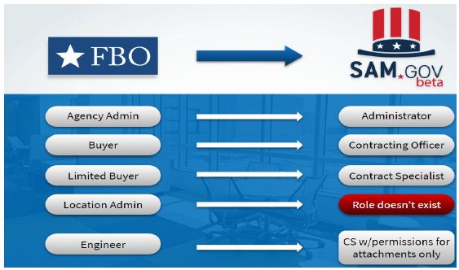
Submit the request, and it will be sent to the Agency Administrator for opportunities to be either approved or rejected.
To Migrate a role:
Role Migration can be accessed either during the account creation process, from the “Go to my role” link in your workspace, or by going to your Profile, then selecting Migrate Roles from the left menu.
To migrate a role, select FBO.gov from the dropdown menu, then enter your FBO.gov login and password, then select Migrate. You should see a notice pop up that the migration was successful, and when you go to My Roles, you should now see your role in the table.
It is also important to note that some roles will have different names in beta.SAM.gov than they did in their legacy system, so users migrating their roles may notice a change in their role name. For example, users migrating roles will notice that the FBO roles of ‘Buyer’ and ‘Limited Buyer’ have been renamed ‘Contracting Officer’ and ‘Contracting Specialist’, respectively, within beta.SAM.gov. Please refer to the graphic above to see what FBO roles will be in beta.SAM.gov.
Finally, after all the other steps are completed, you should check out your workspace. Before launch, your beta.SAM.gov workspace will have your profile, view of your Federal Hierarchy, and management of following, and saved searches. At launch, your beta.SAM.gov workspace will additionally include a widget allowing you to access Contract Opportunities. You are now prepared to begin working on your notices.

Additional Information and Resources
If you are not the Federal Hierarchy Administrator, you will need to reach out to your corresponding Federal Hierarchy Administrator. That information can be found by emailing newsamtesting@gsa.gov. Additionally, if you need to deal with questions regarding your Administrator Role email newsamtesting@gsa.gov.

FY2020 Per Diem Rates for Federal Travelers Released
On August 8, 2019, the U.S. General Services Administration released the fiscal year (FY) 2020 travel per diem rates, which will take effect on October 1, 2019.

By law, GSA sets these rates for the continental United States annually. Per diem rates provide caps, or maximums, to the amounts that can be reimbursed to federal employees for lodging and meals while on official travel. Lodging per diem rates are based on local market costs of mid-priced hotels.

GSA’s lodging per diem rate methodology for FY2020 was the same as previous years and includes taking five percent off of the final average daily rate in each location, which provides an additional savings measure. The standard lodging rate for FY2020 applies to approximately 2,600 counties and will increase from $94 to $96, which is the average adjustment. The standard Meal & Incidental Expenses (M&IE) rate remains $55.

In fiscal year (FY) 2020, there are 322 Non-Standard Areas (NSAs) that have per diem rates higher than the standard CONUS rate.

Changes to the NSAs for FY2020:

- Boise, ID (Ada County) is a new NSA location this year.
- Park County, MT has been added to the Big Sky, MT NSA area.
- Missoula and Flathead Counties in Montana were separated into their own NSAs instead of a combined NSA.

The following locations that were NSAs (or part of an established NSA) in FY 2019 will move into the standard CONUS rate category:

- Dover, DE (Kent County)
- South Bend, IN (St. Joseph County)
- Benton Harbor/St. Joseph/Stevensville, MI (Berrien County)
- Lake County, MT
- Medina County, OH
- Aiken County, SC
- Sheboygan County, WI

As in previous years, GSA still uses:

- Only "fire safe" properties; GSA is required by law to use only properties that are certified as being in compliance with the Hotel & Motel Fire Safety Act of 1990.
- Properties that fall within the mid-price range.
- Data from the prior 12-month period. For FY 2020, this is from April 2018 through March 2019;
- Business travel week data (Monday through Thursday).

Agencies are reminded that the Federal Travel Regulation allows for actual expense reimbursement when per diem rates are insufficient to meet necessary expenses. Please see FTR §301-11.300 through 306 for more information.
For more information on FY 2020 travel per diem rates, please visit www.gsa.gov/perdiem.

Contractor Performance Assessment Reporting System (CPARS)
The information presented is not all inclusive, for detailed information regarding CPARS or the CPARS workflow process check out the Guidance for Contractor Performance Assessment Reporting System (CPARS) and the CPARS User Manual.

What is CPARS?
In accordance with FAR 42.1502, past performance evaluations shall be prepared and entered into CPARS at least annually and at the time the work under a contract or order is completed.
Why it’s Important: Improving the collection and use of information about contractor performance and integrity strengthens the NIH’s ability to efficiently purchase goods and services.
Assessments of a contractor’s performance on a contract and general information about their adherence to certain Federal rules and regulations are critical factors in the source selection process.

CPARS User Roles
With the exception of the Contractor Rep role, all CPARS User Roles must be held by a federal employee. To support the CPARS workflow, each user is assigned a “unique” level of access by the Focal Point; which is based on the individual’s assigned responsibility in the process.
- Focal Point (FP) – must be a federal employee.
  - System Duties / Responsibilities – Assign User Roles, Register Contract Actions, Communicate with AOR/AO evaluation status; Track, monitor CPARS Workflow process; and attend all relevant training.
- Alternate Focal Point (AFP) – must be a federal employee.
  - System Duties / Responsibilities – Same as Focal Point.
- Assessing Official Rep (AOR)* - normally filled by Contracting Officer Representative (COR) or Program Manager (PM)
  - System Duties / Responsibilities – Enters Ratings & Narratives, Validates and Send Evaluation to Assessing Official, attend all relevant training.
- Assessing Official (AO) – normally filled by a Contract Specialist (CS) or Contracting Officer (CO)
  - System Duties / Responsibilities – Reviews Evaluation, Sign, Send to Contract Rep, upon return from CR Finalizes (Closes) the Evaluation, attend all relevant training.
- Contractor Rep (CR) – filled by the Contractor (Vendor/Supplier) – must not be filled by a federal employee.
  - System Duties / Responsibilities – Reviews the Evaluation, either concurs or non-concur, sends back to AO, attend all relevant training.
- Reviewing Official (RO) – normally held by a position one level above the CO/CS (i.e., Team or Branch Lead)
  - System Duties / Responsibilities – Settles disputes, communicates with AO & CR, Finalizes (Closes) the Evaluation, attend all relevant training.
*In the event the role of the AOR is performed by the AO for a particular Office of Acquisition, simply assign the user role of AO. The AO has the same system functions and authorities as the AOR.

Focal Point (FP)
Each NIH Office of Acquisition may assign as many Focal Points as required. However, Alternate Focal Point access is limited to five (5) Alternate Focal Points per contract action.
- Must be held by a federal employee (FTE).
- Focal Point (FP): The Focal Point provides overall support for the CPARS process for their specific NIH Office of Acquisitions.
Focal Point / Alternate Focal Point Training Requirements
- CPARS Overview - https://www.cpars.gov/webtrain_auto.htm
  - The CPARS Overview online course benefits ALL User Roles
- Focal Point and Agency POC Auto Register Function - https://www.cpars.gov/webtrain_all.htm
- CPARS Reports
Focal Point Access Request
- Complete the Overview Training and the Focal Point and Agency POC Auto Register Function Training (https://www.cpars.gov/webtrain.htm),
- Send a copy of the certificate for the Focal Point and Agency POC Auto Register Function training to cpars@mail.nih.gov, and
- Request Focal Point Access at: https://www.cpars.gov/userforms.htm
CPARS Auto Register Process (Assign Then Register)
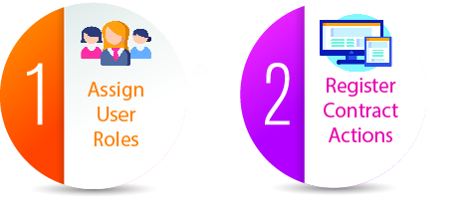
A daily feed from FPDS-ng is the basis for the Auto Register Report.
Focal Points should grant access to the user BEFORE Auto Registering the contract action.
Please Note: When the Focal Point/Alternate Focal Point Auto Register contracts actions before assigning user roles; this automatically changes the evaluation status to DRAFTED (which bypasses the Assessing Official Rep).
This is not an issue if you only want to assign the role of Assessing Official.
In this scenario it would be the responsibility of the AO to enter the Ratings & Narratives.
- Use the CPARS User Manual to learn how to assign user roles to multiple contract actions (see, clone access, remove, transfer user roles).
CPARS Timeline
- 30 Days After Contract Award Date: The FP/AFP assigns user roles; register the contract action.
- 335 Days After Contract Award Date: The Evaluation appears on the AOR / AO To-Do List.
- 365 – 485 Days After Contract Award Date: The AOR / AO enters Evaluation Ratings and Narratives; Validates and sends to AO for Review
- 365 – 485 Days After Contract Award Date: AO Send Evaluation to the CR. The AO is locked out of the action for 60 Days.
- Day 61 After Evaluation Sent to CR: Evaluation returned to AO, CR locked out and may no longer send comments.
  - If the Contractor Rep concurs, the AO must either:
    - Close the Evaluation
    - Modify and close Evaluation
  - If the Contractor Rep does not concur, the AO must either:
    - Send the Evaluation to the RO (Evaluation Updated as Pending).
    - Modify and Send the Evaluation to the RO (Evaluation Updated as Pending)
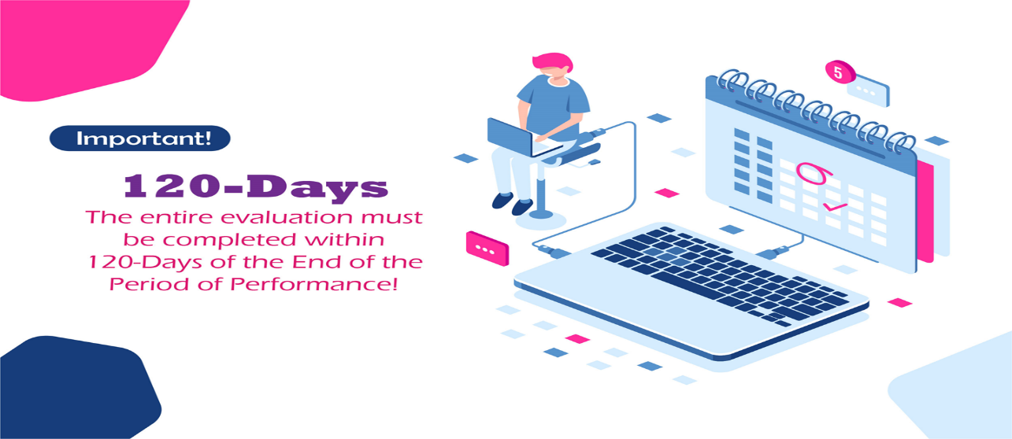

Alternate Focal Point (AFP)

Must be held by a federal employee (FTE).

See Focal Point Information – The AFP has the same authorities and system functionalities as the FP.

The Focal Point is responsible for the assignment of the Alternate Focal Point user role.
The Focal Point / Alternate Focal Point roles are pivotal in the CPARS Workflow process. Please make every effort to ensure that contract actions are registered within 30 Days of the Award Date; and that all user roles are assigned to each and every registered action.

View Performance Access
Federal Employees Only: View all Evaluations useable in Source Selection determinations.
Go to www.cpars.gov
Click on Access Info tab - https://www.cpars.gov/userforms.htm
Scroll down the page until you see, Access (View Performance)
Click on the link “Request Access (View Performance)”
Follow the prompts

CPARS Resources
- CPARS Guidance - https://www.cpars.gov/refmatl.htm
- CPARS Help Desk - webptsmh@navy.mil
- ​CPARS Training - https://www.cpars.gov/webtrain.htm
- CPARS Website - https://www.cpars.gov/
- NIH CPARS Help Desk – cpars@mail.nih.gov
- NIH CPARS SharePoint Site - https://oalmsps.od.nih.gov/DDO/CDMP/CPARS/SitePages/Home.aspx​

Use NIH-Wide Contracts for Your End of Fiscal Year Needs
As we approach the end of FY year 2019, the Office of Logistics and Acquisition Operation (OLAO) is proud to offer the NIH community the NIH Wide IDIQ contracts to acquire services and the GDC Supply center for lab and office supplies. OLAO considers itself as NIH’s premier central services organization for logistics, property acquisition services. The NIH wide contracts are administered by the Special Contracting Team in OLAO. These IDIQ contracts provide the NIH with a streamlined mechanism for the acquisition of services and supplies from a pool of highly qualified pre- approved vendors.
During the busy fourth quarter, using these contracting mechanisms are very beneficial especially for procurements that must be awarded by September 30th.
Benefits of utilizing NIH Wide contracts and Supply center.
- Provide cost-effective services through competition among a vetted group of qualified vendors.
- Support NIH-wide strategic sourcing efficiencies
- Promote the small business goals set forth by NIH (FY19 SB goals is 28%)
- Available for use by all of NIH
- Reduce the risk of protest (task orders less than $10M are not subject to protest)
Websites are available for each contract providing resources that includes:
Base Contract SOW; Standard Operating Procedures (SOP); Frequently Asked Questions (FAQ)
Fact Sheet; Sample Task Order Documents; Contract support email accounts have been set up to receive questions. Trainings are available for each contract upon request; YouTube channel with “How To” videos.
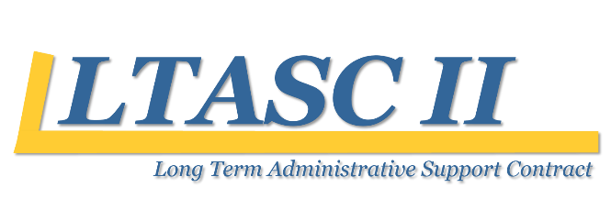
LTASC II is available to obtain commercially provided administrative services on a long-term (minimum of 12 months) basis from 17 small business vendors. http://ltasc.od.nih.gov/

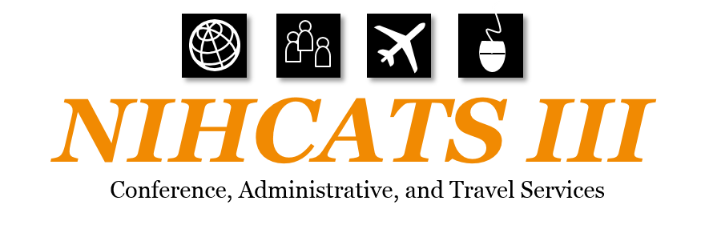
NIHCATS III is available to provide a wide range of meeting, conference, and travel support services related to conferences from 13 possible small business vendors. The NIHCATS III contracts are available to the NIH and other Federal agencies for services performed both in the United States and abroad. http://nihcats.olao.od.nih.gov/

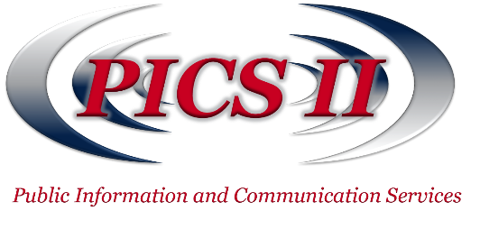
PICS II is available to provide services from 10 small businesses in the areas of media, communication, and information dissemination and technology by purchasing superior communication goods and services, especially where this expertise does not exist in-house. http://pics.olao.od.nih.gov/

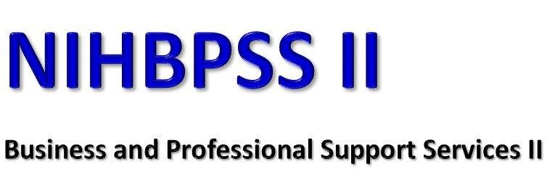
The NIHBPSS II Contract is available to purchase business operation and professional support services from 14 possible vendors. http://nihbpss.olao.od.nih.gov/

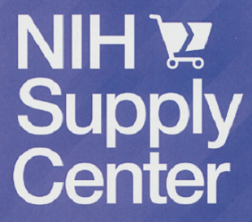
The NIH Supply Center is the Agency´s internal, not-for-profit, FAR and ISO 9001-2015 certified and approved first source for providing lab, medical and office supplies. Online orders can be placed through NBS, POTS and the Online Product Catalog (Coming Soon) https://nihsccatalog.od.nih.gov or by visiting our two stores located in buildings 10 and 31.
https://nihsc1.od.nih.gov/
For further information please contact Sharmaine Fagan-Kerr, Branch Chief, Special Contracting Team, at either 301-594-3744 or at sharmaine.fagan-kerr@nih.gov .

Recap Corner
Below is a recap of recent OALM communications to the NIH acquisition workforce.
ID | Title | Date | Purpose
19-37 | FY 2014 Canceling Year Lines | 5/13/2019 | Provide update on canceling 2014 year lines
19-38 | FedDataCheck Webinar - Miscoding the new FPDS-NG Item 6T - Inherently Governmental Functions | 5/14/2019 | FedDataCheck (FDC) Alert 141 identifies actions where FPDS Item 6T Inherently Governmental Functions (IGF) and Item 8A Product or Service Code (PSC) conflict. Item 6T Inherently Governmental Functions is only required on actions with a PSC as a ‘Service’ (PSCs which begin with an “ALPHA”). The number of FY19 actions by ICs is listed below.
19-39 | NEW SharePoint Site for DCIS, CPARS, and FedDataCheck - | 5/14/2019 | Provide New SharePoint Site for DCIS, CPAR, and FedDataCheck
19-40 | FedDataCheck Webinar - Commercial Item Acquisition Procedures - Expanding Universes and Inconsistent Coding | 5/28/2019 | Provide FedDataCheck Webinar information
19-41 | FY18 Independent Validation and Verification (IV&V) Results | 5/28/2019 | Provide FY18 Independent Validation and Verification Results
19-42 | FPDS Downtime for Production Maintenance | 5/30/2019 | FPDS Maintenance
19-43 | FPDS validation has been reinstated | 6/3/2019 | Reinstatement of FPDS validation
19-44 | Awards not Reported to FPDS/DCIS on Friday, May 31, 2019 | 6/3/2019 | Provide awards not reported to FPDS/DCIS on May 31, 2019
19-45 | Execution of NBS PO Final Close Program on FY 2014 Canceling Year Funds | 6/10/2019 | Provide executive of NBS PO Final Close Program on FY2014 Canceling Year Funds
19-46 | DCIS Data Corrections - FedDataCheck 123 Alert Email Tip | 6/14/2019 | Provide DCIS Data Corrections
19-47 | FedDataCheck Webinar -- – Linking FPDS-NG to Sub-Awards and their corresponding Highly Compensated Officers | 6/17/2019 | Provide FedDataCheck Webinar
19-48 | FY 2014 Canceling Year Lines & NBS Automated Close Program Run of June 21 | 6/27/2019 | Provide FY 2014 Canceling Year Lines & NBS Automated Close Program
19-49 | FY 2014 Canceling Year Lines & Scheduled NBS Automated Close Program Run of July 20 | 7/1/2019 | Provide update on cancelling year lines & scheduled NBS Automated Close
19-50 | FPDS Changes – June 2019 | 7/1/2019 | Provide FPDS Changes
19-51 | PCard Changes – June 2019 | 7/1/2019 | Provide PCard Changes
19-52 | FY 2014 Canceling Year Lines & Scheduled NBS Automated Close Program Run of July 20 | 7/8/2019 | Provide FY 2014 Canceling Year Lines & Scheduled NBS Automated Close
19-53 | DCIS is Down | 7/15/2019 | DCIS Downtime
19-54 | DCIS Connectivity - RESOLVED | 7/15/2019 | DCIS Restored
19-55 | FY 2014 Canceling Year Lines & Scheduled NBS Automated Close Program Run of July 20 | 7/15/2019 | Provide FY 2014 Canceling Year Lines & Scheduled NBS Automated Close
19-56 | FPDS Maintenance Downtime - Saturday, July 20, 2019 | 7/18/2019 | FPDS Maintenance Downtime

Acquisition Training at NIH
Acquisition Training Classes that are offered by the NIH Training Center can be accessed at the following link: Acquisition Management Training
Federal Acquisition Certification Coursework
CON courses and other Federal Acquisition Certification required courses can be found at the NIH Training Center, Federal Acquisition Institute, and Defense Acquisition University.
Section 508 Accessibility Training
Section 508 Accessibility Training courses can be accessed at: CIT Section 508 Accessibility Training Website.
Green Purchasing Training
Green Purchasing Training and other Green Training courses can be found at: OALM Green Purchasing Website.

News from the BPA Program
Need to make a quick buy?
Looking to create value for your customer?
Not sure what a BPA is?
Contact the BPA Helpline at 301-496-5212 or the Helpdesk BPAProgramBranch@od.nih.gov

NIH Blanket Purchase Agreement (BPA) Lists Available Online
Lists of all NIH Blanket Purchase Agreements (BPAs) can be found at the NIH Blanket Purchase Agreement Homepage.
This website contains a number of BPA listings, including:
1. NIH -Wide BPA list (alphabetical list by vendor name);
2. NIH -Wide BPA List sorted by commodity;
3. Open Market BPA Holders; and
4. GSA Federal Supply Schedule BPA Holders.

If you have any questions or need further clarification, please contact the BPA helpline at 301-496-5212 or email.

THANKS!
We would like to thank all those who contributed to this and future editions of the OALM Newsletter.
The OALM Newsletter will be published four (4) times in calendar year 2019. We encourage staff to submit articles that would be of interest to our readers. We will do our best to include such articles in future editions of the OALM Newsletter.
Please address all correspondence to the editors: Milton Nicholas, NicholaM@od.nih.gov Michele McDermott, McDermottMl@od.nih.gov, Jesse Lee, Jesse.Lee2@nih.gov, or Barry Solomon, SolomonBJ@od.nih.gov.
If you have any questions or comments regarding the information, policy and/or procedures published in this issue, you may contact Barry Solomon at the e-mail address above. For future issues please contact the Simplified Acquisitions Helpline on 301-496-0400 or via e-mail at OALMnewsletter@mail.nih.gov and you will be referred to the appropriate editor.

